Open the TI-Nspire document Balancing_Chemical_Equations.tns.  In this activity you will use the simulation to generate chemical equations and to balance these equations by observing how products are formed from reactants. You will be able to adjust coefficients for the reactants until all reactants are used to form the products. |  | 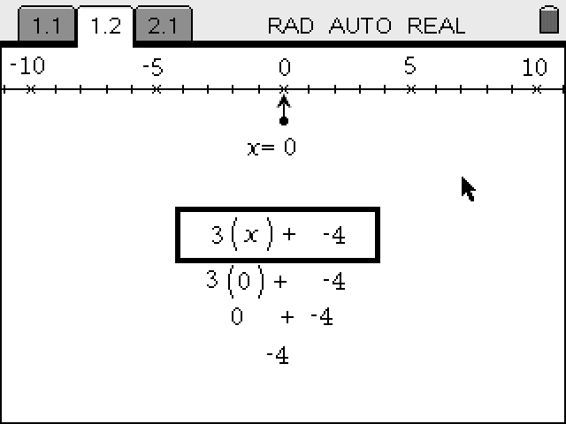
Move to page 1.2. | Press /¢ and /¡ to navigate through the lesson.
1. Review the directions for this part of the activity. You can close the Directions box by clicking . You can also view the directions again by pressing b.
In this activity, you will explore balancing chemical equations for various types of equations:
Level 1 – combination equations
Level 2 – single replacement equations
Level 3 – double replacement equations

2. Start with Equation 1 in Level 1. Use the up and down arrows to change the coefficients that appear in front of each reactant until product is formed without any excess.

Answer questions 1 and 2 here on the activity sheet.
Q1. Record the balanced equation and draw the molecular representations of the reaction. Explain how this representation was derived.
__C +__ S →__ CS₂

Q2. What is the relationship between the “reactants” and “products” atoms? Show work that supports your answer.

3. Balance the remaining equations in the tables for all three levels. Adjust the coefficients that appear in front of each reactant until products are formed without any excess. Once you have balanced the equation, record the coefficients, draw a molecular representation, and record the number of atoms for each element in reactants and products.

Level 1 – Combination
Equation and Molecular Representation
# of atoms for each element
# of atoms for each element | Reactants | Products
__C + __O₂ → __CO₂

__K + __Cl₂ → __KCl

__S + __F₂ → __SF₂

__Na + __F₂ → __NaF

Level 2 – Single Replacement  Equation and Molecular Representation | # of atoms for each element
 | Reactants | Products
__Na + __H₂O → __H₂ + __NaOH

__FeCl₂ +__ K → __Fe + __KCl

__NaBr + __F₂ → __NaF + __Br₂

__AgCl + __Cu → __Ag + __CuCl₂

__HCl + __Zn → __H₂ + __ZnCl₂

Level 3 – Double Replacement  Equation and Molecular Representation | # of atoms for each element
 | Reactants | Products
__Na₂S + __PbF₂ → __PbS + __NaF

__NaOH + __HCl → __H₂O + __NaCl

__PbF₂ + __Na₂S → __PbS + __NaF

__LiCl + __H₂S → __Li₂S + __HCl

__CaBr₂ + __K₂S → __KBr + __CaS

Answer questions 3–6 here on the activity sheet.
Q3. What is the difference between the coefficients and subscripts in a chemical equation?

Q4. Explain how you found the number of atoms for each reactant and product.

Q5. Can you use fractions as coefficients in the chemical equations?

Q6. What are you not able to do when balancing chemical equations? Why?

Move to pages 2.1 – 2.5.
4. Apply what you’ve learned to answer the questions.
Answer questions 7–11 here on the activity sheet or in the .tns file.
Q7. Is this reaction balanced?
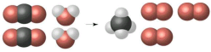

A. Yes, all of the atoms are balanced
B. No, the red atoms are not balanced
C. No, the black atoms are not balanced
D. No, the white atoms are not balanced

Q8. What do you need to do to balance the equation N₂ + H₂ → NH₃? (Select all that apply.)

A. Double the coefficient of N₂(2N₂)
B. Multiply coefficient of H₂by 3 (3H₂)
C. Multiply subscripts of H₂by 3 (H₆)
D. Double the subscripts for NH₃(N₂H₆)
E. Double the coefficient of NH₃(2NH₃)

Q9. Balance the equation given below.
Au₂S₃ + H₂ → Au + H₂S

Q10. Select all equations that are NOT balanced.

A. Ag + O₂ → AgO
B. Sr + H₂SO₄ → SrSO₄ + H₂
C. Ca(OH)₂ + CO₂ → CaCO₃ + H₂O
D. KI + Pb(NO₃)₂ → PBI₂ + KNO₃

Q11. For the equation Fe + H₂SO₄ → Fe₂(SO₄)₃ + H₂ how many atoms of each element are on each side of the equation when it is balanced?

A. 2Fe, 2H, 1S, 4O
B. 2Fe,4H, 2S, 8O
C. 2Fe, 6H, 3S, 12O
D. 2Fe, 8H, 4S, 16O

