Open the TI-Nspire document Natural_Selection.tns.  In this simulation, you will observe how natural selection acts on a population, and how that results in changes to the population over time. You will be able to adjust the parameters that influence natural selection to see how different traits or selections determine the makeup of a population. |  |  | 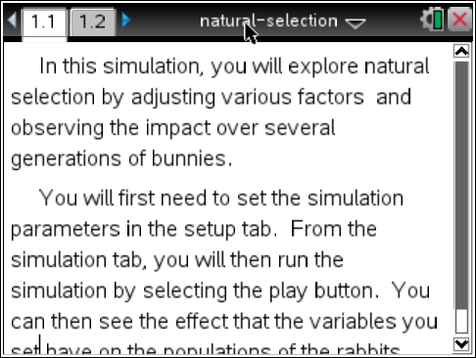
Natural Selection is a term that Charles Darwin first used to describe the mechanisms that act on a population to shape the nature of evolutionary change. There is always a natural variation in a population, some features have a neutral effect, some are an advantage and some are a disadvantage. Those that hurt an individual in the population cause them to be naturally removed through selection. This then increases the influence of helpful traits. It’s important to understand that natural selection acts on the phenotype, or the visible traits in the population, not the genotype, which is the genetic information.

In this simulation, you will set up experiments to see how different phenotypes respond when under a simulation of selection. Read the directions on page 1.1.

Part 1: No Selection

Move to page 1.2.
Select the Setup tab. First, you will examine how populations grow when there is no natural selection, or selective pressure.
- Use the arrows to change the Selection Factor to None.
- Pick a mutation you would like to examine, and when it will be introduced into a wild-type, or non-mutant, population.
- First, you will see what happens when the Mutation is Dominant. Leave all other setting as shown to the right.
- Select the Simulation tab. Select Play  to start the simulation. Let the simulation proceed to at least 6 generations (Gen6) before answering the questions. Notice the information at the top of the Simulation page. Select Pause to stop the simulation.

 | Tech Tip: To change the speed of the simulation, select b or 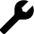 > Speed and then select the desired speed. You may need to back-out to the main Tools Menu to see the desired menu option.
Q1. What is a phenotype?

Q2. How would you expect the simulation to be different if there were a selective advantage to one trait?

Q3. After 6 generations, how many rabbits show the dominant phenotype? The recessive phenotype?

Q4. Can you determine the genotype of the rabbits in this simulation? If so, what is it?

Select the Setup tab. Change the mutation from Dominant to Recessive and leave all of the other settings as before.
A dominant trait masks the effect of a recessive trait. To understand how basic dominant and recessive genotypes influence phenotypes, look at an example. Although people inherit two copies of every gene (one from their mother, one from their father), a trait like freckles can be seen even if you only have one copy. In this case, “freckles” are dominant a dominant allele (alleles are like gene variants) and “no freckles” is a recessive allele. For an individual not to show freckles, this means they have no copies of a freckle gene.

Q5. Do you predict most or few rabbits will show the recessive mutation versus no mutation after 6 generations? Explain.

- Run the simulation for 6 generations.

Q6. How would you expect the simulation to be different if there were a selective advantage to one trait?

Part 2: Selection by Hunger
Next you will examine how the population changes when under selection. Only individuals that survive can pass their genes on to the next generation. If a certain mutation gives the individual an advantage, or fitness, that mutation is more likely to be seen in the population after several generations. This will increase the average fitness of the population, allowing the population to adapt to a change in the environment.

- Select the Setup tab.

- Switch the Selection Factor to Hunger, and Mutation is to Dominant. In this simulation, the rabbits have limited food resources, but there is a new food source into the simulation. Leaving the other settings alone.

- Select a mutation you would like to examine in this simulation (you will have a chance to compare with classmates and try other mutations). Select the Simulation tab. Do not reset the simulation. Repeat the simulation for at least 6 generation.

Q7. Which traits appear to give a selective advantage against hunger in the simulation? Explain why you think so.

Q8. In general terms, how does a phenotype provide a selective advantage to an animal?

Q9. How does the result of the simulation change when you introduce the advantageous mutation as a recessive mutation?

Q10. How does the rabbit population change when there is a Selection Factor in the population, in contrast to the No Selection simulation?

Part 3: Selection by Wolves
In Part 2 you saw that a trait which can give an advantage to individuals becomes more common in the population. The opposite is true as well, sometimes traits give a disadvantage (individuals with those traits die before they can be passed on), and these traits and alleles are less common in the population.

- Select the Setup tab. Set the Selection Factor to Wolves.
- In this simulation, there are two factors that can influence the outcome, wolves and environment (Arctic or Equator).You will test the environment second leaving all settings as in Part Two.

Q11. Which phenotype do you predict will be most common after 9 generations?

Q12. Perform the simulation. Was your prediction correct?

- Compare your answers with a classmate who has done a different simulation, or perform another simulation yourself in order to answer the following questions.

Q13. When wolves are performing natural selection, which phenotype(s) give(s) the selective advantage? What do the rabbits that are most likely to survive look like under the conditions in this part?

Q14. How does the simulation change when the advantageous trait is dominant vs. recessive?

- Next, test how altering only the environment changes the simulation. For some mutations, this has no effect. Select  to change the environment.

Q15. How does the choice of environment influence natural selection? Do you get the same or different results in the Arctic and at the Equator?

Extension:  This simulation may help you to see what happens as climates change or species move into new environments. Set up the following simulation: at the equator, white fur is the dominant mutation, and introducing the mutation after three generations with a Selection Factor of wolves.  Let this simulation go for at least 6 generations before switching the environment to the Arctic by selecting to change the environment.  This will change the selection pressure for the population of rabbits. |  |  | 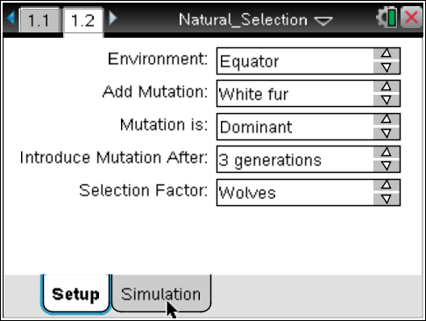
Q16. What did you observe? Was one allele advantageous in both environments?

Q17. How did the population change after the environment is switched?

