Open the TI-Nspire document Slope_Fields.tns.  A slope field is a graphical representation of the family of solutions to a first order differential equation, yʹ = g(x, y). A slope field may be used to visually check an explicit solution to a differential equation or to approximate a solution when the differential equation cannot be solved analytically. Each line segment is tangent to a solution of the differential equation. | 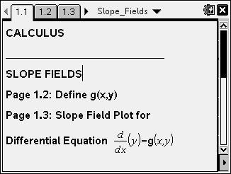

Move to page 1.3. | Press / ¢ and / ¡ to navigate through the lesson.
1. The slope field on this page is a visualization of the family of solutions to the differential equation .
a. Describe the slope of a tangent line to the graph of a solution at a point (0, b), b ≠ 0, on the y-axis. Use the differential equation to justify your answer.

b. Describe the slope of a tangent line to the graph of a solution at a point (a, 0), a ≠ 0, on the x-axis. Use the differential equation to justify your answer.

c. Describe a solution to the differential equation as suggested by the slope field.

d. Use your answers to parts 1a, b, and c to write a possible specific solution to the differential equation. Enter this function for . Is it consistent with the slope field? If not, try to find and graph a function that corresponds to the slope field.

e. Add a calculator page. Use the command deSolve to find the general family of solutions to this differential equation. Find the specific solution to this differential equation that passes through the point (0, 5). Verify analytically that this is a solution to the differential equation.

2. Consider the differential equation , and on page 1.2 define . Move to page 1.3 and consider the corresponding slope field.
a. Where are the slopes the same?

b. Use your answer in part 2a to generalize. If g(x, y) involves only the variable x, then where will the slopes be the same? Justify your answer.

3. Consider the differential equation , and on page 1.2 define . Move to page 1.3 and consider the corresponding slope field.
a. Where are the slopes the same?

b. Use your answer in part 3a to generalize. If g(x, y) involves only the variable y, then where will the slopes be the same? Justify your answer.

4. Consider the differential equation , and on page 1.2 define . Move to page 1.3 and consider the corresponding slope field.
a. Where are the slopes the same?

b. Use your answer in part 4a to generalize. If the differential equation is of the form , where a and b are constants, then where are the slopes the same? Justify your answer.

5. Match each differential equation with its corresponding slope field (shown on the next page). Use the TI-Nspire to solve each differential equation and graph a particular solution on the corresponding slope field.
a. b. c.

d. e. f.

g. h. i.

j

(i)  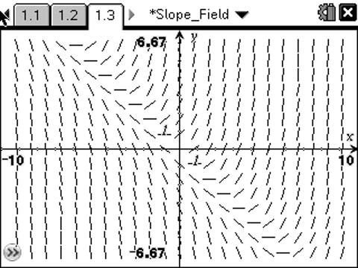  (iv)  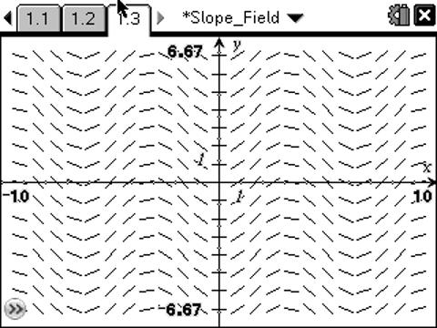  (vii)  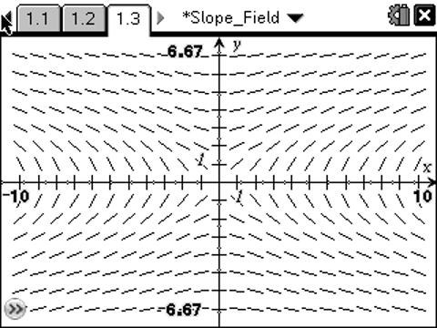  (x)  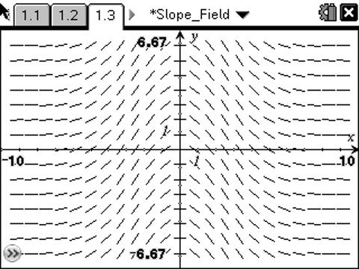 | (ii)  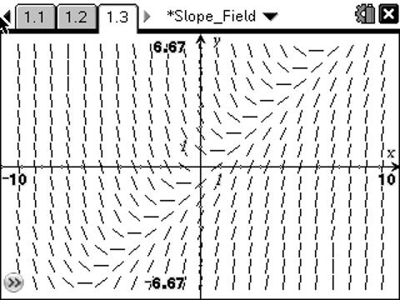  (v)  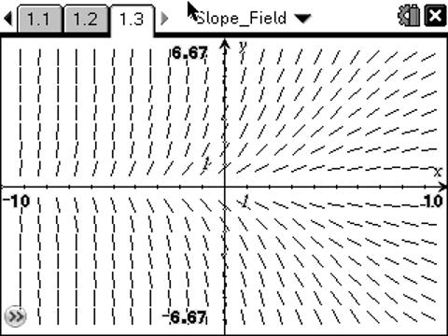  (viii)  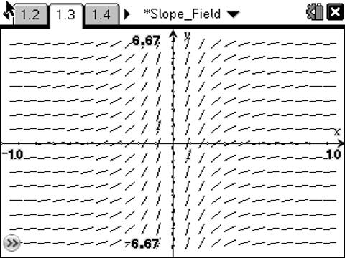 | (iii)  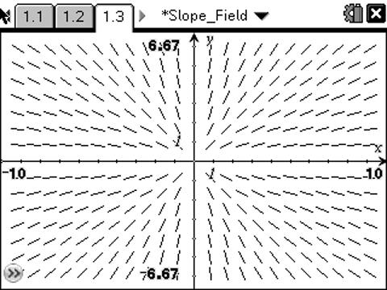  (vi)  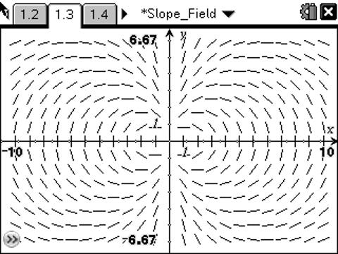  (ix)  