Open the TI-Nspire document Why_Am_I_Charged.tns.  What kind of elements make up ionic compounds? How are the formulas of ionic compounds written? What holds the ions in table salt crystals together? These questions and many others will be addressed in this simulation. | 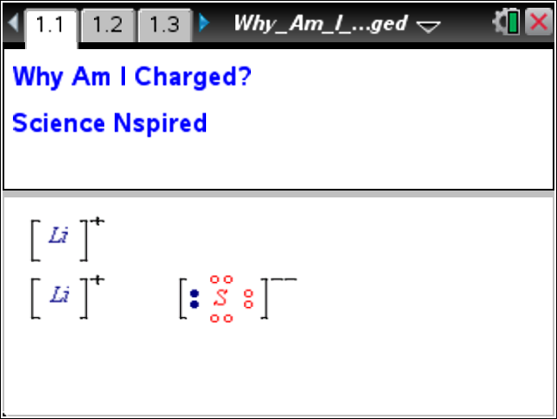

Atoms of an element have equal numbers of protons (positively charged) and electrons (negatively charged) and, therefore, are neutral in charge. Metals are elements that have 1, 2, or 3 electrons in their outer shell. They tend to lose these electrons to obtain a stable filled inner shell called an octet. This octet is called a noble gas configuration since it is the structure of a noble gas atom. After losing the electrons, the ion that is left has an excess of protons and therefore has a positive charge. Positively charged ions are called cations.

Nonmetals, on the other hand, have 5, 6, or 7 electrons in their outer shell and tend to gain 1, 2, or 3 electrons to obtain a stable octet (noble gas) configuration. These ions now have an excess of electrons and have a negative charge. Negatively charged ions are called anions. The presence of ions in solution allows the solution to conduct electricity-CaCl₂ because it contains Ca²⁺ and Cl^{-–} ions.

The transfer of electrons between a metal and a nonmetal is called an oxidation-reduction reaction, or redox reaction. This is because the metal is oxidized (loses electrons) and the nonmetal is reduced (gains electrons). The number of electrons lost must equal the number gained, and both must occur simultaneously because of the law of conservation of matter. The product of this reaction will be an ionic compound called a salt. A salt is an ionic compound made up of positive and negative ions in a ratio that causes the charges to cancel. The attraction between opposite charges holds ionic compounds together.

Move to pages 1.2 – 1.6. Answer the following questions here or in the .tns file.
Q1. Atoms of an element are _______ charged.
A. positively  B. negatively | C. neutrally  D. electrically
Q2. Metals have _______ electron(s) in their outer electron shell.
A. one  B. two | C. three  D. one, two, or three
Q3. Negatively charged ions are called ________.
A. anions  B. atoms | C. cations  D. mesons
Q4. The transfer of electrons between a metal and a nonmetal is an example of a _______.
A. physical change  B. nuclear change | C. singe replacement reaction  D. redox reaction
Q5. The loss and gain of electrons in a redox reaction must be _______.
A. equal  B. simultaneous | C. equal and simultaneous  D. unequal

Move to pages 2.1 and 2.2.
1. Set the number of atoms for each element using Cation and Anion arrows. Use to transfer the electrons between the metal and the nonmetal. Select Reset to try again.
2. From the Menu list, select “New Pair of Ions” to work a new problem.
 | Tech Tip: To work on a new problem, select Menu or  > Why Am I Charged > New Pair of Ions. You may need to back-out to the main Tools Menu to see the desired menu option.
Move to page 2.3.  3. When you have created a correct combination of cations and anions, the equation in the bottom of the window will yield a stable compound. For example:  Ca + Cl₂ ➔ [Ca]²⁺ +2[1/2Cl₂]⁻ ➔ CaCl₂  Note: If the formula is correct, the charges for the ions will appear once the transfer of electrons is complete. The charges will total to zero. |  | 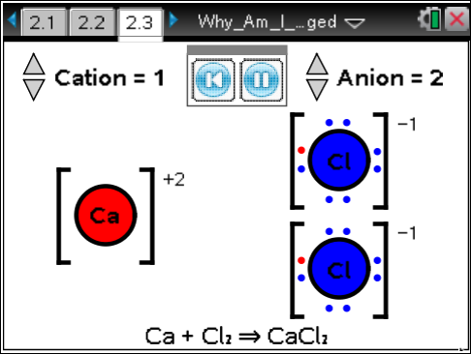
4. If your ratio of ions is incorrect, a message indicating that the charge does not balance will be displayed. You will need to adjust either the number of cations or the number of anions to obtain a correct formula. Repeat the process until you have successfully completed all 10 possible combinations.  5. As you are working through the combinations, think about the relationship between the ratio of cations to anions and the number of electrons transferred. |  | 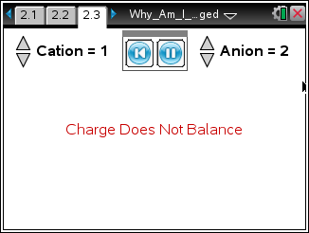
Move to page 2.4.
6. You will be prompted to write the formula of a cation, an anion, then a compound. Ions MUST have a charge. Write ion charges with the number followed by a charge: 2+. Write single charges as – or +. The 1 is understood. On page 2.4, select ·. Choose OK.
 | Tech Tip: To start the quiz, double-tap anywhere on the screen. The keyboard will appear. Select enter and follow the prompts. To input values during the quiz, tap the input box. The keyboard will appear. To enter a numerical value, select the button “.?123” located to the left or right of the space bar. To enter a + or – symbol, select the button “#+=.” Enter the appropriate symbol, and then select enter.

Move to pages 3.1 – 3.10. Answer the following questions below or on your device.
Q6. When sodium reacts with chlorine, _______ sodium atom(s) react(s) with ________ chlorine atom(s).
A. one, two  B. two, two | C. two, one  D. one, one
Q7. When lithium loses an electron to a nonmetal, it gains a _______ charge.
A. neutral  B. negative | C. equal  D. positive
Q8. Fluorine is a diatomic molecule. When F₂ reacts to make two fluoride ions, there must be a total of ______ electrons gained.
A. zero  B. one | C. two  D. four
Q9. Barium reacts with sulfur in a _______ ratio.
A. 2:1  B. 1:1 | C. 1:2  D. 2:2
Q10. The reaction of lithium with sulfur requires the transfer of _______ electron(s).
A. one  B. two | C. three  D. four
Q11. The reaction of sodium and oxygen requires _______ atom(s) of sodium to react with one atom of oxygen.
A. one  B. two | C. one half  D. three
Q12. The reaction of barium and fluorine requires _______ flourine atom(s).
A. zero  B. one | C. two  D. three
Q13. Table salt consists of a(n) _______ ion and a(n) _______ ion.
A. potassium, nitrate  B. sodium, fluoride | C. potassium, fluoride  D. sodium, chloride
Q14. What holds sodium chloride together?

Q15. Why does salt water conduct electricity?

