Open the TI-Nspire document Slope_CI_and_Test.tns, or use the Create document to create the .tns file yourself.  In this activity, you will determine the association between the number of hours spent per week playing video games and Grade Point Average (GPA). You will input data into a list, conduct a hypothesis test for the association, and find a confidence interval for the slope. | 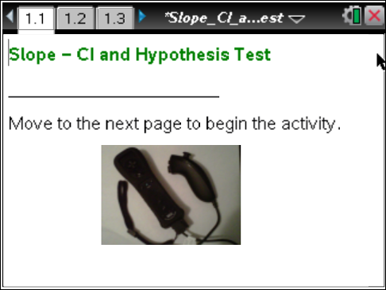

A school district wants to see if there is an association between a student’s GPA and the number of hours spent playing video games per week. The data from 14 randomly selected high school students are displayed below.

Student | Hours of Video Game Play per Week | GPA
A | 17.5 | 2.0
B | 15 | 3.0
C | 25 | 0.8
D | 15.5 | 2.7
E | 11 | 2.6
F | 12.5 | 3.6
G | 3.5 | 4.0
H | 6 | 3.2
I | 24 | 1.0
J | 13 | 2.9
K | 20.5 | 1.8
L | 9 | 3.5
M | 23.5 | 1.5
N | 2 | 3.8

Move to page 1.2. | Press / ¢ and / ¡ to navigate through the lesson.
1. Why might the district be interested in determining if there is an association between video game playing and GPA?

2. a. What conditions must be checked in order to perform an inference procedure?

Move to page 1.3.

b. Page 1.3 shows the scatterplot of GPA vs. number of hours of video games played per week and the residual plot for the least-squares regression line. Do these plots meet the conditions for a hypothesis test on the slope? Explain your reasoning.

Move to page 1.4.

c. Page 1.4 displays the normal probability plot of the residuals. Are the conditions satisfied? Explain your reasoning.

Move back to page 1.2.

3. a. State the null and alternative hypotheses for the slope (both numerically and in words) to determine whether there is a linear association between the variables.

b. The results of the hypothesis test on slope are displayed in the spreadsheet. The degrees of freedom for a hypothesis test for slope is found by subtracting two from the sample size (n-2). How many degrees of freedom should be used in this test?

c. What is the t-test statistic and p-value for the hypothesis test? Explain the meaning of the
p-value.

d. Make a decision to reject or fail to reject your null hypothesis using an alpha value of 0.01. Write your conclusion in context.

e. If the hypothesis test were changed to determine whether the variables have a useful negative linear relationship, how would the alternative hypothesis and the p-value change? Explain your reasoning.

Move to page 1.5.

4. The page shows the calculations of a 95% confidence interval for the slope.
a. Show two ways the interval can be calculated based on the output.

b. What is the 95% confidence interval for the slope? Explain what it means in context.

c. Does this confirm that playing video games causes your GPA to go down? Explain your reasoning.

5. a. How do the results of the hypothesis test compare to the confidence interval?

b. Your job is to report the results of your research back to the school board. You only have time to explain either the results of the hypothesis test or the confidence interval. Which do you think provides the most valuable information? Explain your reasoning.

