Problem 1 – Creating a Scatter Plot
Read the directions on page 1.2. On page 1.4, create a scatter plot of List1 and List2 from the spreadsheet. Use the Attributes tool to select Points are connected.  Sketch the graph from page 1.4. |  | 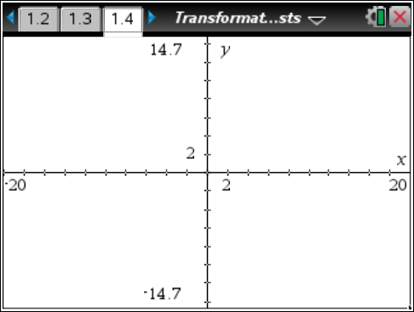
Problem 2 – Reflections and Rotations
On page 2.2, create list3 with the opposite of all the x-values in list1. Create list4 with the opposite of all the y-values in list2.
On page 2.4, add the following scatter plots one at a time. Identify the type of reflection that occurs for each type of ordered pair.
A: x ← list3 and y ← list2  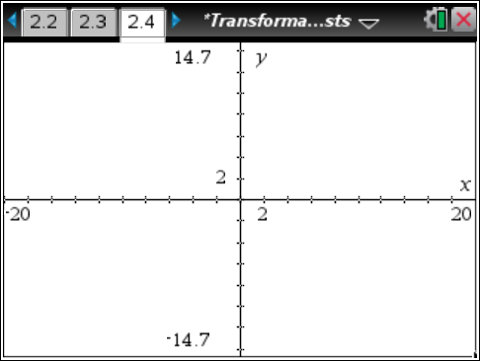  (–x, y) ________________ | B: x ← list1 and y ← list4  (x, –y) _________________ |  | C: x ← list2 and y ← list1  (y, x) __________________
On page 2.6, add the following scatter plots one at a time. Identify the type of rotation that occurs for each type of ordered pair.
D: x ← list4 and y ← list1  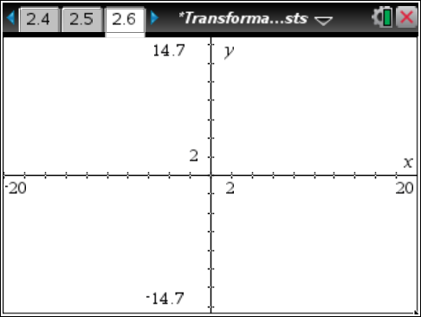  (–y, x) _________________ | E: x ← list2 and y ← list3  (y, –x) _________________ |  | F: x ← list3 and y ← list4  (–x, –y) _________________
Problem 3 – Translations
On page 3.2, enter the following formulas to translate the scatter plot on page 3.3.  list3: =list1–5 list4: =list2+3  Where did the image shift? How many units left/right and how many units up/down? |  | 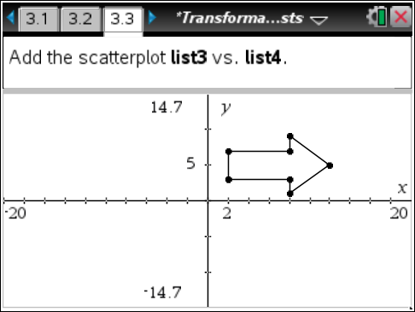
Translate the scatter plot into Quadrant 3 by editing the formula bars for list3 and list4.
list3 formula: ____________________
list4 formula: ____________________
Explain how the image shifted:

Problem 4 – Dilations
On page 4.2, enter the following formulas to dilate the scatter plot on page 4.3.  list3: =0.5*list1 list4: =0.5*list2  Explain what happened to the image. |  | 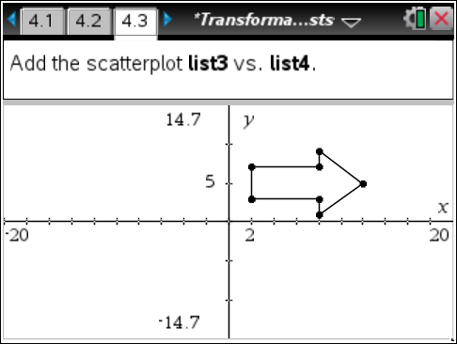
Dilate the scatter plot into Quadrant 3 by editing the formula bars for list3 and list4.
list3 formula: ____________________
list4 formula: ____________________
Explain what happened to the image.

