Science Objectives  In this lesson, students will  - Explore how the structure of DNA supports its semi-conservative replication  - Identify the name and function of several key enzymes in DNA replication  - Recognize the function of Okazaki fragments in DNA replication  Vocabulary  About the Lesson  - Using three simulations, students will interact with DNA replication to explore semi-conservative replication and identify specific enzymes and their roles in replication. Assessments are embedded in the activity to engage discussion and gauge learning.  - As a result, students will:  - Learn the basic functions of the following DNA replication enzymes: helicase, primase, ligase, polymerase I and III.  - Learn how the double helix reproduces in a semi-conservative fashion  - Learn the role and function of Okazaki fragments in replication of the lagging strand.  TI-Nspire™ Navigator™  Not required. If using Navigator:  - Send out the DNA_Replication.tns file.  - Monitor student progress using Class Capture.  - Use Live Presenter to have students demonstrate how to negotiate the simulations and to spotlight student answers.  - Collect student responses from assessment items that are embedded throughout the document.  Activity Materials  - DNA_Replication.tns document  - TI-Nspire™ Technology | 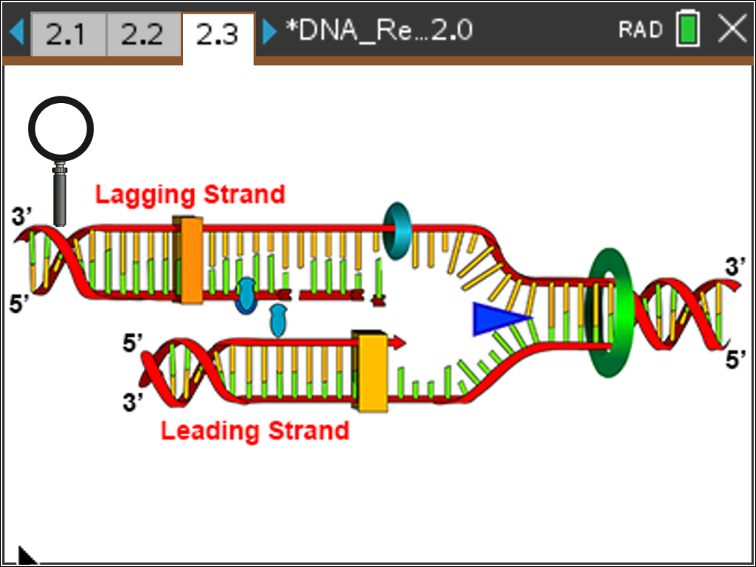  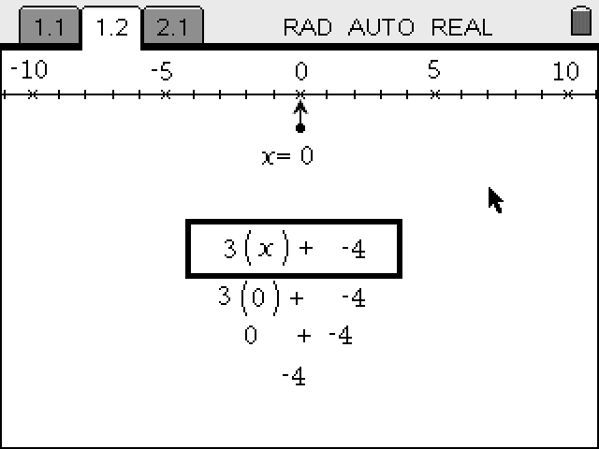  TI-Nspire™ Technology Skills:  - Download a TI-Nspire document  - Open a document  - Move between pages  - Open Directions Box  - Explore ‘Hot Spots’  Tech Tips:  Make sure that students know how to move between pages by pressing /¡ (left arrow) and /¢ (right arrow).  Lesson Materials:  Student Activity  - DNA_Replication_Student.doc  - DNA_Replication_Student.pdf  TI-Nspire document  - DNA_Replication.tns
  - Double helix | - Leading strand
  - Lagging strand | - Polymerase I
  - Polymerase III | - Helicase
  - Base pairs | - Okazaki Fragments
  - Primase

Discussion Points and Possible Answers
Allow students to read the background information on the student activity sheet and in the tns file on pages 1.2–1.3.

Move to pages 1.4 – 1.5.

1. Students are introduced to DNA replication. Before they learn about the key features of this process, they will answer some questions to get them thinking about DNA replication. This may be a good time to have a class discussion where students share their answers.
Have students answer questions 1-2 on the handheld, the activity sheet, or both.
Q1. Why is it important to replicate DNA without errors? What might happen if there were errors in DNA replication?

Sample Answers: prevent mutation, preserve genetic material
Every time DNA replicates, it is done with very high fidelity.

Q2. When should DNA be replicated? What life events would include DNA replication?

Sample Answers: cell division, growth, reproduction

Move to pages 1.6 – 1.7.  2. Students are to read the information on page 1.6 about semi-conservative DNA replication. On page 1.7, they will view a simulation that shows two rounds of DNA replication. They are to click the right arrow to view the rounds of replication. | 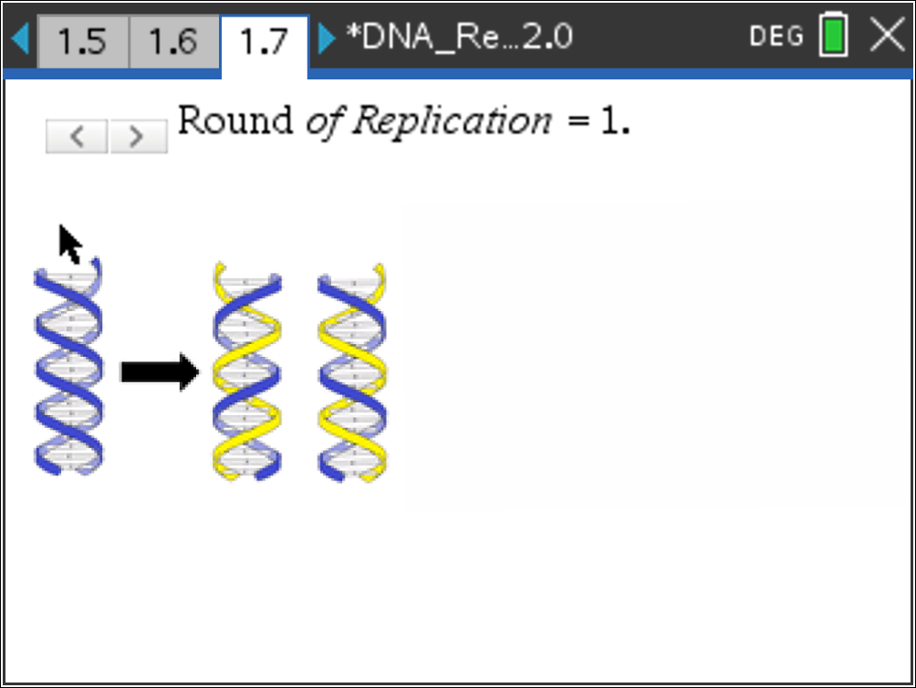
Have students answer questions 3-5 on the handheld, the activity sheet, or both.
Q3. If one double helix of DNA replicates times, how many double helices will you have?

Answer: C. 8

Q4. What happens to the original template DNA after a round of replication? Explain.

Sample Answers: Incorporated into new DNA. The semiconservative replication of DNA means that “new” DNA is half new and half old DNA.

Q5 DNA polymerase, the enzyme that replicates DNA, can add about 1,000 bases per second to the growing DNA strands. How many seconds would it take DNA polymerase to replicate one set of human chromosomes (3,000,000,000 bases long)?

Answer: 3,000,000 seconds
This is 50,000 minutes. This is one reason that there are many copies of polymerase involved in replicating the human genome.

Move to pages 2.1 – 2.3.  3. Students are to read the information on pages 2.1 and 2.2 about the enzymes that perform DNA replication. On page 2.3, students are given a simplified image of DNA replication, showing the leading and lagging strands. After reading the directions given, students can click to close the directions and view the simulation. They are to explore the enzymes that are involved in the replication of DNA by clicking the image when a magnifying glass appears. | 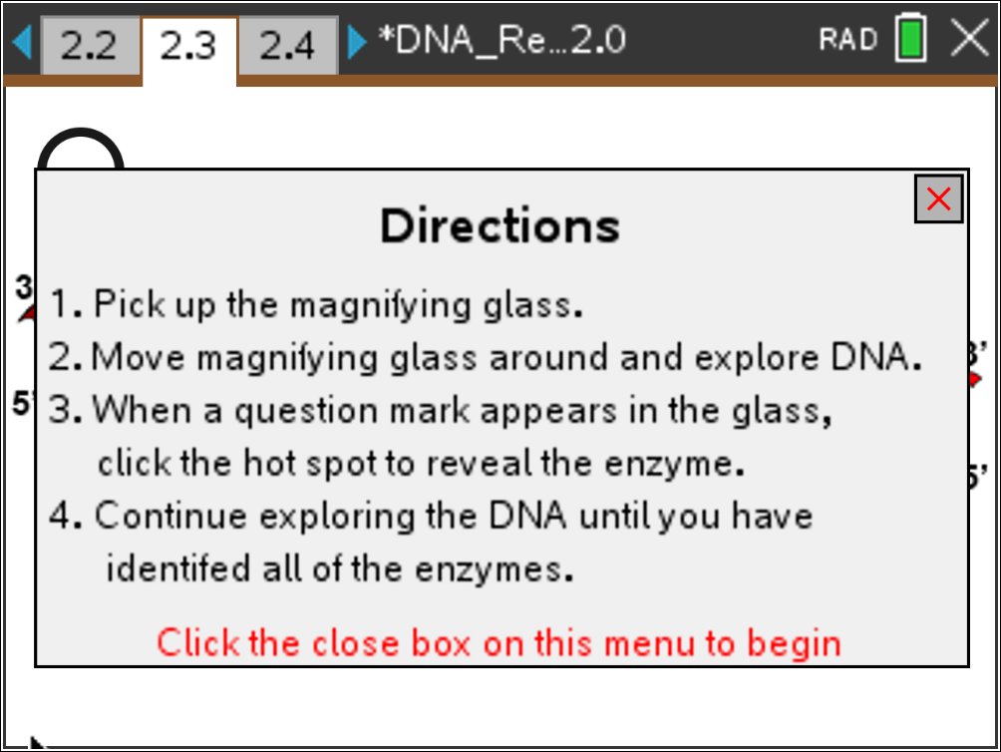
If needed at any time during the simulation, students can press b if they would like to view the directions again.
Have students answer questions 6–10 on the handheld, the activity sheet, or both.
Q6. Which enzyme acts first in DNA replication?

Answer: A. Helicase
Helicase exposes the strands of DNA for other enzymes to access.

Q7. DNA replication uses two different polymerases. Why do you think that is?

Sample Answers: Each polymerase works at a different site; Polymerase I replicates short segments, Polymerase III replicates longer segments.
Each polymerase performs differently; Polymerase III can stay bound to and replicate long segments of DNA, while Polymerase I does not.
Q8. What is the difference between the leading strand and the lagging strand?

Sample Answer: direction of replication, requires additional primers
Both strands replicate with the same enzymes, but the lagging strand must replicate in short segments to make up for replicating away from the direction of the helicase. More on Okazaki fragments in the next segment.

Q9. What is the purpose of primase?

Answers: B. Creates an RNA primer that Polymerase III can elongate
DNA must be added to a substrate (during replication, an RNA primer), 5’ to 3’. Polymerases only elongates DNA, they do not initiate it.

Q10. Which enzyme(s) add(s) new DNA nucleotides to an existing strand? (Select all that apply.)

Answers: C. Polymerase I and D. Polymerase III
Only the polymerases actually add DNA nucleotides to the existing strand.

Move to pages 3.1 – 3.3.
4. Students are to read the information on pages 3.1 and 3.2 about Okazaki Fragments. On page 3.3, students will see a strand of DNA. In this simulation, students drag the circle along each segment on the left side of the page slowly. This simulation will show how Okazaki fragments are built and then joined. Encourage students to pause the dragging of the circle to read the information about DNA replication that appears.
Tech Tip: The simulation can be ‘reset’ by running backwards. If students move the circle/sliders backwards, they can “rewind” the simulation. Note they may not see the same labels, so the simulation should be run forwards to avoid confusion.
Have students answer questions 11–14 on the handheld, the activity sheet, or both.
Q11. Replication of the leading and lagging strands requires different enzymes.

Answer: Disagree
The same set of enzymes is used in both. Primase, Polymerase I and ligase are much more active on the lagging strand.
Q12. What order best describes the order that these enzymes will act during normal replication?

Answer: D. Primase, Polymerase III, Polymerase I, Ligase
Students may want to revisit page 2.3 to answer this question. Primase adds and RNA primer, so Polymerase III can work. The RNA primer is removed and filled in by Polymerase I, and ligase closes the remaining gap (at the 3’ end).

Q13. How is replication of the leading and lagging strands different?

Answer: Lagging strand has Okazaki fragments.
Q14. Why are there no Okazaki fragments on the leading strand?

Sample Answers: Unwinds the same direction as replication
There is one primer at the start of the leading strand, but this strand can replicate without additional primers.

TI-Nspire Navigator Opportunities

Choose a student to be a Live Presenter to demonstrate how to negotiate the simulations. The questions in the activity may be distributed as Quick Polls or used as a formative or summative assessment

Wrap Up
When students are finished with the activity, retrieve the .tns file using TI-Nspire Navigator. Save grades to Portfolio. Discuss activity questions using Slide Show. Students can also turn in the student activity sheet with written answers.

Assessment
- Formative assessment will consist of questions embedded in the .tns file. The questions will be graded when the .tns file is retrieved. The Slide Show will be utilized to give students immediate feedback on their assessment.

