Open the TI-Nspire document Light_Refraction.tns.  Have you ever put the end of a pole under water and observed that it looks like it is no longer straight? Instead, it appears to be bent as you view it from above. In this lab we are going to explore this phenomena that occurs when an object is placed in a liquid. |  | 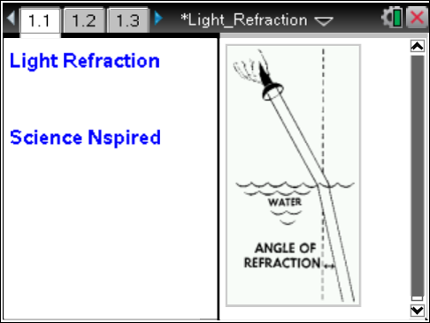
Move to pages 1.2–1.4.
When light moves from air into a liquid, light is refracted. The angle of incidence (θ₁) is the angle between the incident light ray and a line perpendicular to the surface. The angle of refraction (θ₂) is the angle between the normal and the path of the refracted light ray.
The index of refraction for a given medium is the ratio of the speed of light traveling through a vacuum to the speed of light traveling through the medium.
1. Play with the index of refraction on page 1.3 and observe how it affects the paths of the light ray.
Move to pages 1.5–1.8. Answer the following questions here or in the .tns file.
Q1. When the refractive index of the liquid medium increases, _________.
- θ₁ = θ₂  - θ₁ > θ₂ | - θ₁ < θ₂  D. the angles cannot be predicted
Q2. Calculate the sine of θ₁ and the sine of θ₂.

Q3. What is the ratio of sin(θ₁) to sin(θ₂)?

Q4. What is the relationship between the angle of incidence, the angle of refraction, and the medium’s index of refraction?

Move to pages 2.1–2.3.
In the last problem light was refracted as it traveled from a vacuum into a medium. In Problem 2 you will examine what happens as light travels from one medium into another.
2. n₁ is the index of refraction for medium 1 and n₂ is the index of refraction for medium 2. Explore the simulation by changing n₁ and n₂, observing what occurs as you vary these values.

Move to pages 2.4–2.10. Answer the following questions here or in the .tns file.
Q5. If n₁ > n₂, then _________.
- θ₁ = θ₂  - θ₁ > θ₂ | - θ₁ < θ₂  - Cannot be determined
Q6. Calculate the ratio of n₁/n₂.

Q7. Calculate the ratio of the sin(θ₁)/sin(θ₂).

Q8. How does the ratio of n₁/n₂ compare to sin(θ₁)/sin(θ₂)?

Q9. The correct relationship between the angles and refractive indexes is/are _________.
(More than one response may be correct.)
A.  B. | C.  D.
Q10. Air has a refractive index of 1.0003 and water has a refractive index of 1.3330. If a light ray in air strikes water at an angle of 15.0°, what will the angle of refraction be in water?

Q11. A beam of light passes through a layer of benzene at a 20.0° angle to the normal. When it enters the layer of water, the angle of refraction is 30.88°. If the refractive index for water is 1.0003, what is the refractive index for benzene?

