Open the TI-Nspire document Continuity_and_Differentiability_2.tns.  Objective: To determine when a function is continuous or differentiable.  Directions: Follow directions in the TI-Nspire document to determine when the given functions are continuous and/or differentiable. | 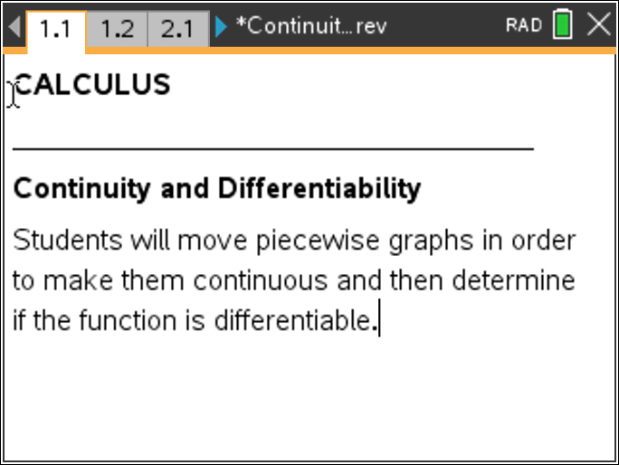

Move to page 2.1. | Press / ¢ and / ¡ to navigate through the lesson.
PART I:

For each question write the function with the values of the slider variable(s) that make the function continuous and differentiable based on the graphs. There may be more than one answer. Confirm your solutions algebraically.

Problem 2.1:

Problem 3.1:

Problem 4.1:

Problem 5.1:

Problem 6.1:

Problem 7.1:

Extension: Go back to each problem and determine if there is more than one solution that will result in a continuous function. If so, explain whether the additional solutions produce a differentiable or non-differentiable function.

PART II:
Calculate the derivative of each function using the values from part I and determine why the graph of the derivative is continuous or not. Explain your conclusion.

Problem 2.1:

Problem 3.1:

Problem 4.1:

Problem 5.1:

Problem 6.1:

Problem 7.1:

