Open the TI-Nspire document Energy_in_Simple_Harmonic_Motion.tns.
Simple harmonic motion is a repetitive motion. It occurs when an object oscillates, or moves back and forth, about an equilibrium point. What keeps the object in motion? Why does a person at the end of a bungee cord keep bouncing up and down after the jump? The answer lies in the conservation of energy principle. In this activity, you will explore this principle and the energy transformations that occur as a mass attached to a spring oscillates in simple harmonic motion.

Move to page 1.2.

Read the introduction. Work must be done on a spring to stretch or compress it. The work is stored as spring potential energy until the spring is released. The amount of potential energy stored in a spring is calculated by the formula . In this formula k is the spring constant of the spring, and x is the amount that the spring is stretched or compressed from its normal length. The next page simulates a mass attached to a spring oscillating across a frictionless, horizontal surface. | 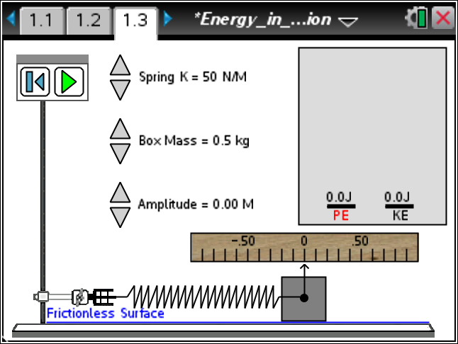
You can manipulate the mass of the object (m), the spring constant of the spring (k), and the amplitude of the motion (a). When the mass is at a position of x = 0 m, the spring is neither stretched nor compressed, and the mass is in equilibrium. Selecting the Play button displaces the mass by an amount equal to the amplitude, and then releases it. The mass will oscillate about the point of equilibrium. Two bar graphs show the spring potential energy and the kinetic energy. The position and speed of the mass are also displayed. You can pause the motion or reset the motion by selecting the appropriate buttons.
Tech Tip: To access the Directions again, select b or Document Tools () > Energy in Simple Harmonic Motion> Directions.
Tech Tip: To access the Directions again, select > Directions.
Move to page 1.3. Answer the following questions here.
Q1. Set the mass to 0.5 kg, the spring constant to 40 N/m, and the amplitude to 0.10 m. Select the Play button and observe the bar graphs as the mass oscillates. Describe what appears to happen with the potential energy of the spring and the kinetic energy of the mass as the mass moves through its cycle.

Q2. As the mass oscillates, pause the motion at one of the endpoints. This pause should be where the mass turns around, at x = 0 m (as the mass passes through equilibrium), and somewhere between equilibrium and an endpoint. Record the values of position, speed, spring potential energy, kinetic energy, and the sum of the two energies for each location. Note: you may grab the center dot and move the square to where you want it.
x = ______ m | v = ______ m/s | U_{s} = ______ J | K = ______ J | U_{s} + K = ______ J
x = ______ m | v = ______ m/s | U_{s} = ______ J | K = ______ J | U_{s} + K = ______ J
x = ______ m | v = ______ m/s | U_{s} = ______ J | K = ______ J | U_{s} + K = ______ J
Q3. The sum of the spring potential energy and the kinetic energy is the total mechanical energy of the system. What do you observe about the total mechanical energy as the mass oscillates?

Q4. Where is the mass moving the fastest? Describe the distribution of energy at this position.

Q5. Where is the mass moving the slowest? Describe the distribution of energy at this position.

Q6. Increase the mass to 1.0 kg, but keep the spring constant and the amplitude the same. Repeat the measurements made in Question 2 above and record the values below.
x = ______ m | v = ______ m/s | U_{s} = ______ J | K = ______ J | U_{s} + K = ______ J
x = ______ m | v = ______ m/s | U_{s} = ______ J | K = ______ J | U_{s} + K = ______ J
x = ______ m | v = ______ m/s | U_{s} = ______ J | K = ______ J | U_{s} + K = ______ J
Q7. Compare the measurements in Question 6 to the measurements in Question 2. What appears to be the effect of increasing the mass of the object? What changes and what stays the same?

Q8. Change the mass back to 0.5 kg, increase the spring constant to 80 N/m, and keep the amplitude at 0.1 m. Repeat the measurements made in Question 2 and record the values below.
x = ______ m | v = ______ m/s | U_{s} = ______ J | K = ______ J | U_{s} + K = ______ J
x = ______ m | v = ______ m/s | U_{s} = ______ J | K = ______ J | U_{s} + K = ______ J
x = ______ m | v = ______ m/s | U_{s} = ______ J | K = ______ J | U_{s} + K = ______ J

Q9. Compare the measurements in Question 8 to the measurements in Question 2. What appears to be the effect of increasing the spring constant of the spring? What changes and what stays the same?

Q10. Keep the mass at 0.5 kg, change the spring constant back to 40 N/m, and increase the amplitude to 0.2 m. Repeat the measurements made in Question 2 and record the values below.
x = ______ m | v = ______ m/s |  | U_{s} = ______ J |  | K = ______ J |  | U_{s} + K = ______ J
x = ______ m | v = ______ m/s |  | U_{s} = ______ J |  | K = ______ J |  | U_{s} + K = ______ J
x = ______ m | v = ______ m/s |  | U_{s} = ______ J |  | K = ______ J |  | U_{s} + K = ______ J
Q11. Compare the measurements in Question 10 to the measurements in Question 2. What appears to be the effect of increasing the amplitude of the motion? What changes and what stays the same?

Move to pages 1.4 – 1.6. Answer the following questions below and/or in the .tns file.
Q12. Choose the factors that determine the total mechanical energy of a mass on a spring system.
(More than one response may be correct.)
A. mass of the object |  | B. spring constant of the spring |  |  |  | C. amplitude of the motion
Q13. As the mass moves from maximum displacement back toward equilibrium _________.
A. the spring potential energy, kinetic energy, and total energy all increase.  B. the spring potential energy decreases, but the kinetic energy and total energy increase. |  |  |  | C. the spring potential energy decreases, the kinetic energy increases, and the total energy stays constant.  D. the spring potential energy, kinetic energy, and total energy all decrease.
Q14. Choose the combination that will give the mass the greatest speed as it passes through equilibrium.
A. large mass, large spring constant, large amplitude  B. small mass, small spring constant, small amplitude |  |  |  | C. large mass, small spring constant, small amplitude  D. small mass, large spring constant, large amplitude

Move to page 2.1.  Read the introduction. The next page simulates a mass hanging from a spring. Gravity affects the motion of the mass, so there is gravitational potential energy in the system too. You can set the amplitude of oscillation. As the mass oscillates, bar graphs show the gravitational potential energy (U_{g}), the spring potential energy (U_{s}), and the kinetic energy (K) of the system. |  |  |  |  | 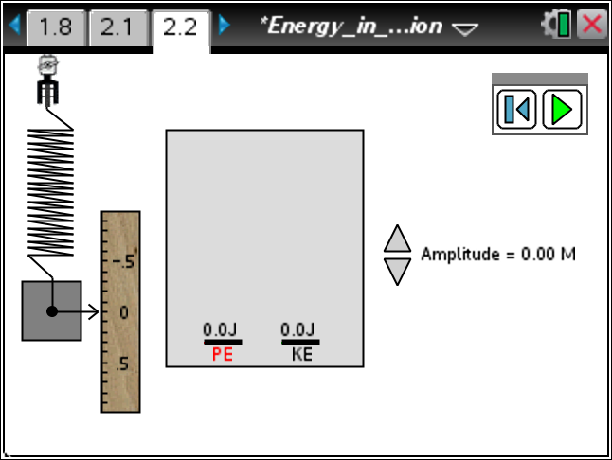
Move to page 2.2. Answer the following questions here.
Q15. Set the amplitude to 0.10 m, and start the animation. Describe qualitatively the energy changes you observe as the mass oscillates.
Q16. As the mass oscillates, pause the motion at the lowest point in the motion, at the midpoint of the motion, and at the highest point of the motion. Record the values of the height, speed, spring potential energy, gravitational potential energy, kinetic energy, and the sum of all three energies below.
h = ____m | v = ____ m/s | U_{s} = _____ J | U_{g} = _____ J | K = _____ J |  | U_{s} + U_{g} + K = _____ J
h = ____m | v = ____ m/s | U_{s} = _____ J | U_{g} = _____ J | K = _____ J |  | U_{s} + U_{g} + K = _____ J
h = ____m | v = ____ m/s | U_{s} = _____ J | U_{g} = _____ J | K = _____ J |  | U_{s} + U_{g} + K = _____ J
Q17. In this scenario, the total mechanical energy is the sum of the spring potential energy, the gravitational potential energy, and the kinetic energy. What do you observe about the total mechanical energy of the system as the mass oscillates?

Q18. Describe the energy transformations which occur as the mass rises from its lowest point to the midpoint of its motion.
Q19. Describe the energy transformations which occur as the mass rises from the midpoint of its motion to the highest point of its motion.

Q20. Increase the amplitude of the motion to 0.20 m, and repeat the measurements made in Question 16. Record the values below.
h = ____m | v = ____ m/s | U_{s} = _____ J |  | U_{g} = _____ J |  |  | K = _____ J |  | U_{s} + U_{g} + K = _____ J
h = ____m | v = ____ m/s | U_{s} = _____ J |  | U_{g} = _____ J |  |  | K = _____ J |  | U_{s} + U_{g} + K = _____ J
h = ____m | v = ____ m/s | U_{s} = _____ J |  | U_{g} = _____ J |  |  | K = _____ J |  | U_{s} + U_{g} + K = _____ J
Q21. Summarize the effects of increasing the amplitude on the motion of the mass and the energy of the system.
Move to pages 2.3 – 2.7. Answer the following questions below and/or in the .tns file.
Q22. The kinetic energy of the mass as it oscillates vertically is _________.
A. maximum at the lowest point.  B. maximum at the midpoint. |  |  |  |  |  | C. maximum at the highest point.  D. constant throughout the motion.
Q23. At what point in the motion is all of the energy in the form of kinetic energy?
A. at the highest point  B. at the midpoint |  |  |  |  |  | C. at the lowest point  D. at no point in the motion
Q24. Increasing the amplitude of the motion produces which of the following changes?
(More than one response may be correct.)
A. The total mechanical energy increases.  B. The maximum speed of the mass increases. |  |  |  |  |  | C. The distance traveled by the mass increases.  D. The maximum spring potential energy decreases.
Q25. The maximum height above the lowest point reached by the mass is _________.
A. equal to the amplitude of the motion. |  |  | B. equal to twice the amplitude of the motion. |  |  |  |  | C. equal to the total length of the spring.
Q26. When the mass stops and turns around _________.
A. both the gravitational potential and the spring potential energies are maximum.  B. the total mechanical energy is zero. |  |  |  |  | C. both the gravitational potential and the spring potential energies are minimum.  D. the sum of the gravitational potential and the spring potential energies is equal to the total mechanical energy.

