Open the TI-Nspire document Two Variable Linear Equations.tns.  An ordered pair (x, y) can be thought of as a pair of numbers that can be substituted into an equation involving x and y. Those same two numbers can be thought of as the coordinates (x, y) of a point in the plane. This activity relates those two ideas to each other to give you a visual way of thinking about a point as the solution to a linear equation in two variables. | 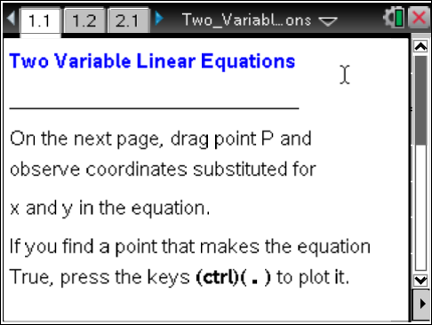

Move to page 1.2. | Press / ¢ and / ¡ to navigate through the lesson.
1. a. Move point P, and describe how the coordinates relate to the equation shown in the screen.

b. Move point P until you find a point that makes the equation true. Press / ^ to mark this point. What are its coordinates?

2. a. If x = 0, what value of y is needed to make the equation true?

b. Move point P so that the first coordinate is 0, and the equation is true. Press / ^ to mark this point. If y = 0, what value of x is needed to make the equation true?

Move point P so that the second coordinate is 0, and the equation is true. Press / ^ to mark this point.
3. Move point P to a new location where the equation is true. Press / ^ to mark this point. Mark at least one more point that makes the equation true.
a. How are the points you marked related to each other?

b. Make a guess about what will happen if you draw a graph of the equation.

c. Press "show? yes" arrow at the bottom of the screen to see the graph of the equation? Does the graph support your guess? Why or why not?

A solution to an equation in two variables is an ordered pair (x, y) that makes the statement true. Each point you have marked is one solution to the equation.
4. a. How many solutions does this equation have? How do you know?

b. Suppose the coordinates of two different points both make the same equation true. Can the coordinates of those same two points make a different equation true? Why or why not?

