Activity Overview  In this activity, you will create a pair of parallel lines cut by a transversal. You will also measure angles.  Materials  • Technology needed (TI-Nspire™ handheld, computer software) | 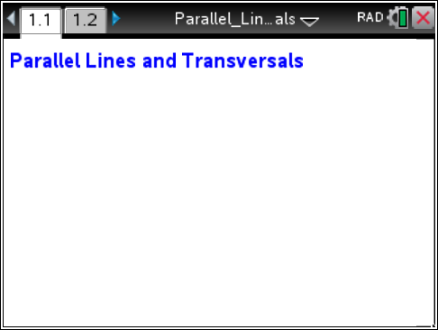

Step 1 Preparing the Document
- Open a new document by pressing c > New Document > Add Notes.
- Type Parallel Lines and Transversals
Note: To format the text, first select the text by holding down the shift key (g) and pressing the right or left arrow key on the Touchpad. Then, press Menu > Format > Format text, and select B for bold. Press d to exit Format text. To select a color for the text, press Menu > Format > Text color. Click the desired color, and then press x to deselect the text.
- Press ~ > File > Save. Type Parallel_Lines_and_Transversals. Tab to ¾, and press ·.
Note: To obtain the underscore, press / _.
4. To add a Geometry page, press / ~ > Add Geometry.
5. To hide the scale in the right corner of the screen, select Menu > View > Hide Scale. Alternatively, right-click (/ b) on the scale and choose Hide Scale.
6. Press c > Settings > Document Settings. Select Fix 0 for display digits and press ·. Return to the current document.

Step 2 Drawing a Line  1. Select Menu > Points & Lines > Line.  2. Move the cursor to a location toward the bottom of the page and press x. This will place a point on the page. Immediately press g J to label the point.  3. Move the cursor to the right and press x to create the line.  4. Press d to exit the Line tool. | 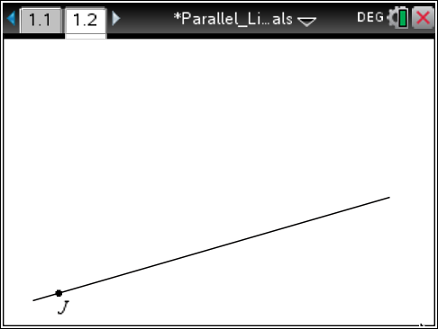
Step 3 Drawing a Line Parallel to a Given Line  1. Select Menu > Construction > Parallel.  2. Move the cursor to the line through point J and x to select the line. A ghosted line parallel to the line through point J will appear.  3. Move the cursor away and up from the line through point J. Press x to identify a point and drop the line. Then immediately press g F to label the point. Press d.  4. Move the cursor so that you can grab the right end of the line and pull it to the length that you desire. Press d. | 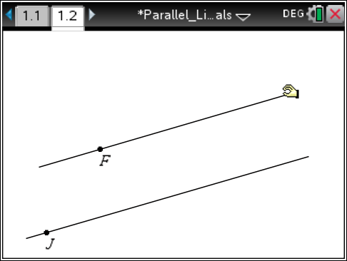
Step 4 Drawing a Transversal  1. Select Menu > Points & Lines > Line.  2. Place a point above the top line by pressing x. Immediately press g D to label the point.  3. Drag the cursor until a new point appears on the bottom line. (It will say point on.) Press x. Immediately press g B to label the point.  4. Press d to exit the Line tool. | 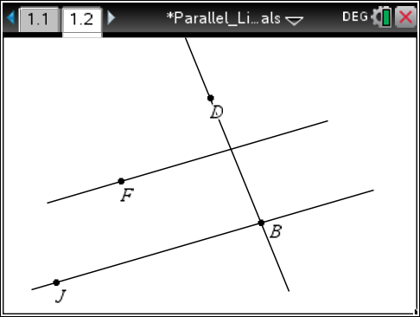
Step 5 Measuring Angles  1. Select Menu > Measurement > Angle.  2. Click on point D. Move the cursor toward the intersection with the line containing point F until the text reads intersection point. Press x and then immediately press g A. Move the pencil to point F and press x.  3. Measure ∠JBA by first clicking on point J, then point B, and finally on point A.  4. Press d to exit the Angle tool. | 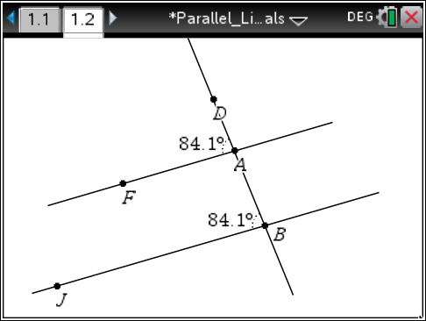
Step 6 Changing the screen  1. Move the cursor to the angle measure until the word text appears.  2. Press / x. Use the arrows to drag the measure to the interior of the angle.  3. Press x to place the angle measure.  4. If using the TI-Nspire™ CX, the color of the lines can be changed. To change the color to the parallel lines, right-click  (/ b) on each parallel line. Select Color > Line Color. Choose a color. Then press d. | 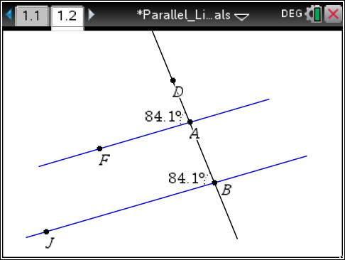
Step 7 Saving the Document  1. Press / S. | 