Open or create the TI-Nspire document Area_Measures_and_Right_Triangles.tns. It is highly encouraged that you create the document.

In this activity, you will make a conjecture about the relationships among the areas of three equilateral triangles and make a connection to the Pythagorean Theorem.

Move to page 1.2.  Part 1: Making a conjecture | Press / ¢ and / ¡ to navigate through the lesson.
- Which of the points A, B, C, M, N, and P cannot be moved? Explain why.

- Grab and drag point C. Observe the four triangles and the
three area measures. What changes and what stays the same?

- Grab and drag points A and B. Observe the four triangles and the three area measures. Compare your observations to those you made when dragging point C.

- Make a conjecture about the relationship between the three area measures.
Part 2: Testing the conjecture  To test your conjecture, you will store some area measurements in a spreadsheet.  To insert a list and spreadsheet page: Press / ~ > Lists & Spreadsheet.  Name the columns: Highlight the cell above the formula row in Column A and type amc. Press ·. Move to Column B above the formula row and type bnc. Press ·. Move to Column C above the formula row and type apb. Press ·. | 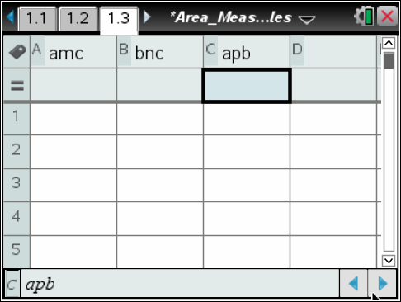
Set up the manual data capture: Move to Column A in the formula row. Press Menu > Data > Data Capture > Manual. Press h and select aamc by pressing x. Press ·.  Move to Column B in the formula row. Set the data capture as described above and select abnc. Move to Column C in the formula row. Set the data capture as described above and select aapb.  Press /◄ to return to page 1.2. Press /^ to collect data.  Drag points A, B, or C. Press /^ to collect data again. Drag a point and continue to collect at least four different data points. | 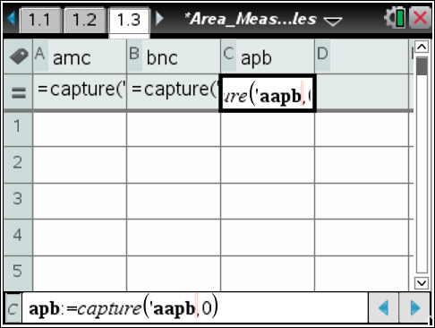
Press /► to return to page 1.3.
- What relationship do you observe among the data lists?

Move to Column D in the row above the formula row. Type S and press ·. Remain in the formula row of Column D. Press = h and select amc. Press + h and select bnc. Press · to perform the calculation that adds columns A and B. Compare the values in Column D with the areas in Column C.  - How does this data verify or disprove your conjecture? | 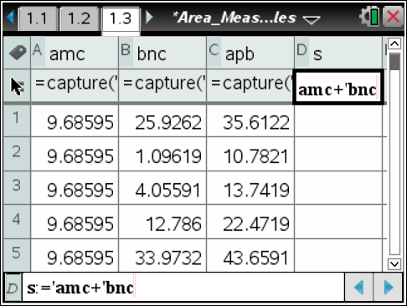  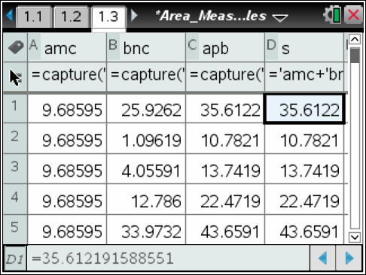
- Use what you know about the relationship of the measures of the legs of a 30°-60°-90° triangle to express the height of equilateral triangles with sides lengths a, b, and c.

- If the equilateral triangles have side lengths a, b, and c, what are the areas of the three triangles?

- Use the answers to question 8 to write an equation for the conjecture.

- Divide the left and right sides of this equation by the GCF of all the terms. Do you recognize this equation? Where have you seen this equation before?

- What other figures could be drawn on the sides of right triangles for which the following statement would be true?
The sum of the areas of the two figures on the legs equals the area of the figure on the hypotenuse.

