 | Math Objectives  - Students will be able to recognize that the first set of finite differences for a linear function will be constant.  - Students will be able to recognize that the second set of finite differences for a quadratic function will be constant.  - Students will be able to determine the relationship between the constant set of first differences and the slope of a linear function.  - Students will be able to recognize that it is not possible to make inferences about the type of function from a set of data without further information.  Vocabulary  - finite differences • constant • degree  - rate of change (slope) • linear, quadratic and cubic functions  About the Lesson  - This lesson involves an investigation into the sets of finite differences for linear and quadratic functions. As a result, students will:  - Calculate the first differences in a set of ordered pairs of a linear function.  - Relate the set of first differences in a linear function to the slope (rate of change).  - Calculate the first and second differences in a set of ordered pairs of a quadratic function.  - Relate the sign of the second differences to the concavity of the quadratic function.  - Investigate a function where none of the differences in a set of ordered pairs are constant.  Teacher Preparation and Notes.  - This activity is done with the use of the TI-84 family as an aid to the problems.  Activity Materials  - Compatible TI Technologies: TI-84 Plus*, TI-84 Plus Silver Edition*, TI-84 Plus C Silver Edition, TI-84 Plus CE  * with the latest operating system (2.55MP) featuring MathPrintTM _{functionality.} |  | 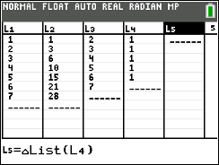  Tech Tips:  - This activity includes screen captures taken from the TI-84 Plus CE. It is also appropriate for use with the rest of the TI-84 Plus family. Slight variations to these directions may be required if using other calculator models.  - Watch for additional Tech Tips throughout the activity for the specific technology you are using.  - Access free tutorials at http://education.ti.com/calculators/pd/US/Online-Learning/Tutorials  Lesson Files:  Student Activity  Finite_Differences_84CE_Student.pdf  Finite_Differences_84CE_Student.doc
This activity looks at the finite (common) differences of polynomial functions and investigates the relationship between the constant value of finite (common) differences and the slope, or rate of change, of a line (or the leading coefficient of a quadratic function). |  | 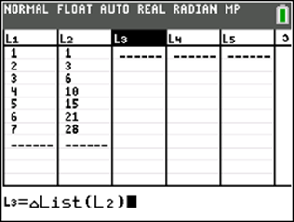

Teacher Tip: When working with data, it is important to know what type of function is represented before making conclusions about the function. Although a function may seem to fit the data, it is not sufficient evidence of a particular function. Unless context suggests a model, or the type of function is given, you cannot make mathematical conclusions from a finite set of data points. If you know the data are from a cubic, the third set of finite differences will be constant, but if you know that as x increases by 1, the third set of differences is constant for a given set of values with no other information. The function is not uniquely defined.
Tech Tip: Note that some of the screenshots shown here are taken from the TI-Nspire CX family of handhelds. This is intentional for clarity of what is trying to be represented in the image.

Below, there is a table of points (xc, yc) for a linear function. An interesting property for some functions is called the Finite Differences Method (common differences). The set of first differences is $y_{2}-y_{1}, y_{3}-y_{2}, y_{4}-y_{3}$ (the value of y minus the previous value of y) over consecutive equal-length input-value intervals (when the x-values increase by the same amount). In column C, enter the values of the first differences.

xc | yc | Differences
-3 | -14 | 3
-2 | -11 | 3
-1 | -8 | 3
0 | -5 | 3
1 | -2 | 3
2 | 1 | 3
3 | 4

1. What do you notice about the set of first differences?
Answer: The set of first differences is a constant.

Teacher Tip: Be certain that students understand how to find the set of differences. Many students will want to subtract $y_{1}- y_{2}$. While subtracting in that order will yield constant differences, the later connections to the slope of the line and the leading coefficient of the quadratic will not be as easy to determine if students subtract in that way. Another possible connection that students may have studied earlier is the notion of sequences. Using the slider on the following pages, you can look at the differences and demonstrate that the second and third differences are zero. This may lead you to talk about the first time the differences are constant.

Graph the ordered pairs from the table above. Find the equation of the linear function passing through these ordered pairs.
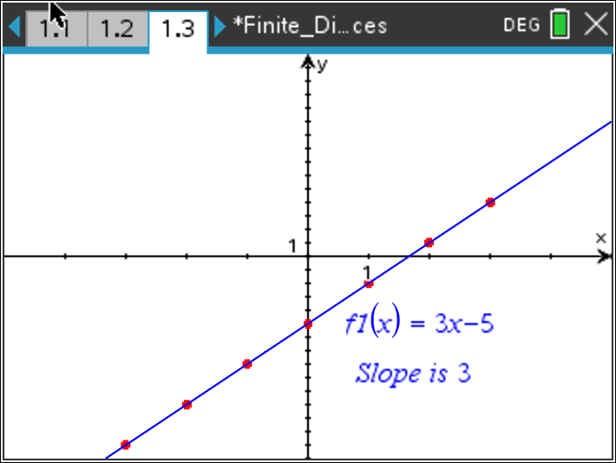

2. a. What do you notice about the set of first differences, the slope (rate of change) and the equation?

Answer: The set of first differences is the slope of the graph (when the increment of the x-value is 1). Because the equation of the line is given in slope-intercept form, the slope is the coefficient of the first degree term in the equation.

b. Use the linear equation f(x) = mx + b to explain the relationship between the set of first differences and the slope (rate of change). (Hint: Consider how the value of the function changes for any x and x + 1.)
Answer: The ordered pairs would be (x, mx + b) and (x + 1, m(x + 1) + b). The difference in the y-values will be m(x + 1) + b – (mx + b). This simplifies to m. The slope (rate of change) of the line will be the change in y-values over the change in corresponding x-values or $\frac{m\left(x+1\right)+b-(mx+b)}{\left(x+1\right)-x}$ which also simplifies to m. For a linear equation, the set of first differences are constant, and the constant is the slope (rate of change).

Teacher Tip: Students might need to investigate specific linear equations
to really understand the connection before they are able to generalize their findings.

3. a. Using the table below, find the differences until they are equal.
First Differences
-14 – (-9) = -5
xc | yc
-3 | -14
-2 | -9
-1 | -4
0 | 1
1 | 6
2 | 11
3 | 16
Answer:
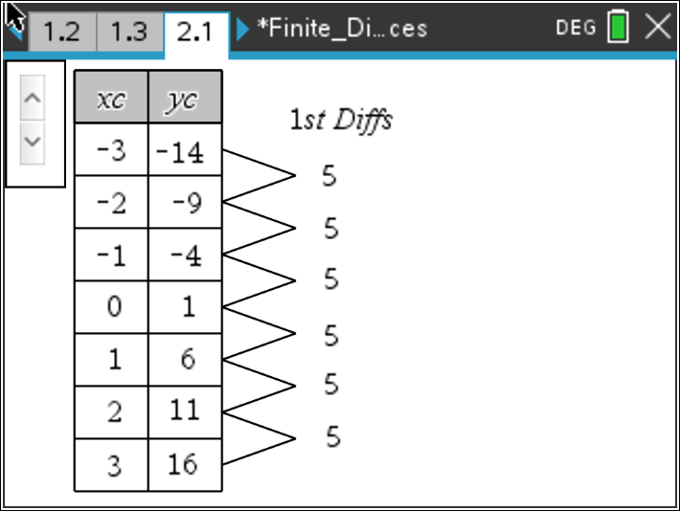

b. Graph the set of ordered pairs above and find the equation of the linear function.

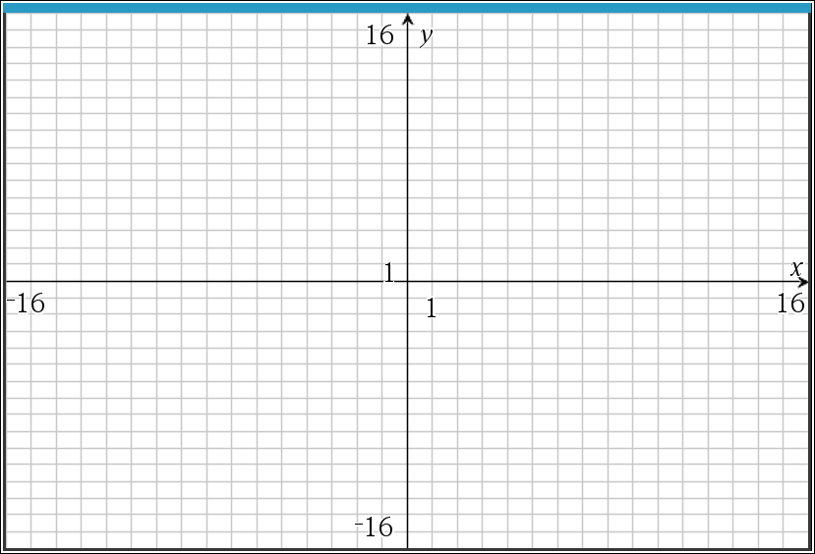
Answer:
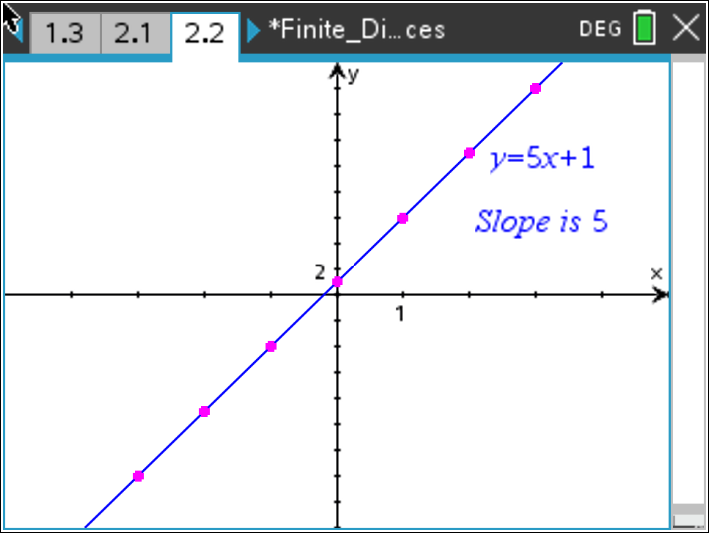

c. Is the slope (rate of change) related to the differences?

Answer: Yes, with an x-value increment of 1, the slope is equal to the set of first differences.

Teacher Tip: In order for the finite differences to determine the degree of the polynomial function, the x-values must be shown in equal increments. When the increment of the x-values is 1, the constant first difference is also the slope (rate of change) of the line.

4. a. Using the table below, find the differences until they are equal.
First Differences
1 – (-1) = ___
xc | yc
-6 | -1
-4 | 1
-2 | 3
0 | 5
2 | 7
4 | 9
6 | 11
Answer:
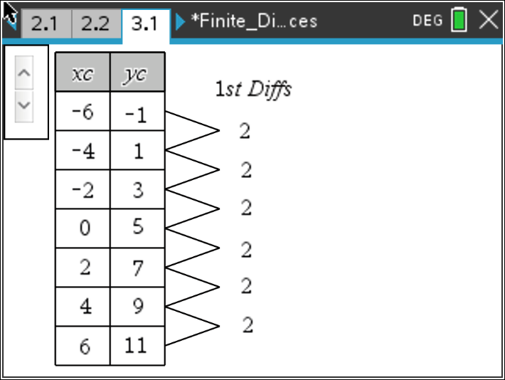
b. Graph the set of ordered pairs above and find the equation of the linear function.

Answer:
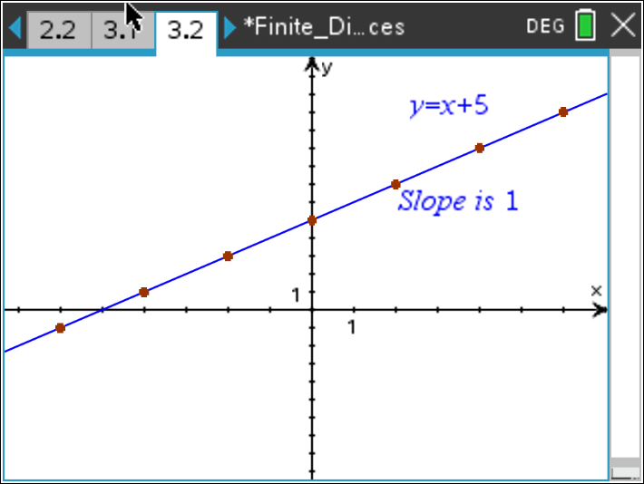

c. What is the relationship between the first set of differences (when the x-value
increases by something other than 1) and the rate of change of the line? Explain.
Answer: Because the x-value increase is not 1, the slope of the line is determined by rise (set of first differences) over the run (x-value differences).

Teacher Tip: By using an increment of something different than 1, this
reinforces the idea of slope $=\frac{∆y}{∆x}$.

5. a. Using the table below, find the differences until they are equal.
First Differences
4 – 7 = ____
xc | yc
-3 | 7
-2 | 4
-1 | 1
0 | -2
1 | -5
2 | -8
3 | -11
Answer:
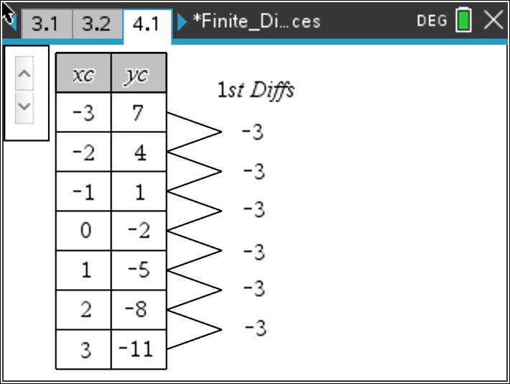

b. Graph the set of ordered pairs above and find the equation of the linear function.
Answer:
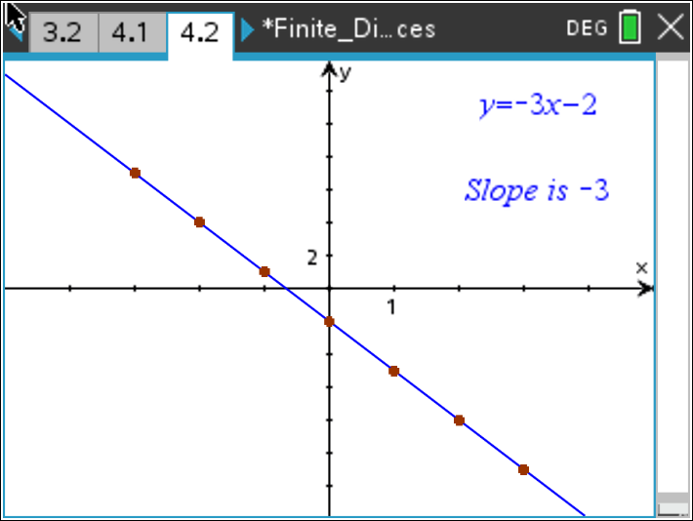

c. When the first set of differences is negative, what impact does that have on the
graph?
Answer: The slope of the line is negative and therefore goes down from left to right.

6. Looking at linear data, Meredith subtracted $y_{1}-y_{2}$ and found the constant set of first differences to be 5. Owen subtracted $y_{2}-y_{1}$ and found the constant set of first differences to be –5. What is the rate of change of the line, assuming that the x-values are increasing by 1? Explain why the order in which the subtraction is performed is important.

Answer: The rate of change of the line is –5. In the formula for the slope (rate of change), the rise and run must both be calculated in the same direction. In these examples $x_{2}- x_{1}=1$. So, in order for the first difference to be equal to the slope, you must evaluate $y_{2}- y_{1}$.

7. a. Using the table below, find the differences until they are equal.
First Differences Second Differences
3 – (12) = ___
xc | yc
-3 | 12
-2 | 3
-1 | -2
0 | -3
1 | 0
2 | 7
3 | 18

Answer:

b. What do you notice about the set of first differences? Second differences?

Answer: The set of first differences is not constant but does increase by a constant amount. The set of second differences is constant.

This is the graph of the quadratic function with the set of ordered pairs from the table above.
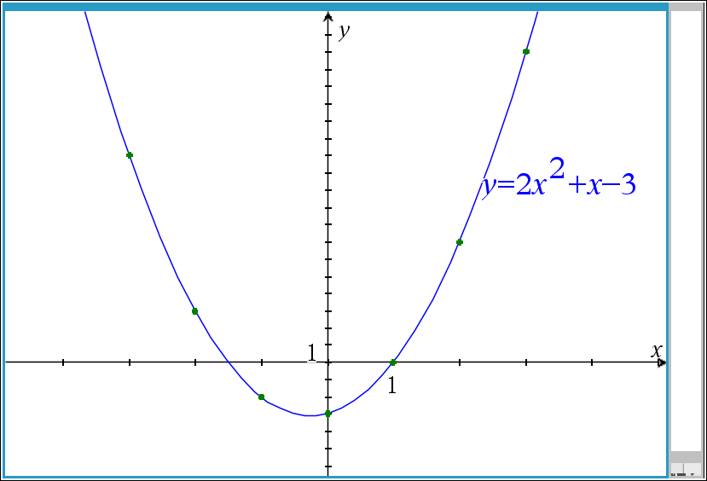

8. a. With an x-value increase of 1, what seems to be the relationship between the second differences and a, the leading coefficient in the equation?

Answer: The value of the constant second differences, 4, is equal to double the leading coefficient in the quadratic equation, 2, when the x -value increases by 1.

b. Tanesia made a conjecture that the rate of change for the quadratic function is a linear
function. Does her conjecture seem reasonable? Why or why not?

Sample answer: Some students might think her conjecture is reasonable because if
the second differences are constant, the function that generated them would be
linear. Some might have trouble thinking about rate of change varying. This is an
opportunity to refer to the graph and explore what would have to be true if the rate of
change were constant.

Teacher Tip: Ask students to describe the rate of change of the quadratic
and to think about how the rate of change is changing.

9. a. Using the table below, find the differences until they are equal.
First Differences Second Differences
-5 – (-12) = ___
xc | yc
-6 | -12
-4 | -5
-2 | 0
0 | 3
2 | 4
4 | 3
6 | 0

Answer:
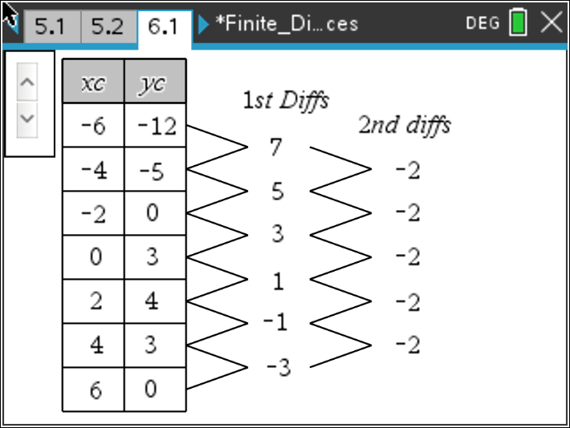

b. What do you notice about the set of first differences? Second differences?

Answer: The set of first differences is not constant but does increase by a constant amount. The set of second differences is constant.

This is the graph of the quadratic function with the set of ordered pairs from the table above.
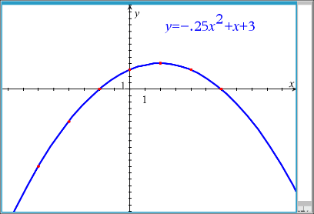

10. With an x-value increase of 2, what is the relationship between the second differences and a, the leading coefficient in the equation?

Answer: The value of the set of constant second differences is equal to double the leading coefficient in the quadratic equation (as before), but also multiplied by the increment squared.

11. a. Using the table below, find the differences until they are equal.
First Differences Second Differences
9 – (25) = ___
xc | yc
-3 | 25
-2 | 9
-1 | -1
0 | -5
1 | -3
2 | 5
3 | 19

Answer:
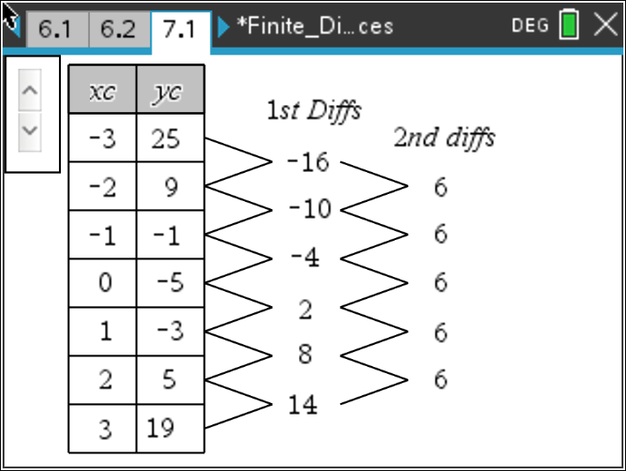

b. What do you notice about the set of first differences? Second differences?

Answer: The set of first differences is not constant but does increase by a constant amount. The set of second differences is constant.

This is the graph of the quadratic function with the set of ordered pairs from the table above.
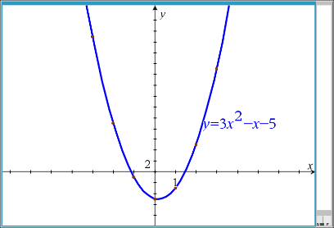
12. Regardless of the x-value increase, what is the relationship between the second differences and a, the leading coefficient in the equation?

Answer: The difference is equal to $2a{\left(∆x\right)}^{2}$. The second difference will have the same sign as the leading coefficient a.

13. Revisit the three quadratics from questions. Remember what you learned earlier about the relationship between the sign of the leading coefficient a and the direction in which the quadratic opens.

a. Make a prediction about the relationship between the constant difference and the sign of the leading coefficient, a.

Sample answer: When the quadratic opens down, the set of constant differences will be negative; when the quadratic opens up, the set of constant differences will be positive.

b. Use the graph of the function and what you know about the rate of change of a quadratic function to explain why your prediction is reasonable.

Answer: For any x, when the curve opens up, the rate of change is always increasing; the second difference can be thought of as the "rate of change" of the rate of change of the quadratic function. When this number is positive, the curve will open up. In earlier work, students learned that when a > 0, the quadratic opens up. Likewise, when the curve opens down, the rate of change is always decreasing, and the "rate of change" of the rate of change is negative, which matches earlier work that suggested when a < 0, the quadratic opens down.

Teacher Tip: Students may need to sketch or estimate (using points and intervals from the graph) how the rate of change behaves for a quadratic. It might also help to have them think about velocity and acceleration, where acceleration is the rate at which the velocity is changing. For example, if you brake hard while driving, the velocity of the car changes rapidly; if you brake gently, the velocity slowly decreases.

14. Using the table below, predict how many subtractions it will take until the differences are
constant.
xc | yc
-3 | -16
-2 | -3
-1 | 0
0 | -1
1 | 0
2 | 9
3 | 32

Answer: Students should test their predictions and find that the 3rd differences are
constant.
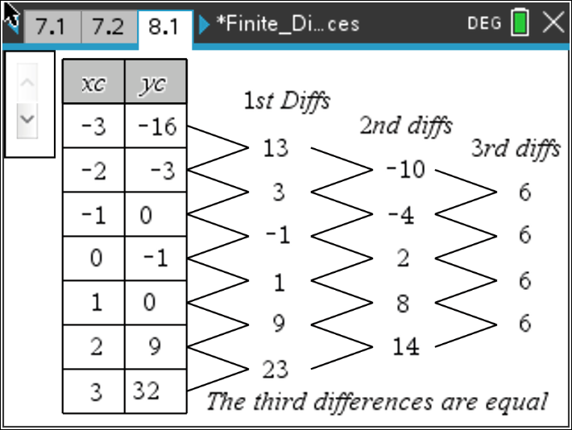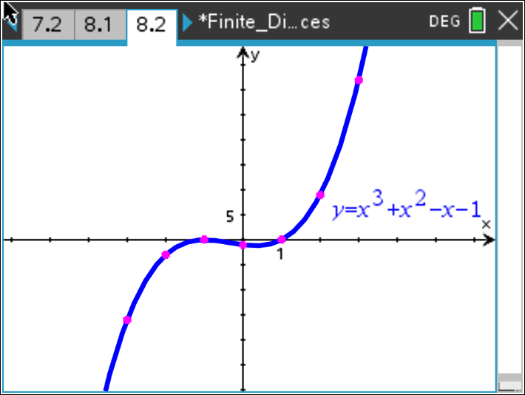

The points in the table above are from a cubic equation.
15. Which set of finite (common) differences would be a constant for a polynomial of n^{th} degree? Explain your reasoning.

Answer: The set of common differences that would be a constant for a polynomial of
n^{th} degree would be the n^{th} common difference.
16. Summarize your results from the investigation.
a. For a linear function, if the first set of differences is a positive constant, the graph ____has a positive slope/rate of change__. $\left(slope= \frac{the constant}{∆x}\right)$

b. For a linear function, if the first set of differences is a negative constant, the graph ____has a negative slope/rate of change__. $\left(slope= \frac{the constant}{∆x}\right)$

c. For a quadratic function, if the second set of differences is a positive constant, the graph __opens upwards__________________. $\left(a= \frac{the constant}{2a{(∆x)}^{2}}\right)$

d. For a quadratic function, if the second set of differences is a negative constant, the graph __opens downwards _______________. $\left(a= \frac{the constant}{2a{(∆x)}^{2}}\right)$

17. Let’s use our technology and tables to find your common differences. Using the table below, open a list and spreadsheet page and enter the following values into the first two columns remember to name each column first.

xvalue | yvalue | diff1 | diff2
1 | 1 | 2 | 1
2 | 3 | 3 | 1
3 | 6 | 4 | 1
4 | 10 | 5 | 1
5 | 15 | 6 | 1
6 | 21 | 7
7 | 28

To find the common differences on the handheld, move your cursor to the column top titled $L_{3}$. Press 2nd stat (list), OPS, 7: $∆List (L_{2})$, enter. Find the differences of these first differences in $L_{4}$ by repeating the process completed in $L_{3}$.
Using your knowledge gained from this activity while comparing common differences, explain the function that this table represents and explain how you came to that conclusion.

Sample Answer: Since the first differences form a linear pattern (all increase by one) and the
second differences are constant (all are one), this represents a quadratic function.

18. a. Using the table below, find the 1st, 2nd, and 3rd common differences. What is different about the
sets of finite (common) differences and the graph of this function, compared to the others you
have looked at in this activity?

xc | yc
-3 | 0.125
-2 | 0.25
-1 | 0.5
0 | 1
1 | 2
2 | 4
3 | 8

Answer:
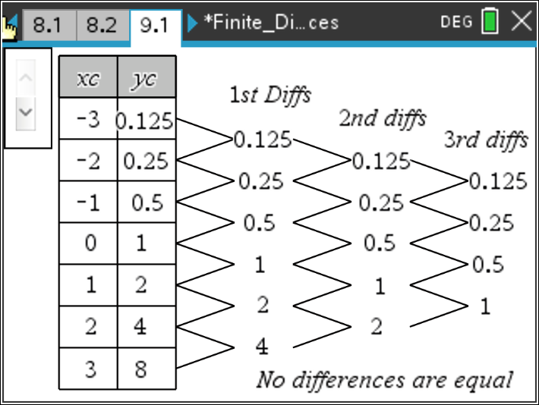

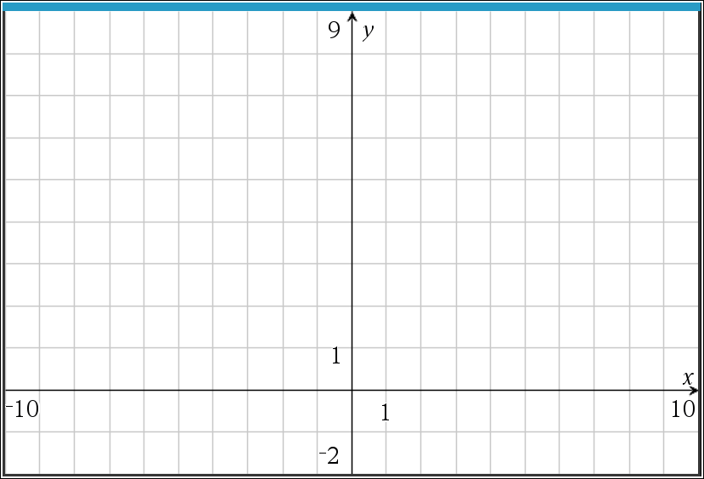
Answer:
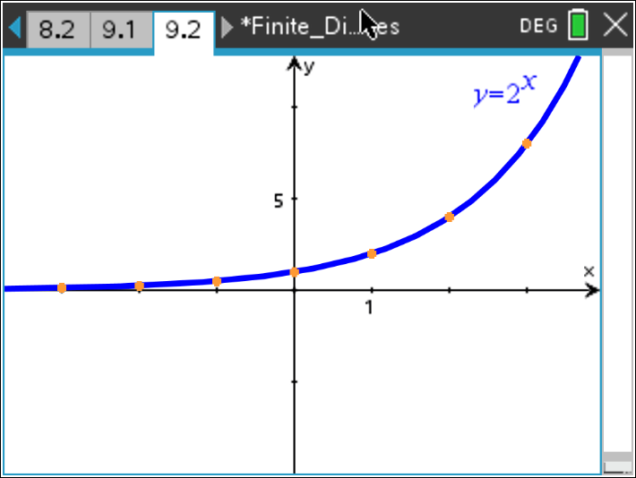

b. Explain why the pattern of differences repeats in the way it does.

Answer: The difference is that sets of finite differences do not become a constant. In fact, it
should be obvious that the same set of finite differences is generated each time.

c. What type of function do you think fits this data? Describe the relationship between this table and
the function you predict it is.

Sample answer: This is not a polynomial function but an exponential function. The sequence is
generated by multiplying by 2 to obtain each succeeding element, so for all $y_{n+1}- y_{n}$ the
differences will be $2^{n+1}- 2^{n}= 2^{n}\left(2-1\right)= 2^{n}$ . This will happen over and over again for every
set of differences. Instead of finding a common difference, find a common multiple by dividing
each successive output (y) by its previous output (y), $\frac{y_{n+1}}{y_{n}}$. In this instance the common multiple
will be 2. We say that since the outputs are proportional and the inputs are over equal length
intervals, this function is exponential.

Teacher Tip: Another discussion is to relate all of the differences to the notion of rate of change The first differences give the rate of change, the second differences are the rate of change of the first differences, etc. Students may continue the study of finite differences in calculus.

Teacher Tip: Using real data for linear or quadratic scenarios, the differences may not ever be constant.

Wrap Up
At the end of the discussion, students should understand:
- That the set of first differences of a linear function is a constant.
- That the set of second differences of a quadratic function is a constant.
- When looking at linear data and when the x -value increases by 1, the value of the constant set of first differences is the slope of the line.
- Not all sets of differences eventually become constant, and some patterns that appear to do so may be misleading.

Assessment
Sample Questions:
- What degree of polynomial has the fifth set of finite differences as a constant?
  - Linear: degree 1
  - Quadratic: degree 2
  - Cubic: degree 3
  - Quartic: degree 4
  - Quintic: degree 5

- Given polynomial data, if the set of first differences is –3, what can you tell about the polynomial?
  - The polynomial is linear with a positive slope.
  - The polynomial is linear with a negative slope.
  - The polynomial is quadratic and opens upwards.
  - The polynomial is quadratic and opens downwards.

