Open the TI-Nspire document 3-Way_Tug_0_War.tns.  It is easy to determine the winner of a normal tug o’ war: the team that pulls the other team across the line wins. There are two opposite forces in the rope and the team who pulls the hardest (actually pushing against the ground hardest) wins. With a 3-way tug, it is not so obvious who the winner will be. You will investigate a 3-way tug and calculate how to win with the least effort.  The study of forces in systems like this is called “Statics” and is an extremely important part of engineering. | 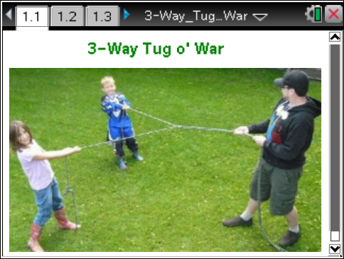

Problem 1: Vector Components  In this simulation you will calculate how to balance forces in a 3-way tug o’ war, but first we will review how to work with force vector components. | Press / ¢ and / ¡ to navigate through the lesson.
You may have experience combining vectors using components in the Cartesian coordinate system (x,y). In this activity you will go beyond this to balance forces in a compass or map system (N,E). Begin with a quick review in this 3-Way Tug o’ War Student Activity handout and practice on the pages of the .tns file.

Move to page 1.4.  - Vectors have magnitude and direction. In the Cartesian system (x,y), direction is measured as an angle counter-clockwise from the positive x axis. In the compass or map system (N,E), direction is measured as an angle clockwise from North. (Set your system to calculate with degrees: press c > Settings > Settings > Graphs and Geometry and set both Graphing Angle and Geometry Angle to Degree.)  - Rotate vector A in the Cartesian and compass systems. | 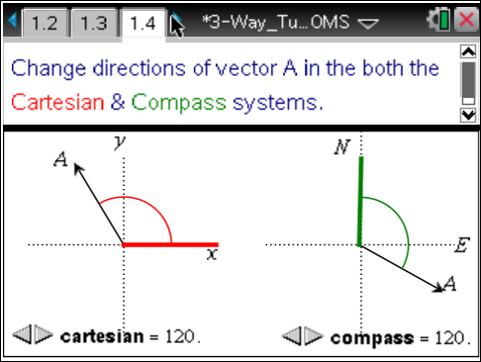
Move to page 1.6.  - The two direction systems are equivalent, just flipped diagonally to each other. Mathematically, they are the inverse of each other. On the next page, use the Reflect tool to flip either the Cartesian or the compass vector and arc across the diagonal. Note how  x-axis becomes North and the y-axis becomes East, or North becomes x and East becomes y. Drag either vector tip to change the direction. | 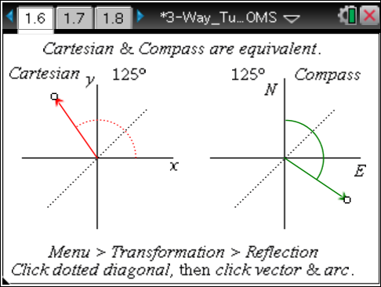

Move to page 1.7.
To find a component of a vector, we can use simple trigonometric functions. For Vector A with magnitude A units and direction Θ, the components can be called Ax, Ay in the Cartesian system or AN, AE in the compass system.
Ax or AN = A cos Θ and Ay or AE = A sin Θ. Once we understand this we really don’t need to worry about much else. The exception is that you will need to remember to use the correct angle in the direction system we are using.
Move to page 1.8.
Study the example question, diagram, and solution on page 1.8 before trying examples on pages 1.9.
Move to page 1.9.
Q1. A plane is flying with a speed of 220 km/h at a compass heading of 140°. What are the velocity vector components (A_{N} and A_{E})?

Move to page 1.10.
Setting our origin at the tail of our vector makes finding coordinates much easier; the (x,y) or (N,E) components become the coordinates of the vector. To add components to find a resultant, we need only add the corresponding coordinates, keeping in mind that some might be negative. This sum gives the coordinates of the resultant vector. Resultant coordinates of A + B + C + … = R can be found by:
R_{N} = A_{N} + B_{N} + C_{N} + …
R_{E} = A_{E} + B_{E} + C_{E} + …
Move to page 1.11.
Study the diagram on page 1.11 adding two vectors A and B. Note the solution obtained by finding the components of vector A and vector B and adding them to find the resultant components Rn and Re. Vectors A and B can both be dragged to change their values. Practice finding these values, then move on to the next example question on page 1.12.
Move to page 1.12.
Q2. Two ropes are pulling on the same tree stump. A represents a force of 500 units pulling in a direction of 30°. B represents a force of 200 units pulling in a direction of 100°. What are the components of the resultant vector along the N and E directions? (Use ScratchPad » for your calculations.)

Problem 2: Force Vectors in Balance: The Equilibrant
Move to page 2.1.
Forces are an important application of vectors. In the study of statics, many forces can be acting simultaneously, but they all balance each other. To maintain that balance, we sometimes need to apply a balancing force called the equilibrant (Eq). The equilibrant is the force that is equal in magnitude but opposite in direction to the resultant of all the other forces: Eq = –R.
Move to page 2.2.  An easy way to determine the equilibrant to a force system is to first find the coordinates for the resultant. In other words, express the equilibrant in terms of vector components along the (x,y) or along the (N,E) axes. Since Eq = –R, you can then find the equilibrant coordinates by just changing their signs.  - Drag vector tips to see how resultant and equilibrant coordinates relate.  Now you need to find the magnitude and direction of the equilibrant. Use the Pythagorean theorem to find the magnitude of the equilibrant and trigonometry (tan⁻¹) to find its direction. | 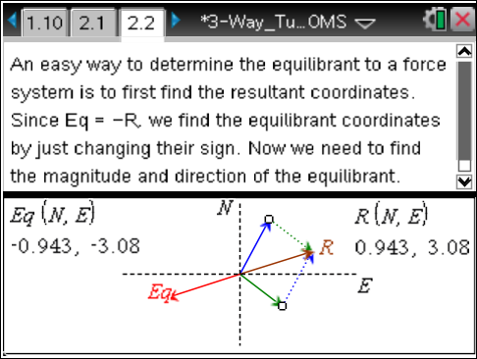
Finding an Equilibrant Force summary:
- Find component coordinates for each force.
- Add all component coordinates to find resultant coordinates in each direction.
- Change the sign of resultant coordinates to get equilibrant coordinates in each direction.
- Use the Pythagorean theorem to find the magnitude of the equilibrant (and resultant).
- Use the E and N equilibrant coordinates to find the angle of the equilibrant: Θ = tan^{–1} (E/N).
- Reference the angle in a diagram to find correct quadrant and adjust for direction.
A table as shown below may be helpful:

A_{north} = | A cos(Θ_{A})=
A_{east} = | A sin(Θ_{A})=
B_{north} = | B cos(Θ_{B})=
B_{east} = | B sin(Θ_{B})=
Eq_{north} = | A_{north} + B_{north} =
Eq_{east} = | B_{north} + B_{east} =
Eq mag = | Sq rt (Eq_{north}² + Eq_{east}²) = | *
Eq dir = | Tan⁻¹(Eq_{east} / Eq_{north}) + 360° = | *
*Eq mag and Eq dir together specify the equilibrant.

Problem 3: 3-Way Tug o’ War
Now that you can find an equilibrant, you can take part in the 3-Way Tug o’ War.
You will play against A and B on a field with North, East, and South axes marked. A will only pull in the NE quadrant. B will only pull in the SE quadrant. You can pull in any westerly direction. Your task will be to hold A and B in place by providing the equilibrant force to the system. You may use ScratchPad », paper, or another calculator for your work. The table above may be helpful to organize your work.
Move to page 3.2.  - When you have your materials ready, move to page 3.2. Click the START button to see the forces applied by A and B. Do your calculations, then provide your equilibrant force using the sliders to set your magnitude (mag) and direction (dir). When you are ready, set the CHECK slider to 1 to check your work.  Click START to try again. | 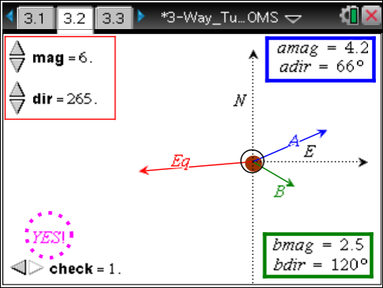
Extension

Move to page 3.3.
Now imagine solving a 4-, 5-, or 6-way tug o' war!
If you look at bridges or towers you will find struts, beams, and cables all in balance. Some members may be under tension (pulling); others may be under compression (pushing). An engineer calculated the range of forces in each of these so that the components would have the appropriate strength to be safe.
Investigate a simple structure by sketching it, researching some data, and making some reasonable assumptions. Then calculate the forces needed to balance at a joint. Don’t forget that weight of materials is a force.
For a complete analysis, it is likely that torques would also need to be considered. That is beyond the scope of this activity.

