Open the TI-Nspire document Tangents_to_a_Circle.tns.  A line that intersects a circle in two points is called a secant. What is a tangent line, and how does it differ from a secant line? This activity will explore properties of tangents. | 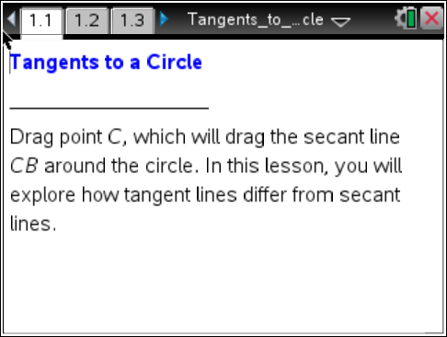

Move to page 1.2.

is a secant of circle A. ∠CBA has been measured. Dragging point C also drags the around the circle. As you drag C, points P and B will move away from each other or closer to each other.

- a. As you drag point C, what happens to ∠CBA?

b. When points P and B are very close to each other, what is the measure of ∠CBA? What happened to point P?

c. When ∠CBA measures 0°, where is point P on the circle in relation to B?

d. When ∠CBA measures 90°, what has happened to the secant line?

Move to page 1.3.

A tangent line has been constructed at point T. Drag point B to move the tangent line around the circle.

- A tangent line intersects the circle in exactly one point, which is known as the point of tangency. How is a tangent related to the radius at the point of tangency?

Move to page 2.1.

This page shows two tangent lines intersecting at point B.

- Drag point B and observe the tangent segments and .
- What can you conjecture about the tangent segments and ?

- What happens to the tangent segments when B is inside the circle? Why?

- Select to show the radii and . Look at the triangles formed from the segments. What do you notice about ΔAOB and ΔCOB?

Move to page 3.1.

- Prove that .
- Select ∆ to draw and . Press ∆ to show the next step. Why is ?

- Select to show the next step. Why is ? Why is ?

- Select to show the next steps. Why is ΔAOB ≅ ΔCOB?

- Why can you conclude ?

