Open the TI-Nspire™ document Creating_a_Parallelogram.tns, which has the parallelogram already constructed, or follow your teacher’s instructions to construct the parallelogram.
In this activity, you will drag vertices and use measurement tools to generalize a variety of patterns involving side lengths and angle measurements so that you can draw conclusions about the properties of a parallelogram. | 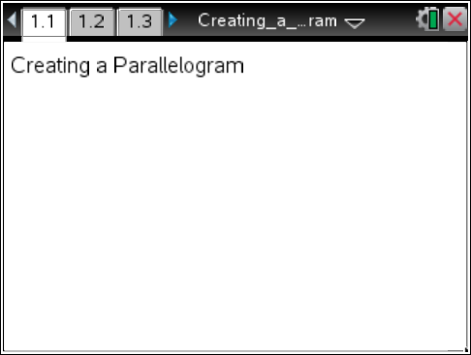

Move to page 1.2 to begin the lesson. | Press / ¢ and / ¡ to navigate through the lesson.

Note: Pages 1.3 and 1.4 are identical to page 1.2.  Use these pages as needed.  - Manipulate the parallelogram by dragging the vertices.  (Note: If you did not construct the parallelogram, discuss a and b with your teacher.)  a. Why is parallelogram ABCD considered “constructed” and not just drawn? Explain.  b. Can every vertex of the constructed parallelogram be dragged? Explain why or why not. | 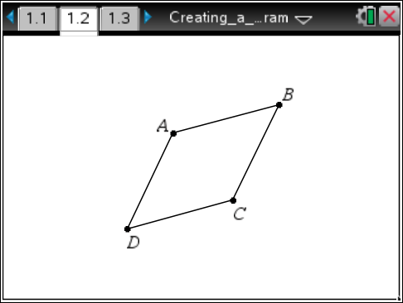
Press Menu > Measurement > Length to measure the sides. Use the Touchpad to move the cursor to one of the sides and e to select a side (not the perimeter) press x to select the side. A “ghost” measurement will appear. Use the Touchpad to move the measurement to a desired location and press x or · again. Repeat for all sides.

2. Press d. Drag a vertex of the parallelogram and describe the side-length relationships in the parallelogram.

Move to page 1.3.

Press Menu > Measurement > Angle to measure each of the interior angles. Angle measurements require selecting 3 points with the vertex of the angle selected second. Move the pencil cursor to the first point of the angle, and press x or · to select the first point. Move the cursor to the second point (vertex of the angle) and press x or·. Repeat for the third point. An angle arc and measurement will appear. Repeat for all interior angles.

- Press d. Drag a vertex of the parallelogram and describe at least 2 angle relationships.

Move to page 1.4.

Press Menu > Points & Lines > Segment. Draw the diagonals of the parallelogram by moving the cursor to a vertex and pressing x or · and moving to the opposite vertex and pressing x or ·. Repeat to draw the other diagonal.

- Use measurement and construction tools to explore the diagonals. Measure the lengths of the diagonals. Find the point of intersection of the two diagonals and use that to find the lengths of the parts of the diagonals that are created when the diagonals intersect. When a vertex is moved, what can you conjecture about the diagonals of a parallelogram?

- Rectangles, rhombi, and squares are special parallelograms. All properties of parallelograms hold true for these figures as well, but are there more? Drag the vertices and measure other segments and angles as needed.
a. Return to page 1.3 and drag the vertices until you get a rectangle. Are there any other special properties for a rectangle?

b. Return to page 1.2 and drag the vertices until you get a rhombus. What other special properties hold for a rhombus?
c. Return to pages 1.2 or 1.3 and drag the vertices until you get a square. What other special properties hold for a square?

Return to page 1.4 to explore areas.

6. Press Menu > Shapes > Triangle. To create triangle ACD:
a. Move the cursor to point A and press x or ·.

b. Move the cursor to point C and press x or ·.

c. Finally move the cursor to point D and press x or ·.

d. Repeat to create ΔACB, ΔADB, and ΔDCB. Press d to exit the tool.

7. Press Menu > Measurement > Area.

a. Move the cursor to ΔACD and press x or · to select it. Move the cursor to a nearby location and press x or · again to place the area measurement in the desired location. Repeat the process for the other 3 triangles.

b. Drag any of the vertices.

8. What is true about the areas of the triangles formed by the diagonals?

9. a. Repeat step 6 to overlay triangles over each of the small triangles formed. When moving to the point where the diagonals intersect, it will say only intersection point.

b. Repeat step 7 to measure the areas of all of the small triangles.

10. Drag any of the vertices. What is true about the areas of the smaller triangles formed by both diagonals? What is special about the triangles?

