Open the TI-Nspire document Translation_Mutation.tns  Have you ever received a text message that didn't make sense? For example, you just sent a joke to a friend and the response was BOL - Be on Later - instead of LOL - laughing out loud! Or, have you ever encountered the mix up between CTC - Care to chat? and CTN - Can't talk now? How about BBL - Be back later and BBS - Be back soon? Can a single letter substitution really make that much difference? |  | 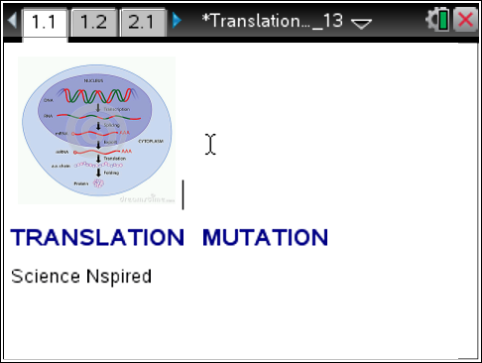
Move to pages 1.2 – 1.5 and read the background information for this activity.
Well, in the world of making proteins, the answer is YES. Proteins have many important jobs in your body, so it's important that they are made correctly. Proteins determine the color of your skin and hair. They also speed up the reactions in your body, like how quickly you digest the pizza you ate at lunch. Also, your body makes special proteins called antibodies that fight off disease and keep you healthy.
Proteins are really large molecules made up of long chains of amino acids. Each amino acid has its own 3 letter code, just like the text abbreviations you use every day. The coded information on the amino acid is a small part of the genotype of an organism. The way this information shows physically in the body is known as the phenotype of the organism. For example, the coding on a protein can give a person brown hair. The coding is a part of the person’s genotype, while the physical trait of brown hair is part of the phenotype of the person. Sometimes, if one single letter is substituted for another, a translation error occurs. When this happens, the protein is made incorrectly, or it may not be made at all! This error is called a mutation. In this activity you will learn how a gene mutation of just one letter causes an error in the production of the protein hemoglobin.

Move to page 1.6.
Read the directions for the simulation.

Tech Tip: To access the Directions again, select > Directions.
Tech Tip: To access the Directions again, select b or Document Tools () > Genetic Mutation > Directions.

1. Select and drag the DNA helix to the left and right to view the normal gene. The HbA gene codes for normal hemoglobin. | 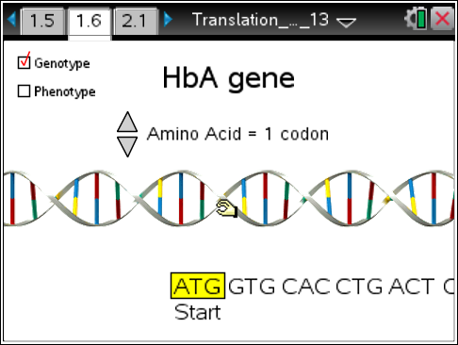
2. Select the up and down arrows (¤ and £) to view the amino acid specified by each codon. | 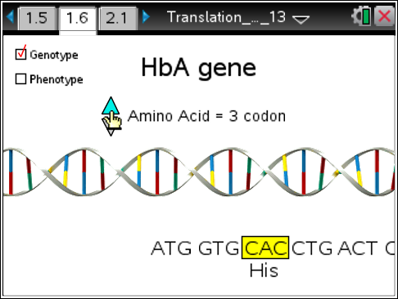
3. Select the Phenotype checkbox to view the red blood cell.

4. Select the Genotype checkbox.

5. Use the up and down arrows to highlight the mutation site. Place the cursor below the site and a pencil pointer will appear. Use the pointer to mutate the gene. As you toggle back and forth, note the specific letter substitution and the switch from HbA to HbS at the top. | 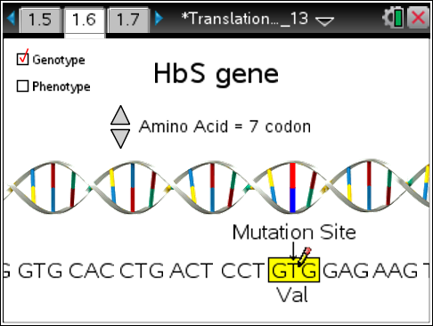
6. Select the Phenotype checkbox. Compare this red blood cell to the normal blood cell in step 3.

Move to pages 1.7 - 1.11.
Answer questions 1 – 5 below and/or in the .tns file. You may need to return to page 1.6 to review the simulation.

Q1. Red blood cells are bags of hemoglobin so the shape of hemoglobin determines their shape. What is the normal shape of RBCs?

A. round
B. sickle

Q2. What letter substitution caused the translation mutation?

- T → A
- A → T
- G → C
- C → G

Q3. What amino acid substitution caused the translation mutation?

- val (valine) for glu (glucine)
- glu (glu) for val (valine)

Q4. Mutated hemoglobin is sticky and clumps together. What is the shape of the red blood cell containing mutated hemoglobin protein?

A. round
B. sickle

Q5. Hemoglobin transports oxygen in the blood. What symptom would a person with sickle-cell anemia experience?

A. hunger
B. thirst
C. fatigue

