Open the TI-Nspire document Light_Me_Up.tns.  Why does the lifeguard order you out of the ocean when there is a lightning storm? Why is it dangerous to use a hairdryer or other electrical appliance while you are in the bathtub? Why are sports drinks advertised to replenish the electrolytes in your body? These questions and others will be answered in this simulation. | 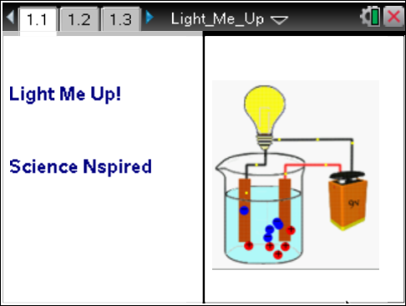

Atoms of an element have equal numbers of protons (positively charged) and electrons (negatively charged) and, therefore, are neutral in charge. Atoms that have lost one or more electrons have a positive charge and are called cations. Atoms that have gained one or more electrons are called anions. Electrolytes are substances whose aqueous solutions conduct electricity. Nonelectrolytes are substances whose aqueous solutions do not conduct electricity.
Soluble ionic compounds such as sodium chloride (NaCl) dissociate completely to produce many ions in aqueous solution and therefore conduct electricity well. NaCl in aqueous solution dissociates into two ions: Na⁺ and Cl–. MgCl₂ dissociates into three ions—one cation and two anions. These compounds are strong electrolytes. If an ionic compound is not soluble in water, then the solution will not conduct electricity.
Covalent compounds are neutral, but certain covalent compounds will ionize when placed in water. These compounds are often acids. An example is hydrochloric acid, HCl. If these covalent compounds ionize completely, or nearly so, they produce many ions in solution and are strong electrolytes. Some covalent compounds like acetic acid ionize slightly, producing few ions in solution. They conduct electricity poorly since there are few ions to carry charge.
Most covalent compounds do not produce ions (ionize) in water. An example is sucrose, C₁₂H₂₂O₁₁. Without ions, solutions formed from these compounds do not readily conduct electricity.

Move to pages 1.2–1.6. Answer the following questions here or in the .tns file.
Q1. An electrically neutral atom has an equal number of _________.
A. protons and neutrons  B. neutrons and electrons | C. protons and electrons  D. protons, electrons, and neutrons
Q2. Positively charged atoms have _________ one or more electrons.
A. lost  B. gained | C. reduced  D. formed
Q3. The charge on a molecule is _________.
A. positive  B. zero | C. negative  D. undefined

Q4. A substance in aqueous solution that conducts electricity is _________.
A. an atom  B. a compound | C. an electrolyte  D. a nonelectrolyte
Q5. A substance that ionizes only slightly in aqueous solution is called a _________.
A. nonelectrolyte  B. strong electrolyte | C. weak electrolyte  D. compound
Move to pages 2.1 and 2.2.
1. On page 2.2 choose a compound from the list to investigate. Molecules will appear without a charge. Ions appear with charges (+ and –).  NOTE: You will need a copy of solubility rules for these compounds to answer the questions.  2. Press the play button () to begin the simulation. |  | 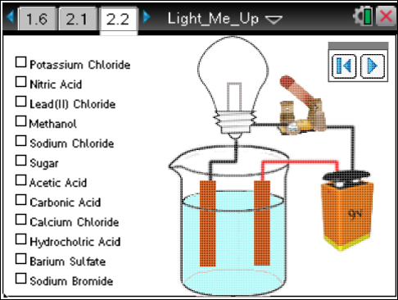
3. Observe carefully whether ions exist, whether the bulb burns, and if there is a flow of electrons. Also note the movement of the particles (ions or molecules) and think about what it means if nothing in the solution is moving.
4. Press the reset button () to reset the simulation.
5. Then choose a new compound.
Move to pages 2.3–2.5. Answer the following questions here or in the .tns file.
Q6. If LiCl were dissolved in water, the solution would _________.
A. not conduct electricity  B. conduct electricity poorly | C. generate electricity  D. conduct electricity well
Q7. An aqueous solution of HBr would _________.
A. not conduct electricity  B. conduct electricity poorly | C. generate electricity  D. conduct electricity well
Q8. Predict what would happen to the light bulb if solid CaCO₃ were placed in the water and stirred. Explain.

Move to pages 3.1–3.11. Answer the following questions here or in the .tns file.
Q9. HCl(aq) is considered to be a _________.
A. nonelectrolyte  B. weak electrolyte | C. strong electrolyte  D. nonconductor
Q10. An aqueous solution of sucrose (table sugar) is considered to be a _________.
A. nonelectrolyte  B. weak electrolyte | C. strong electrolyte  D. conductor
Q11. Sodium bromide would have _________ ions in solution.
A. zero  B. a couple | C. some  D. many
Q12. An aqueous solution of nitric acid would cause the light bulb to _________.
A. remain unlit  B. light up dimly | C. burn brightly  D. burn out
Q13. An aqueous solution of methanol consists of _________.
A. molecules  B. cations | C. anions  D. cations and anions
Q14. An aqueous solution of calcium chloride (CaCl₂) would contain _________ anions as cations.
A. half as many  B. the same number of | C. twice as many  D. none of the above
Q15. Given equal molar solutions of sodium chloride, calcium chloride, and aluminum chloride: which would contain the greatest number of ions? (Hint: Write their chemical formulas.)
A. sodium chloride  B. calcium chloride | C. aluminum chloride  D. all 3 would contain the same number of ions
Q16. Referring to the previous question, which solution would conduct electricity best?
A. sodium chloride  B. calcium chloride | C. aluminum chloride  D. all would conduct equally well
Q17. Why does the lifeguard order you out of the ocean when there is a lightning storm?

Q18. Why is it dangerous to use a hair dryer or other electrical appliance while you are in the bathtub?

Q19. Why are sports drinks advertised to replenish the electrolytes in your body?

Q20. Barium sulfate is an ionic compound. Explain why it does not conduct electricity.

