Open the TI-Nspire document Traveling_Blue_Genes.tns.  In this simulation, you will observe DNA gel electrophoresis in action. Then you will adjust several factors that affect the process of gel electrophoresis and observe the impact they have on the process. | 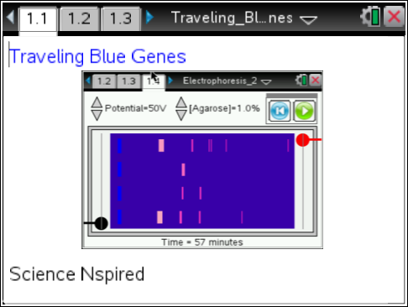
James Watson and Francis Crick figured out the structure of the DNA (deoxyribonucleic acid) molecule in the early 1950’s. Watson and Crick probably had no idea that the term “double helix” would be so often used in classrooms and in conversations everywhere.

The DNA from every organism is composed of the same basic parts and assembled in the same way. Looking like a twisted ladder, the outside supports, or backbone, of the DNA molecule consist of phosphate groups and deoxyribose sugar. The rungs of the DNA ladder are composed of pairs of the nitrogenous bases, adenine (A), thymine (T), guanine (G), and cytosine (C). Because phosphate groups on the backbone are negatively charged, they are attracted to anything that is positively charged.
The process of DNA Gel Electrophoresis relies on this chemical property of phosphate. DNA from the cells of organisms can be “cut up” with special molecules called restriction enzymes. Then these differently-sized DNA fragments can be “pulled” through a gel, which is made of agarose and feels like gelatin, by running an electrical current through it. Small fragments of DNA move through the gel faster and further than larger fragments. When these fragments of DNA are stained with a dye, they appear as bands embedded within the gel. The distances of the bands from an original starting point can be used to calculate the size of the DNA fragments.

Move to pages 1.2-1.5.
On page 1.2 – 1.4, you will find instructions for using the simulation and analysis on 1.5. They are also included below. Read these before you move ahead.
Directions:  1. Use the up and down arrows to set the simulation voltage and agar concentration.  2. Select the Play button to begin the gel electrophoresis simulation. Select the Pause button to stop when fragments are close to the end, or right side, of the gel. | 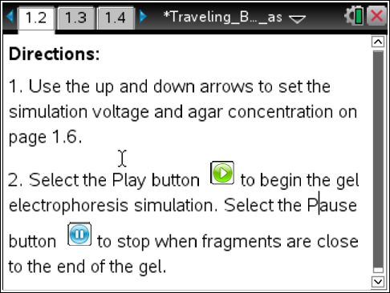

3. Move the cursor over the fragment until the cursor changes into a cross hair . Then select the fragment once to measure the migration distance and fragment weight and add them to the spreadsheet. This data is automatically entered into the List & Spreadsheet on page 1.14.
4. Continue to measure all ladder fragments and the two unknowns.
5. Graphically analyze the data using a best-fit equation on page 1.16.
6. Select the Reset button to run the simulation again on page 1.6.
7. Select Erase Measurements from the simulation menu to clear the data.
Move to page 1.5.  Here you will see a “gel” setup with electrodes (the black and red objects at bottom left and top right) indicating the direction of the electrical current and four “wells” with a different sample of DNA indicated. Much like a Jell-o mold, a gel is poured while hot into a box, and a comb is placed in it. Once the gel sets, the comb is removed, leaving wells to put different DNA samples in. In the gel, there are two samples of known size, Lambda Phage DNA cut with the restriction enzymes, EcoRI and HindIII. These are both common controls for this type of experiment. The other wells contain two unknown samples of DNA. You will be determining the size of the unknown DNA.  Move to page 1.6.  Here you can simulate running a gel and observing how the DNA samples separate. Follow the instructions provided to run the gel and measure the known and unknown band sizes. The blue boxes on the left are the wells and the pink bands are DNA.  - Follow the directions given above to run the gel and watch how the bands progress.  - Using the mouse to move the cursor, select each band to measure the distance traveled. This data is captured in the spreadsheet on page 1.14.  - You may want to repeat the simulation by adjusting the voltage of the current running through the gel and adjusting the density of the gel, or Agarose, before answering the following questions. | 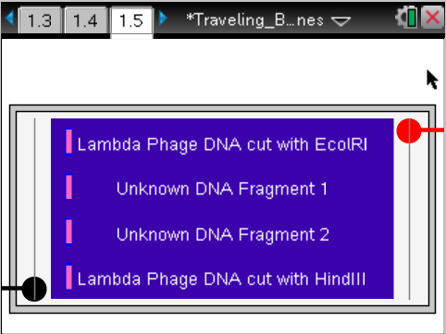  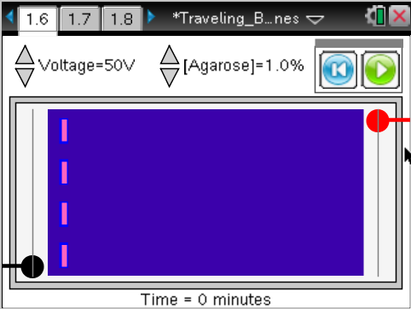  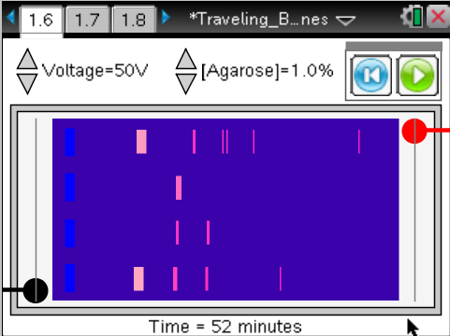
Tech tip: The cursor will change to a cross when you are in the correct spot to take the measurement of the band.
Tech Tip: To take a measurement of a band, tap the band as it moves across the screen.
Move to pages 1.7 - 1.13.
Answer questions 1 - 7 here and in the tns file.

Q1. The DNA moves
- as a result of diffusion.
- due to the charge on the molecule
- because the gel is tilted downward.
- as a result of a temperature difference across the gel.

Q2. True or False: Increasing the voltage across the gel causes the DNA to migrate slower.

Q3. True or False: Increasing the agar concentration in the gel causes the DNA to migrate slower.

Q4. True or False: Reversing the voltage causes the DNA to migrate the opposite direction.

Q5. True or False: The longer the gel runs the further the DNA migrates.

Q6. If the gel runs too long, the DNA...
- collects at the end of the gel.
- runs off the end of the gel.
- stays in the same position.
- evaporates.

Q7. True or False: The purpose of a DNA ladder is to have a standard between migration and fragment size.

Move to page 1.14.  4. Here you will see that the known bands have two numbers, migration distance (which you just measured) and number of base pairs. The size of DNA is measured in “base pairs” (bp). One bp is one “rung” on the DNA ladder: either a T-A pair or a G-C pair. | 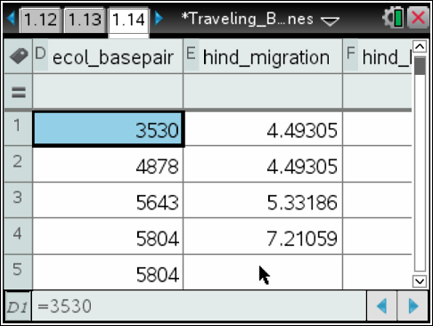
Move to pages 1.15 - 1.16.  - Read the directions on page 1.15. On page 1.16, you will see a Data & Statistics page that will allow you to view a graph showing the relationship between the size of each fragment of DNA and its migration distance.  - Page 1.17 is a similar graph showing the HindIII migration and size. Observe the similarities and differences in these two graphs. Follow the directions on page 1.15 to fit a regression to this data. | 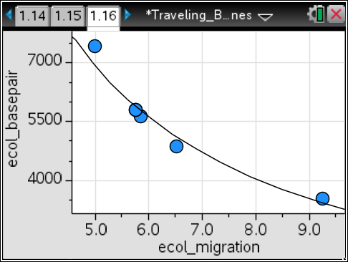
- Sketch your graph to the right and draw in a non-linear, best-fit model that fits the data. Your teacher will ask you to make predictions about migration distances of unknown fragment sizes and predictions about sizes of fragments that migrate certain distances. | Sketch of Graph
Move to pages 1.17 - 1.18.
Answer questions 8 - 9 on this worksheet and in the .tns file. Answer questions 10 - 16 on this worksheet.
Q8. Based on the graphical analysis of the data, the DNA fragment size of unknown 1 is approximately:
- 6,000 bp
- 8,000 bp
- 10,000 bp
- 12,000 bp

Q9. If the two unknowns are the same gene harvested from two different individuals...
- both have the same genotype.
- unknown 1 is homozygous and unknown 2 is heterozygous.
- unknown 2 is homozygous and unknown 1 is heterozygous.
- not enough information to determine.

Q10. What is a restriction enzyme?

Q11. What is the relationship between DNA fragment size and migration distance?

Q12. What is meant by a “base pair”?

Q13. What is the relationship between the amount of time that a gel runs and the migration distance of the DNA fragments?

Q14. Describe the effect of gel density on the movement of DNA fragments through the gel.

Q15. If you want to run a DNA gel electrophoresis experiment with only a short time available, what general parameters would ensure the best results?

Q16. If you want to run a gel from the time you leave class until the start of class the next day, what general parameters would ensure the best results?

