Open the TI-Nspire document Reflections_in_the_Mirror.tns.

How do mirrors work? How do you know where to stand to see your reflection in the mirror? When you look into a mirror how far away does your image seem to be behind the mirror? Why are there times when you look in a mirror and you cannot see your whole body? How would you adjust the situation so you can see more?
The light reflected from an object will hit a mirror in such a way that you will see its reflection as if it were behind the mirror. The mirror forms a line of reflection for the object. The simulation that you will be working with re-creates this situation.  In this activity you will explore how a mirror works using a simulated one. You will explore how distance between a mirror and an object is related to distance between the mirror and the image. You will also determine how to observe the image of objects that are not at eye level. |  |  | 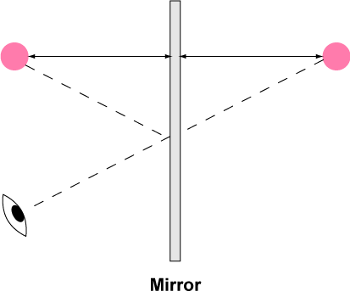
Move to pages 1.2 and 1.3.  1. On page 1.3, use the Reflection tool to reflect point X over the mirror and label the point X'.  - Click on Menu and under Geometry select Transformation, and then select Reflection.  - When the tool is active, click point X, which is the point that will be reflected in the mirror.  - Next, click the line (representing the mirror) that you wish to reflect across.  - When the image point appears, create a text label and input “X'.” |  |  | Press / ¢ and / ¡ to navigate through the lesson.  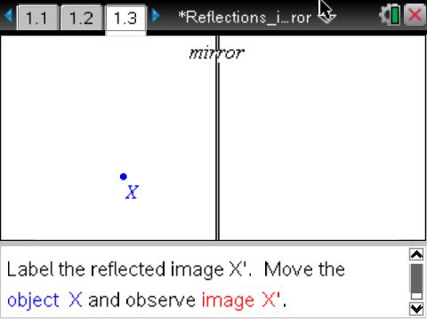
Tech Tip: To reflect an object find the reflect tool (Menu and under Geometry select Transformation and under that select Reflection). Click on point X and then click on the mirror line. The point will appear on the opposite side. When the point appears type X' immediately and the label will be attached.

Move to pages 1.4–1.6. Answer questions 1 and 2 here and/or in the .tns file.
Q1. Move the point X around the screen. Describe how the image, X’, moves as you move the object.

2. On page 1.5, you will use the Length measurement tool to measure the distance between the object and the mirror and between the image and the mirror.
- Make sure the Geometry window is active. If it isn’t, press /e.
- Measure the distance from X to the mirror using the Length tool (Menu > Measurement > Length).
- Click on point X and then click on the line representing the mirror.
- You’ll see the object distance.
- Repeat by measuring the image distance from X' to the mirror.
Q2. How is the object distance related to the image distance? Does this relationship stay the same when you move the object?

Tech Tip: When measuring an angle be sure to click on three points. The first point on one segment, the second point on the vertex and the third on the other side or segment of the angle.

Move to pages 1.7 and 1.8.
3. Follow the directions on page 1.7. On page 1.8, construct a line segment from point X to point X'. Measure the angle created between the mirror and the segment.

Move to pages 1.9 and 1.10 Answer questions 3 and 4 here and/or in the .tns file.
Q3. What angle does the connecting segment make with the mirror? Does this angle change when you move the object?

Q4. Suppose XY is the length of an object. How does the length of the image, X'Y', compare to XY?

Move to pages 2.1–2.3.  4. How does an observer at point X see the image at point Y?  - On page 2.2 draw a line segment from point X to image Y'.  - To measure the angle of reflection, first construct a perpendicular line to the mirror at the point where segment XY' intersects the mirror. This y is called the “normal.”  - Measure the angle between XY' and the normal; this is the angle of reflection. |  |  | 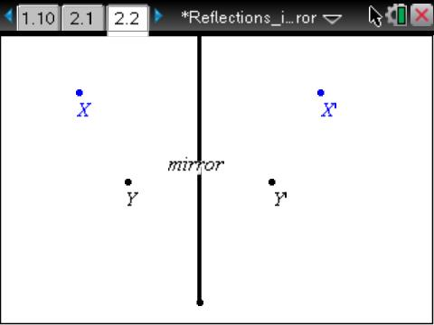
5. Draw a segment from Y to the point where segment XY' intersects the mirror. Measure the angle of incidence between this segment and the normal. Follow the sequence of screens shown below.

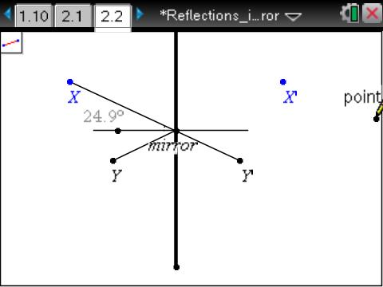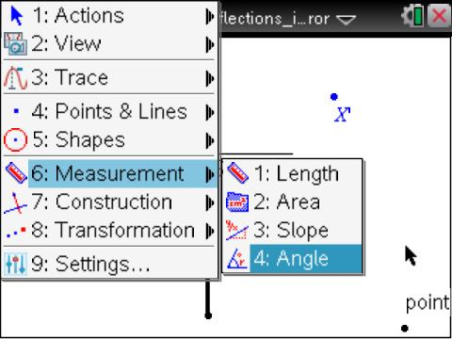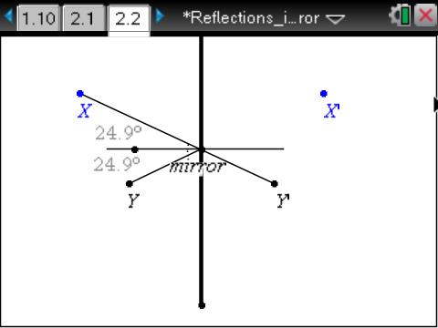
Move to pages 2.4 and 2.5. Answer questions 5 and 6 here and/or in the .tns file.
Q5. What angle does the connecting segment make with the normal to the mirror? Does this angle change when you move the object?

Q6. If X or Y is moved away from the mirror, does it change your answer for the last question?

Move to pages 3.1 and 3.2.
6. Read the scenario on page 3.1. Then move to page 3.2, which simulates the following scenario:

An object is 15 cm in front of a mirror. An observer is standing 40 cm away from the mirror and looking at the image of the object.
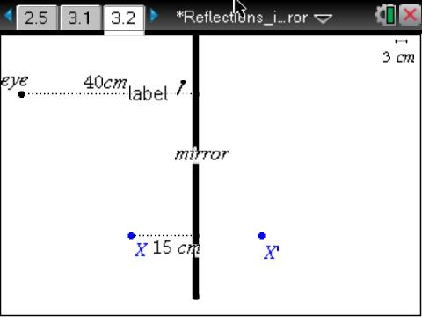 | 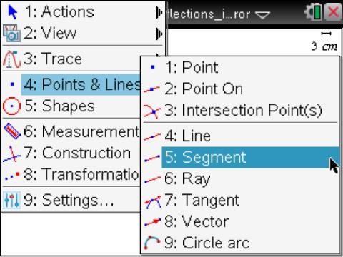 | 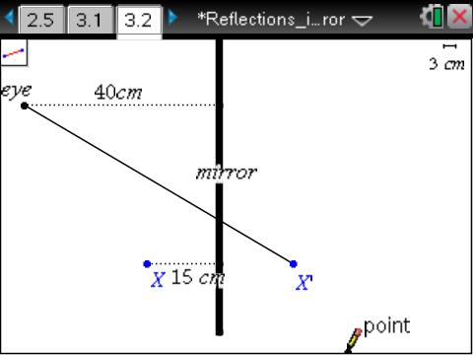
- Start at this screen. | - Select the Segment tool. | - Construct a segment connecting the points shown.

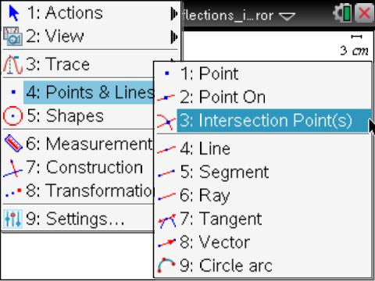 | 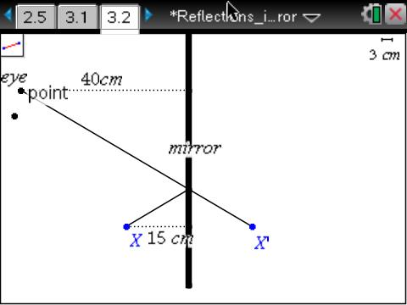 | 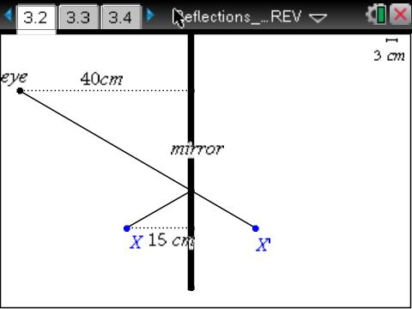
- Find the intersection point between the mirror and the segment. | - Construct the another segment from the intersection to X. | - Measure the distance from the point on the mirror to X’.
Move to pages 3.3 and 3.4. Answer questions 7 and 8 here and/or in the .tns file.
Q7. How far behind the mirror will the image appear to the observer?

Q8. Will this distance change if the observer moves closer to the mirror? Explain your answer.

Move to pages 3.5–3.7. Use the diagram on page 3.5 to answer questions 9 and 10 here and/or in the .tns file.  Q9. Will the person be able to see his or her feet by moving farther from the mirror? Make a prediction. |  |  | 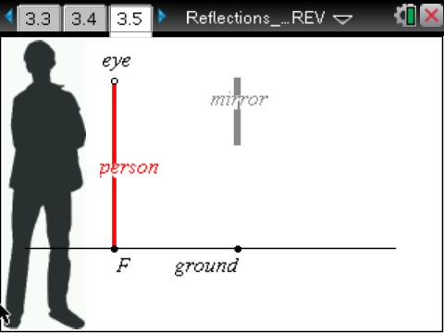
8. Now, use the simulation to test your prediction. Move the dot at eye level to get closer or further away. The man will not move.

Q10. Was your prediction correct? If not, explain any errors in your reasoning.

