Open the TI-Nspire document Gravity_and_Objects.tns  Have you ever heard the expression “What goes up must come down?” You observe this effect all the time. For example, if you throw a ball into the air or knock a pencil off of a table, the objects will fall down towards the earth. You may have heard that gravity causes objects to fall towards the earth, but did you also know that the force gravity exists between every single massive object in the universe? In fact, you exert a gravitational force on everything around you, from your desk to your friends! |  |  | 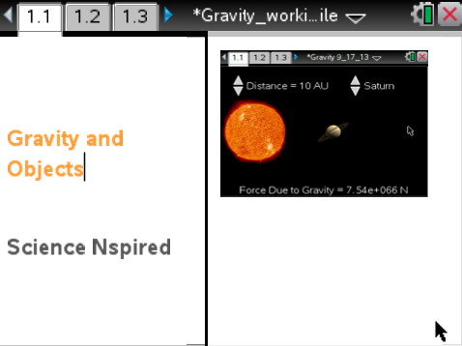
Move to page 1.2 read the background information for this activity.

Sir Isaac Newton developed one of the most fundamental laws in physics: the law of universal gravitation. Newton’s law states that every mass exerts an attractive force on every other mass. This attractive force is known as gravity. Knowing this is vital to understanding why planets orbit stars and do not stray off into space. As Earth revolves around the Sun, it is the force of gravity that keeps it in orbit. In this activity, you will investigate how the mass of objects and the distance between objects affects the force of gravity that the objects experience.

Move to page 1.3. Answer question 1 below and/or on your device.
Q1. Which of the following best explains Newton’s law of gravitation?

A. The mass of two objects depends on the force of gravity between them.
B. Gravity is dependent only on the distance between two different objects.
C. Gravity causes all objects in motion to stay in motion.
D. Every mass exerts an attractive force on every other mass.

Move to page 1.4.
Read the directions for the simulation.
1. First, you will begin by observing how the gravitational force between two objects is related to mass of the objects. Select the up and down arrows (¤ and £) to change which planet you are measuring while keeping distance constant at 10 AU (astronomical units). Doing this will change the mass of the object without changing its distance. Observe how the force of gravity between a planet and the Sun is related to the mass of the planet.  Note: Do not reset the simulation yet. |  | 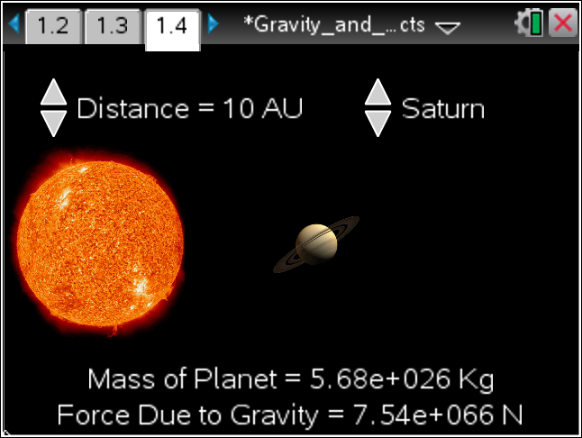
Tech Tip: To access the Directions again, select 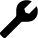> Directions.
Tech Tip: To access the Directions again, select b or Document Tools () > Gravitation > Directions.

Move to pages 1.5 – 1.9.

2. Examine the data in the spreadsheet on page 1.5. Then, move to page 1.6 and plot the data on a graph. Select the x-axis and then select the variable mass from the dropdown menu. Select the y-axis and then select the variable force from the dropdown menu.

3. After examining the data in the spreadsheet on page 1.5 and the graphic representation on page 1.6, record the data onto the table below and answer questions 2 – 4 below and/or in your .tns file.

Planet | Mass (kg) | Distance (AU) | Force (N) | Copy force versus mass graph below from page 1.6.
Mercury |  | 10
Venus |  | 10
Earth |  | 10
Mars |  | 10
Jupiter |  | 10
Saturn |  | 10
Uranus |  | 10
Neptune |  | 10

Q2. What happens to the force of gravity between a planet and the Sun as you select a planet with a greater mass?

A. The force of gravity goes up.
B. The force of gravity goes down.
C. The force of gravity does not change.

Q3. What evidence leads you to your conclusion in the previous question?

Q4. Before you manipulate the distance, predict what will happen to the force of gravity between a planet and the Sun when you change the distance between them.

Tech Tip: To scroll through data in the spreadsheet on screen 1.5, press your finger anywhere on the screen and drag it up or down.
Move to page 2.1 and read the instructions. Then, move to back to page 1.4.

4. We are now going to observe how the force of gravity between two objects is related to the distance between them. Before collecting data, we must reset the simulation on page 1.4. To do this, go to page 1.4. Select Menu > Gravitation > Erase Data. This will remove all of the data you previously collected. Note: Be sure that you have recorded all of your data onto your student worksheet before doing this. | 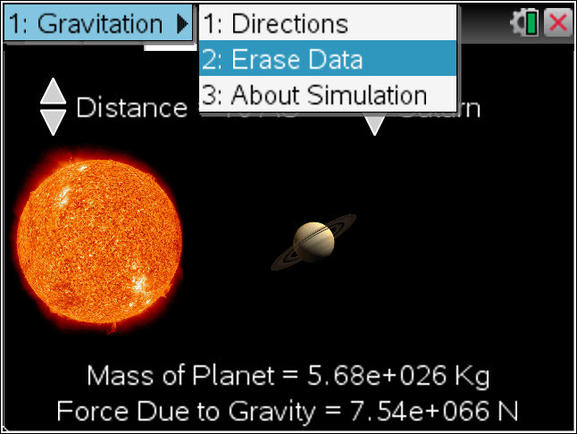
Tech Tip: To erase the data, select > Gravitation> Erase Data.
Tech Tip: Select b or Document Tools () > Gravitation > Erase Data.
5. In the next part of the simulation, you must keep the planet constant and change the distance from 0.5 AU to 30 AU. Pay attention to what happens to the gravitational force between the planet and the Sun as you change the distance between them.

Move to pages 2.2 - 2.8

Q5. As you move your planet closer to the Sun, what happens to the force?

A. The force of gravity increases.
B. The force of gravity decreases.
C. The force of gravity does not change.

Q6. Set your planet to Neptune and your distance to 30 AU. Then, erase the data in your simulation by following the same process as before. Move the distance from 30 AU down to .5 AU. Return to the graph on page 1.6. This time, set the y-axis to force and the x-axis to distance. Does the slope/curve of the current graph match the mass versus force graph you copied earlier? Copy the data from the spreadsheet on page 1.5 and graph from page 1.6 below.

A. Yes B. No

Planet selected | Distance (AU) | Force (N) | Copy distance versus force graph below from page 1.6.
Neptune | 0.5
Neptune | 0.75
Neptune | 1
Neptune | 2
Neptune | 5
Neptune | 10
Neptune | 20
Neptune | 30

Q7. What similarities or differences do you notice between the mass versus force graph and the force versus distance graph?

Q8. The relationship between the force of gravity and distance between two objects is described by the inverse square law. This means that the force of gravity between two objects is inversely related to the square of the distance between them. Return to page 1.6. Set the x-axis to inverse square. Keep the y-axis set to force. How does the graph compare to the mass versus force graph you copied earlier?

Q9. If Earth were a more massive planet, what would happen to the gravitational attraction be between the Sun and the Earth?

A. There would be greater gravitational attraction.
B. There would be less gravitational attraction.
C. There would be the same amount of gravitational attraction.

Q10. Which has a larger effect on the gravitational attraction between two objects?

A. mass
B. distance

Q11. Defend your answer to question 10 with evidence collected during the simulation.

