Open the TI-Nspire document Exponential_Functions_and_the_Natural_Logarithm.tns.  The purpose of this activity is to study the relative growth rate of exponential functions of the form f(x) = b^{x}, to understand their connection to natural logarithms, and to understand more about the natural exponential function. | 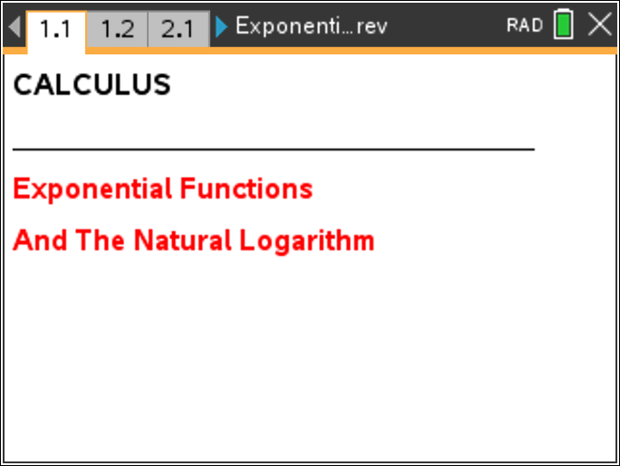

Move to page 1.2. | Press / ¢ and / ¡ to navigate through the lesson.
An exponential function with base b has the form f(x) = b^{x}, where b is any positive real number. If b = 1, f is a constant function with f(x) = 1 and not very interesting. We will be more interested in exponential functions with b ≠ 1.
The relative growth rate of any function f at the value x is simply the ratio of its rate of change or slope, f′(x), to its value f(x), that is, . For example, a linear function, f(x) = mx + b, has a constant rate of change, f′(x) = m (the slope of the line). The relative growth rate of a linear function at x is given by the expression . An exponential function has an amazing and unexpected relative growth rate.

1. For b = 2, use the up/down arrows at the lower left of the screen to move the point x along the axis. At the bottom of the page, observe the slope at x, the value of b^{x}, and the ratio .
a. What happens to the slope at x and the value of b^{x} when you move x to the right of 1?

b. What happens to the ratio when you move x to the right of 1?

c. What happens to the slope at x and the value of b^{x} when you move x to the left of 1?

d. What happens to the ratio when you move x to the left of 1?

2. Use the up/down arrows at the upper left to change the base of the exponential function. Set b = 3.
a. Move the value x along the axis and observe the ratio. Describe what happens to the relative growth rate as x varies.

b. Try other values for b. What happens to the relative growth rate as x varies, for any set value of b?
c. As b increases, what happens to the relative growth rate of the exponential function?

d. Is the relative growth rate ever 0? If so, for what value(s) of b?

e. Is the relative growth rate ever negative? If so, for what value(s) of b?

Move to page 2.1.

3. For any value of b, the constant relative growth rate of the exponential function f(x) = b^{x} is called the natural logarithm of b, abbreviated ln(b). Use the arrow keys to change the value of b and complete the following table of corresponding values for ln(b).
b | 0.1 | 0.2 | 0.4 | 0.5 | 1 | 2 | 2.5 | 3 | 5
ln(b)

a. Explain what happens to the graph of y = f(x) = b^{x} as b increases and is greater than 1.

b. Explain what happens to the graph of y = f(x) = b^{x} as b becomes less than 1.

c. Explain the value of ln(1) geometrically.

d. A student claims that you can also find ln(b), the natural logarithm of b, by just looking at the slope of the graph of y = f(x) = b^{x} at x = 0. Is this correct? Why or why not?

4. Find the following natural logarithms using the up/down arrows for these values of b.
ln(2.6) = ln(2.7) = ln(2.8) =
There is a value b such that ln(b) = 1. The exact value of this special number is labeled e.

5. The value of e lies between two of these values of b: 2.6, 2.7, and 2.8. Which two? Explain your reasoning.

Move to page 2.2.

6. Is e smaller or larger than 2.75? Explain your reasoning.

7. Use this Calculator page to evaluate the natural logarithm in search of the closest three-decimal-place approximation to e you can make.
a. What is your (three-decimal-place) approximation?
e ≈

Every exponential function of the form f(x) = b^{x} has constant relative growth rate = ln(b). The natural exponential function has a constant relative growth rate of exactly 1.

b. What is the base of the natural exponential function f(x) = b^{x}?

c. What is its derivative f′(x)?

