Open the TI-Nspire document Multiplicity_of_Zeros_of_  Functions.tns.  In this activity, you will explore the equations of polynomial functions in both factored and standard form. You will discover the characteristics of the zeros of polynomial functions and the multiplicity of the zeros. | 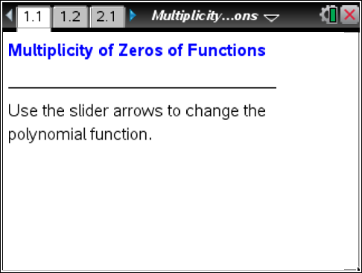

Move to page 1.2.

1. The initial value of the slider is #0.
a. What are the zeros of the function?

b. For what value(s) of x does the graph of the function cross the x-axis?

c. For what value(s) of x is the graph of the function tangent to the x-axis?

d. What degree is the polynomial?

2. Use the slider to change the graph for functions #1–#5. For each function, answer the questions asked in Question 1. Use the table below to record your results.
# | Function | Zeros | Cross | Tangent | Degree
1
2
3
4
5

3. How are the zeros of a polynomial function related to the factors of a polynomial function?

4. How do the exponents in each term in the factored form of the polynomial function affect its graph?

5. When a polynomial has a repeated linear factor, it has a multiple zero. Write the factored form of a polynomial function that crosses the x-axis at x = –2 and x = 5 and is tangent to the x-axis at x = 3. Which of the zeros of the function must have a multiplicity greater than 1? Explain your reasoning.

6. Write two additional polynomial functions that meet the same conditions as described in Question 6. Explain what is different from your function in Question 5, and how you determined your polynomial functions.

Move to page 2.1.

7. Select the slider until it reads #1.
a. Write the factored form of the polynomial function graphed.

b. Describe how you determined the factors of the polynomial function.

8. Select the slider until it reads #2.
a. Write the factored form of the polynomial function graphed.

b. Describe how you determined the degree of each of the factors of the polynomial function.

9. Select the slider until it reads #3.
a. Write the factored form of the polynomial function graphed.

b. Describe how you determined the degree of each of the factors of the polynomial function.

10. For what reasons would you use the factored form of a polynomial function? The standard form?

