Open the TI-Nspire document Visualizing_Equations.  The two sides of an equation can be thought of as the two pans on a balance scale. This activity uses that visual image to allow you to explore solving equations.  Click on the question mark on bottom right of the screen to see directions. | 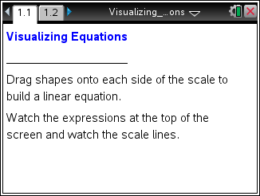

Move to page 1.2. | Press / ¢ and / ¡ to navigate through the lesson.
1. a. Drag two tiles and one tile to the left side, and describe the changes that occur on the screen.

b. What expression is represented on the left side?

c. Place tiles on the right side to make it match the left side. How can you tell that the scale is balanced?

2. a. Describe what happens when you add two tiles to the left side and add two tiles to the right side.

b. What is the new expression on the left side?

c. What is the new expression on the right side?

3. Describe what happens when you remove one from either side of the equation.

4. Press R or click (R)eset in the lower left corner of the screen to reset the page.
a. Place one tile on the left side. What is the expression on the left side?

b. Drag one tile to the left side. What happens as a result?

c. Why does this happen?
5. Press the Reset box. Drag two tiles and one tile to the left side and one tile and two tiles to the right side. The tiles should represent 2x + 1 on the left side and x + 2 on the right side.
a. Press the up and down arrows on the left side and describe what happens.

b. Press the up and down arrows until the two sides are balanced.
Then, add or remove tiles to get one alone on the left side. Be sure to keep the scale balanced. Describe the approach you used, and explain why you used those moves.

c. What is the final answer? x =

6. Renee and Tameka are using tiles to solve the balanced equation 2x – 3 = 7. Renee plans to add 3 to the left side as her first step. Tameka plans to add 3 to both sides for her first step.
Who is correct? Explain your reasoning.

7. Click the Reset box. Then place tiles on the screen to represent 2x – 3 and 3x + 1. Press the arrows until the two sides are balanced.
Add or remove tiles to get one alone on one side and keep the scale balanced. What did you move, and what is the final answer?

8. Click the Reset box on the bottom left corner of the screen. On one side of the scale, Tameka had two sets of x + 1 and on the other side four ones. Move tiles so that your screen is set up the same way.
and
a. Write the equation she was solving in two different ways. Use the tiles and the scale to explain how you know you have a correct representation.

b. Her first step was to divide each side into two equal groups. Next, she decided to remove one group from each side.
She removed from one side and from the other. What do you think about her strategy?

