Open the TI-Nspire document Color_and_Heat.tns.  In this investigation, you will explore different colored plates that are being heated as they absorb and reflect the electromagnetic radiation from light. As time passes in the simulation, temperature data will be collected, displayed, and graphed. You will vary the color of the plate and observe the differences in the absorption and reflection of primary and secondary colors, as well as white, black and gray. | 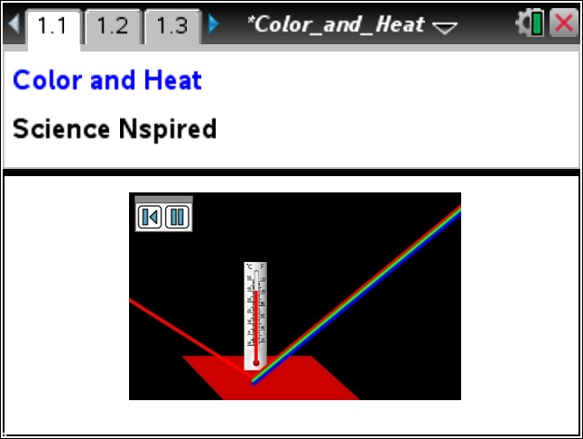
As you explore the temperature of the different colored plates over time, you will begin to see patterns in the relationship between temperature and color, as it relates to the absorption and reflection of light. Primary and secondary colors are related and as you explore this simulation, you will use the data to determine the connections between them.

Part 1: Exploring the System
1. Read the directions explaining how to use the simulation. Close the box by selecting when you are finished.

Tech Tip: Press b if you need to view the directions again.
iPad Tip: Select  Tools > Directions to view the directions again.
2. Select the color plate and choose a color to use. Start the simulation by selecting the Play button . Observe the time and temperature displayed at the bottom of the page. Also, note the colors that are being absorbed and reflected, which are represented by colored lines coming in and going out from the plate. Then, look at page 1.3 for a data table and page 1.4 for a graph of the data.

To pause the simulation, select .

Q1. For the color you selected, what happens in the simulation? Write a description and share this with a neighbor and the class as requested.

3. Test the simulation for all of the colors. Note any patterns or relationships between the temperatures and the color of light that is absorbed and reflected.

Q2. Rank the colors from hottest to coolest based on what you saw in the simulation.

Rank | Color | Reflected Colors
1st (Hottest)
2nd
3rd
4th
5th
6th
7th
8th
9th (Coolest)

4. Compare your rankings with others in the class.

Q3. Describe a situation in which you would pick a color based on what you have learned about how different colors absorb light and heat up. Include the color you would pick and why.

Part 2: A Closer Look
Move to pages 1.3 – 1.4.
5. Now you need to quantify the way each color heats over time. Looking at the spreadsheet on page 1.3 and the graph on page1.4, answer questions 4 and 5.

Q4. Which colors heat the fastest? Why?

Q5. Which colors heat the slowest? Why?

6. Now you will be assigned a time at which you will collect the temperature for each of the nine colored plates. Record your assigned time below.

My assigned time ______________

Move to page 1.5.
Q6. Fill in the temperature readings for your assigned time in the data table below. Add this data to the spreadsheet on page 1.5 as well. Next, rank these colors with 1 being the hottest and 9 being the coolest.

 | Red | Green | Blue | Yellow | Magenta | Cyan | White | Black | Gray
Temp
Rank

Q7. How well does this new ranking match with others in the class? Compare your data with at least one other student that had the same time as yours. Also, compare with others that had larger or smaller assigned times.

Q8. How well does this new ranking match with what you stated in question 2 from Part 1?

Move to page 1.6.
7. After comparing your results, make any adjustments to your rankings. You may now connect the dots to display your rankings.

Q9. Connect the rank with the color. To do this, use the Segment tool.
Tech Tip: Select Menu > Points & Lines > Segment.
iPad Tip: Select Tools > Points & Lines > Segment.
Click on the point next to the rank and then draw the segment to the point in the center of the color.

Tech Tip: Press / Z to undo and press / Y to redo.
iPad Tip: Use  to undo and long tap to redo.
Q10. Given what you have learned, assume that you are in the Arctic and you can bring two blankets. Which two colors would you select and why?

Q11. Your aunt has invited you to spend the summer in the Sahara Desert with her. She said that she would buy two sand buggies to play with and wants to know what colors you want. Pick two colors and explain your rationale for choosing those colors.

Q12. Given what you now know about the heating capicity of these colors, give a situation during which you would pick cyan over yellow. Explain your reasoning.

Part 3: Primary vs. Secondary Colors
8. Now you will explore the relationship between the primary and secondary colors.

Q13. Of the six given colors on page 1.2, list the primary colors.

Q14. Of the six given colors on page 1.2, list the secondary colors.

Q15. Return to page 1.1 and set the color to one of the secondary colors. What colors do you see being reflected? Repeat this for all three secondary colors.

Move to page 1.7.
9. Now test what you have learned using the colors on page 1.7. Grab the open circle in the center of the square to select a color and move it over another.

Q16. What do you notice about the resulting color when you overlap two colors?

