Open the TI-Nspire™ document Spreading_Doom.tns.  In this activity, you will explore a geometric sequence that models the spread of the 2004 mydoom virus. After finding a rule for the sequence, you will apply it recursively to extend it and graph the resulting data as a scatter plot. You will use the function to make predictions about the number of viruses at specific periods of time. | 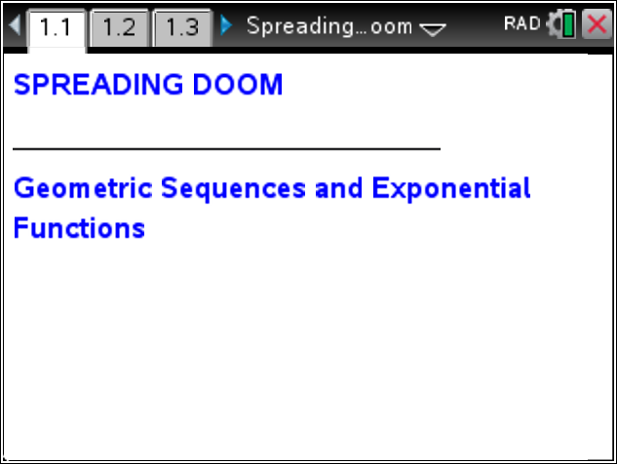

Move to page 1.2.  1. On page 1.2, read about the mydoom virus. In your own words, describe how the virus spread. | Press / ¢ and / ¡ to navigate through the lesson.
Move to page 1.3.

2. What is the common ratio for this sequence?

3. What is the rule for finding the next term?

Move to page 1.4.

4. Move to cell B6, and enter the formula for finding the value of the next term in this sequence. Then, press ·.

Move to page 1.5.

5. Move to cell B6, and press Menu > Data > Fill.

6. Notice the bold, dashed frame around the cell.

7. Press the down arrow until the next five terms have been selected; press ·.

8. The highlighted cells will be populated with values based upon the formula entered.

Move to page 1.5.

9. This is a Data & Statistics page displaying the events from the spreadsheet.

10. To graph a scatter plot of the data, click on the “Click to add variable” message in the center of the lower part of the screen, and select the variable hour. Then click on “Click to add variable” on the left side of the screen, and select the variable email. The scatter plot will be displayed.
11. Describe the shape of the scatter plot.

12. Complete the table on your worksheet and on page 1.6 of the TI-Nspire™ document to help determine a function to model the spread of the mydoom virus.

x | f(x) | Exponential Expression
x = 0 | f(0) = 6,000 | f(0) = 6,000 ⋅ 1.8^____
x = 1 | f(1) = f(0) ⋅ 1.8 = 6,000 ⋅ 1.8 | f(1) = 6,000 ⋅ 1.8^____
x = 2 | f(2) = f(1) _______ = 6,000 ⋅ 1.8 ⋅ 1.8 | f(2) = 6,000 ⋅ 1.8^____
x = 3 | f(3) = f(2) _______ = 6,000 ⋅ ________________ | f(3) = 6,000 ⋅ 1.8^____
x = 4 | f(4) = f(3) _______ = 6,000 ⋅ ____________________ | f(4) = 6,000 ⋅ 1.8^____

Move to page 1.7.

13. Write a function that gives the number of e-mails, f(x), sent by the virus in the x^{th} hour after its release.

Move to page 1.8.

14. Select the Calculator application, enter f1(144), and press ·.

Tech Tip: Change the Document Settings to float to display more significant digits for this result.

Move to page 1.9.

15. To copy the spreadsheet, move to page 1.4, and move to the Lists & Spreadsheet application. Press / K to select this application (the frame should be flashing), and press / C to copy it. Move to page 1.9, and press / I to insert a new page. Press d to close the menu, and finally press / V to paste the spreadsheet.

16. Move to the formula row in column C. Enter your function, using hour for the independent variable, and then press ·.

17. Compare the values in column B with those in column C.

Move to page 1.5.

18. Press Menu > Analyze > Plot Function.

19. Enter your function in the dialogue box, and press ·.

20. This function is an exponential function of the form f(x) = a ⋅b^{x}. In your own words, explain what the values of a and b represent.

