Open or create the TI-Nspire document Midpoint_Quadrilaterals.tns.  Students will explore properties of a midpoint quadrilateral. | 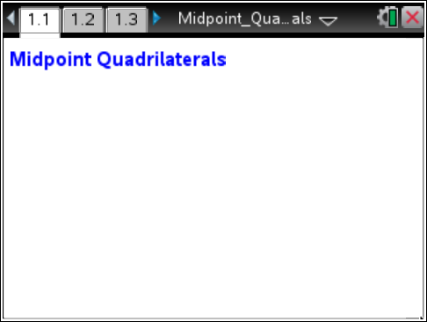

Move to page 1.2. | Press / ¢ and / ¡ to navigate through the lesson.
Part 1 – Exploring the midpoint quadrilateral
On page 1.2, you will see an outer quadrilateral ABCD with an inner quadrilateral PMNS constructed using the midpoints of each side of the outer quadrilateral. Angle measurements, side measurements, and slopes of the sides of the inner quadrilateral are given.
Move to any vertex of the outer quadrilateral and drag to explore. Observe the measurements as they change.
1. What type of quadrilateral is the inner quadrilateral? Explain how you know.

2. Drag any of the outer vertices to form non-convex (concave) quadrilaterals. Is the inner quadrilateral still the same type as what you answered in problem 1?

3. Is the inner quadrilateral ever a special quadrilateral (rectangle, square, and so on)? Drag the vertices to make the outer quadrilateral into the following shape types and record the type(s) of inner quadrilaterals that result. Make outer quadrilateral measurements if necessary.

Outer Quadrilateral ABCD | Inner Quadrilateral PMNS
Parallelogram
Rectangle
Square
Rhombus
Kite
Trapezoid
Isosceles Trapezoid
Move to page 1.3.
Part 2 – Comparing Areas
Press Menu > Geometry > Measurement > Area. Move to the inner polygon until the words polygon MNSP appear and press x. Move the measurement to the upper right part of the screen and press x.
Repeat for outer quadrilateral ABCD. Then press d to exit the Measurement tool.
To increase the number of significant digits, hover the cursor above one of the area measures, press / b > Attributes > 4 > ·. Repeat for the other area measure.
4. What is the relationship between the areas of the inner and outer quadrilaterals?

Move to page 1.4.

Part 3 – Exploring Proof
Press Menu > Geometry > Points & Lines > Segment. Construct diagonal AC of the outer quadrilateral.
Press Menu > Geometry > Measurement > Length to measure the length of the diagonal, AC, as well as the length of sides SN and MP. Press d to exit the Measurement tool.
5. What is the relationship between the diagonal length and the inner quadrilateral side length?

Press Menu > Geometry > Measurement > Slope to measure the slope of the diagonal, AC, as well as the slope of sides SN and MP. Press d to exit the Measurement tool. Drag the vertices of the outer quadrilateral.
6. What is the relationship between the slope of the diagonal and the slope of the midsegment?

7. How could this be used to prove that the inner quadrilateral is a special type of quadrilateral?

