Activity Overview:  In this activity, you will use the construction tools in the Graphs application to construct a midpoint quadrilateral.  Materials  - Technology needed (TI-Nspire™ handheld, computer software) | 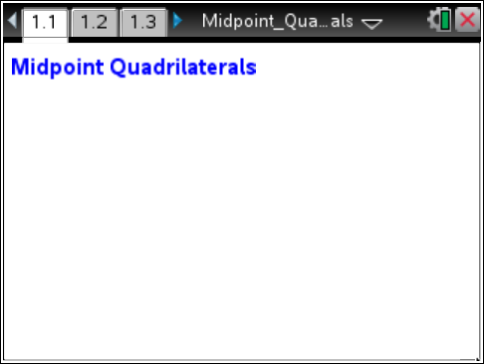

Step 1: Preparing the document
- Open a new document by clicking c > New Document > Add Notes.
- Type: Midpoint Quadrilaterals.

Note: To obtain capital letters, press the g key, then the letter.

- Press ~ > File > Save As ….
Type: Midpoint_Quadrilaterals.
Tab to ¾ and press ·.

Note: To obtain the underscore, press / _.

4. Add a new page by pressing / ~ > Add Graphs.

5. Press Menu > Settings. Select “Float 3” for Display Digits. Tab to Graphing Angle. Select “Degree.” Then press e to move from one field to the next and press x to uncheck all the boxes. Tab to OK and press x or ·.
6. Press Menu > View > Grid > Dot Grid.
7. Press Menu > View > Hide Entry Line.

Step 2: Creating a quadrilateral
1. Press Menu > Geometry > Shapes > Polygon.
2. Move the cursor to a grid point until the words point on appear. Then press enter to set the first vertex of the quadrilateral. Immediately label the point by pressing g A. Move the cursor to three other grid points, press enter, and label these points B, C, and D. After you label point D, press · or x to complete the quadrilateral.
3. Press d to exit the Polygon tool.

Step 3: Constructing midpoints
1. Press Menu > Geometry > Construction > Midpoint.
2. Move the cursor to each side to create a midpoint. Immediately label the midpoints P, M, N, and S as shown in the screen shot to the right.
3. Press d to exit the Midpoint tool.
4. To move a label to a more desired location, move the cursor to the label until “label” appears and the hand appears ÷. To close the hand, press / x. Move the label to the new location and press d.

Step 4: Creating the midpoint quadrilateral
1. Press Menu > Geometry > Shapes > Polygon.
2. Click on each midpoint. After you reach the last midpoint, press · or x to complete the quadrilateral.
3. Press d to exit the Polygon tool.
4. Move the cursor to a side of polygon MNSP until the words polygon MNSP appear. To shade this polygon, press / b > Color > Fill Color. Then use the ¢ or ¤ on the Touchpad or Clickpad to choose the desired color and press ·.
Step 5: Overlaying segments on top of sides  1. Press Menu > Geometry > Points & Lines > Segment.  2. Press · or x on point P and then drag to point M and press · or x for segment PM.  Press · or x for point M and then drag to point N and press · or x for segment MN.  Repeat for segments NS and SP. Then press d to exit. | 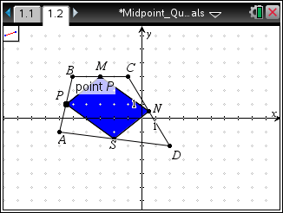
Step 6: Copying a page
1. Press / £ to open the page sorter.
2. While the current page is selected, press / C to copy the page.
3. Press / V two times to paste two new copies of the screen.
4. Press ·. Page 1.4 will be the active page. Move back to page 1.2.
Step 7: Finding angle measurements
1. Press Menu > Geometry > Measurement > Angle.
2. To measure ∠SPM, move cursor to point S, press · or x, move to point P, repeat, and finally to point M, repeat. After the third point has been selected, an angle arc and measurement will appear. Angle measurements will temporarily be near the vertex of the angle.
3. Repeat for the other three inner quadrilateral angles: ∠PMN, ∠MNS, ∠NSP. Press d.
4. Beginning with angle SPM, grab each measurement and move to the upper-right corner, keeping track of where the angle measurements go.
5. To label each measurement, move the cursor to the measurement (should say text) and press x twice. Left arrow to the beginning of the text box and type SPM=. Press ·.
6. Repeat for other angles.
Note: You may want to grab the measurements and move them so that you can read them more easily.
Step 8: Finding side measurements of quadrilateral PMNS  1. Press Menu > Geometry > Measurement > Length.  2. Press x on a segment. You may need to tab until the words segment PM appear. Use arrows to drag the measurement to the upper-left corner. Press x.  3. Repeat for the other inner segments. Press d.  4. Then label as before (explained in part 5 of Step 7 above). | 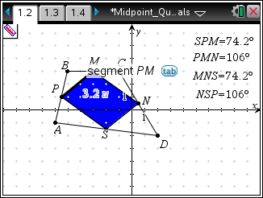
Step 9: Finding the slope of the sides of PMNS
1. Press Menu > Geometry > Measurement > Slope.
2. Press x on each side of PMNS. Drag the slope (m) measurement to the bottom of the page. Press x.
3. Repeat for each side. Press d then label as before. (For example, mPM= …)

Step 10: Saving the document
1. Press / S.

