Open the TI-Nspire document Family of t-curves.tns.  Is there only one t-distribution? This activity investigates that question and shows the relationship of a t-distribution to the normal distribution. | 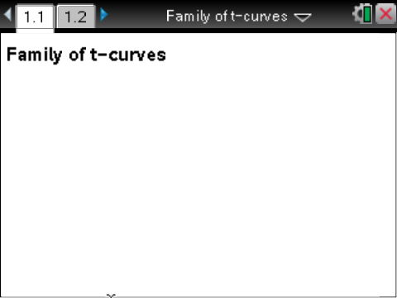

Move to page 1.2. | Press / ¢ and / ¡ to navigate through the lesson.
1. The graph on Page 1.2 displays the normal probability function with mean 0 and standard deviation of 1. Move the slider to display the graph of a t-distribution with one degree of freedom.
a. Describe the graph.

b. How are the graphs of the normal probability distribution and the t-distribution alike, and how are they different?

2. Select MENU > Trace > Graph Trace. Press the right and left arrow keys (the edges of the touchpad) to move the trace point along the curve. The up and down arrow keys on the touchpad will move the point to the other graph.
a. Estimate the coordinates of the point of inflection for each graph.

b. Estimate the maximum height of each of the two distributions.

3. Decide whether the following statements are always true, sometimes true, or never true. Explain your reasoning in each case.
a. The area between the horizontal axis and the normal distribution is smaller than the area between the horizontal axis and the t-distribution.

b. The probability that an outcome will be greater than 1.8 is larger for the t-distribution with one degree of freedom than for the normal distribution.

c. The probability of an outcome is greater using the t-distribution than the normal distribution.
4. Tom claims he can find another normal curve that will exactly match the t-distribution with one degree of freedom by changing the mean and standard deviation of the normal distribution.
a. Do you agree or disagree with Tom? Justify your reasoning.

b. Press / + G to bring up the entry line. Click the up arrow twice to see the equation for the normal distribution f1(x), which was normpdf(x,0,1) where the mean was 0 and the standard deviation was 1. Change the standard deviation to see if your argument for Tom was correct.

5. Return to the normal distribution with mean 0 and standard deviation 1. A variable of interest related to the t-distribution is the number of degrees of freedom.
a. How do you think the t-distribution graph will change if the degrees of freedom, df, are increased?

b. Use the arrow to increase the degrees of freedom, df, to 2. Were you right in your conjecture for part a? Explain why or why not.

Tip: You might want to use a slider rather than the arrow to increase the degrees of freedom more quickly. To do so, highlight the box around the slider, press / > MENU > Maximize.
c. Use the arrow to increase the number of degrees of freedom, df, for the t-distribution. Describe what happens to graph as df increases.

6. Decide whether the following are always true, sometimes true, or never true. Explain your thinking for each answer.
a. The empirical rule, 68%, 95%, and 99.7%, works for both of the distributions.

b. There is really only one t-distribution and one normal distribution.

c. The t-distribution is a function of the standard deviation and the mean of the population.

7. Tinae announced that she is not going to use the normal distribution ever and instead will use the
t-distribution as it seems like it will give better results overall. What would you say to Tinae?

8. The name of this activity is the Family of t-Curves. Does the name make sense? Why or why not?

