Open a new TI-Nspire™ document.  In this experiment, you will observe several factors that determine whether or not a solution conducts electricity, and if so, the relative magnitude of the conductivity. You will use a conductivity probe to measure the conductivity of different solutions and explore whether molecules or ions are responsible for this conductivity. | 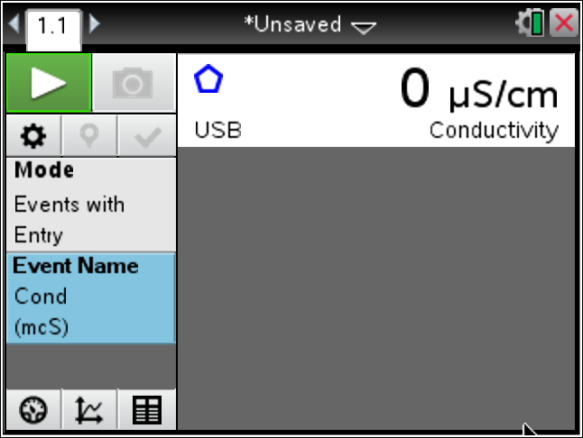

1. Obtain and wear goggles!
CAUTION: Handle the solutions in this experiment with care. Do not allow them to contact your skin. Notify your teacher in the event of an accident.
2. Assemble the Conductivity Probe, utility clamp, and ring stand as shown here. Be sure the probe is clean and dry before beginning the experiment.  3. Set the selector switch on the side of the Conductivity Probe to the 0–20000 µS/cm range.  4. Connect the Conductivity Probe to the data-collection interface, and connect the interface to the TI-Nspire™ CX CAS handheld. | 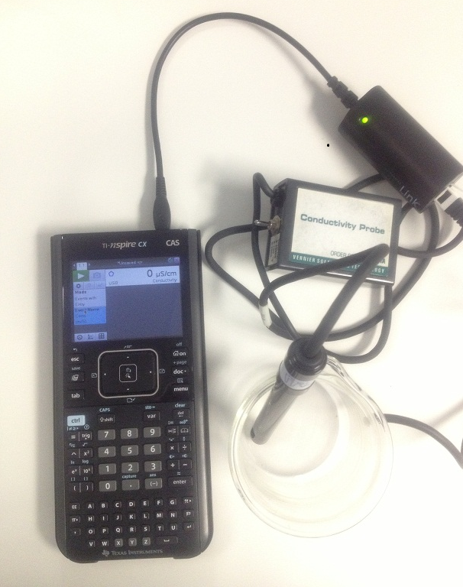
5. Turn on the handheld, open a new document, and do not save the current document, if asked.
6. Add a Vernier DataQuest™ App. Select MENU > Experiment > Collection Mode > Events with Entry.
7. Type in Cond for the name and mcS for the unit.
8. Select MENU > Experiment > Setup Sensors > Zero. Do this only once for the entire experiment.
9. Obtain ~100 mL of distilled water. Divide it equally between two plastic cups. Carefully raise the cup and its contents up around the Conductivity Probe until the hole near the probe end is completely submerged in the solution being tested.
Important: Since the two electrodes are positioned on either side of the hole, this part of the probe must be completely submerged.

10. Press Start Data Collection on the TI-Nspire.
11. When the reading stabilizes, click the keep button to save the data.
12. Type in diw for distilled water, and record the conductivity in the data table on the last page of this worksheet.
13. Add a level teaspoon of table salt to the ~50 mL of distilled water, and stir to dissolve the salt.
14. Place the Conductivity Probe into the salt water to collect more data and press Start Data Collection .
15. When the reading stabilizes, press the keep button, type in saltw for salt water, and record the conductivity value in the data table at the end of this worksheet.
16. Add a packet of sucrose to the other cup of distilled water, and stir until dissolved.

17. Measure the conductivity as above for the salt water, type in sugw for sugar water, and record the conductivity value in the data table.
18. Repeat the data collection using ~50 mL of tap water, and type in tapw for tap water.
19. Press Stop Data Collection .
20. Click on the Table View tab () to view a table of the conductivity values you collected. Record these values in your data table.

21. Press / ~ to insert a Data & Statistics page.
22. Move the cursor to the x-axis, press / b, and select Add X Variable with Summary Variable.
23. Tab to OK from the Summary Chart Dialog Box.
24. Move the cursor to the first bar for distilled water. Press /, and select MENU > Color > Fill Color, and choose a color for the distilled water bar.
25. Repeat for the salt water solution and the sucrose solution, choosing a different color for each one.
26. Compare and contrast the conductivity values for each.

It is now time to think about a researchable question to investigate. You have various substances to test. Read the discussion below before moving to procedure 27.

Discussion:
So far in this activity, you have learned some properties of strong electrolytes, weak electrolytes, and non-electrolytes by observing the behavior of these substances in aqueous solutions using a Conductivity Probe. When the probe was placed in a solution that contains ions, and thus has the ability to conduct electricity, an electrical circuit is completed across the electrodes that are located on either side of the hole near the bottom of the probe body. This results in a conductivity value that can be read by a data-collection interface. The unit of conductivity used in this experiment is the microsiemens per centimeter, or µS/cm.

The size of the conductivity value depends on the ability of the aqueous solution to conduct electricity. Strong electrolytes produce large numbers of ions, which results in high conductivity values. Weak electrolytes result in low conductivity, and non-electrolytes should result in no conductivity.

In each part of the experiment, you are observing a different property of electrolytes. Keep in mind that you will be encountering three types of compounds and aqueous solutions:

1—Ionic Compounds
These are usually strong electrolytes and can be expected to 100% dissociate in aqueous solution.
Example: NaCl_{(s)} Na⁺_{(aq)} + Cl–_{(aq)}

2—Molecular Compounds
These are usually non-electrolytes. They do not dissociate to form ions. Resulting solutions do not conduct electricity.
Example: C₁₂H₂₂O_{11(l)} C₁₂H₂₂O_{11(aq)}

3—Molecular Acids
These are molecules that can partially or wholly dissociate, depending on their strength.
Example: Strong electrolyte H₂SO₄ H⁺(aq) + HSO₄–(aq) (100% dissociation)
Example: Weak electrolyte H₃PO₄ H⁺(aq) + H₂PO₄–(aq) (<100% dissociation)

27. Now that you have read about electrolytes and nonelectrolytes, discuss with your partner an area that you would like to investigate regarding common soft drinks.
- Read the labels of the substances (both solutions and solids) provided to gather more information for your researchable question.
- Write up a hypothesis, and be prepared to share it with the group.
- Also, determine what materials and procedures that you plan to follow.
- Do not begin your experiment until after the group discussion of researchable questions!
28. Once the researchable question has been approved by the group, you will be given time to do complete your research, graph your data, and prepare a report to the group.
Your report will include:
a) your original hypothesis
b) pertinent data (Data table in the DataQuest App)
c) a graph (Data & Statistics page)
d) the conclusion to be drawn from your research—was your hypothesis borne out?
e) suggestion(s) for further research

Student Research

29. Press ~ and select Insert > Problem to add a new problem to your document.
30. Add a DataQuest App.
31. Follow the instructions above for setting up the data collection (the same way you have for your previous three experiments).
You are now ready to collect data for your researchable question.
32. Save your research as a .tns file on your handheld by pressing / ».
33. When prompted, enter a file name.
- To make your report, the teacher will display your bar graph for the class.
34. When finished with your research, clean up your area, discard solutions in the bucket provided, and put equipment away.

Data Table:
Solution | Conductivity  (µS/cm)
Distilled water
Table salt solution
Sucrose solution
Tap water

