Open the TI-Nspire document Charge_Transfer.tns.  In this activity, you will explore the following questions:  - What happens when a positively or negatively charged object is brought near a metal can without touching it? Does this effect depend on the distance between the charged object and the metal can?  - What happens when a positively or negatively charged object is placed inside a metal can without touching it? What if you brought it in contact with the can?  - Does charge change over time? Why? What factors affect this process? |  | 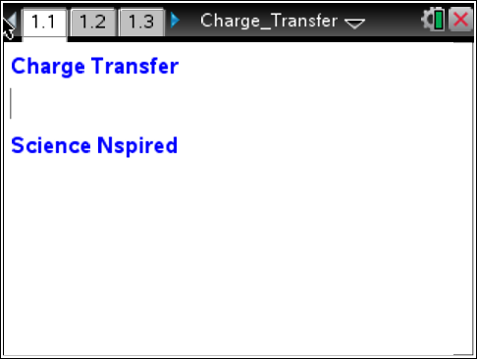
Problem 1: Exploring Charge by Contact and Induction
In this activity, you will measure the charge transferred by induction and by contact onto a metal can from charged cellophane tape. You will measure the charge transferred from different distances and over time. You will analyze these data and develop mathematical models for charge as a function of distance and as a function of time.
1. Connect the sensor cable leads to a Vernier Charge Sensor and then connect the sensor to an EasyLink interface (if working with TI-Nspire handheld) or Go!Link interface (if working with a computer).  2. Slide the switch on the Charge Sensor to the ±10V position. Press the Reset button for a few seconds with the leads touching each other to make sure all charge is depleted from the internal capacitor.  3. Place a square sheet of heavy-duty aluminum foil on the table. Fold the edge of the sheet over several times to form a thicker edge on one side. This will prevent tearing. Connect the black (grounded) lead of the sensor to the folded edge. This sheet of foil is the ground plane. | glass jar  metal can  positive (red) lead  TI-Nspire  EasyLink interface  Charge Sensor  negative (black) lead  aluminum foil
4. Place an inverted glass jar in the middle of the aluminum foil. Place the metal can on top of the glass jar. The opening of the can should be facing upward. Connect the red (positive) lead of the sensor to the bottom lip of the can, as shown in the diagram to the right.
Note: Begin all experiments by touching the can to the foil to ground it, and then zeroing the charge sensor.

Answer the following questions here.
Q1. How can objects be charged by contact?

Q2. How can charge be induced?

Q3. Explain the law of conservation of charge.

5. Stick two pieces of cellophane tape to short pieces of paper or card stock. Make sure most of each piece of tape is hanging off the paper. Charge the tape by sticking the two pieces together—the sticky side of one piece to the smooth side of the other. To get rid of any excess charge, run the pieces of tape gently through your fingers. Try to minimize your handling of the tape.

Move to pages 1.2 and 1.3.  6. Read page 1.2, and then move to page 1.3. Connect the EasyLink or Go!Link interface to your handheld or computer. A charge reading should show up in the DataQuest application.  7. To check that the tapes are not carrying any excess charge, bring the tapes near the metal can (do not touch the can with the tape). The charge sensor reading should not change. Once you have checked for overall neutrality, separate the pieces of tape. |  | 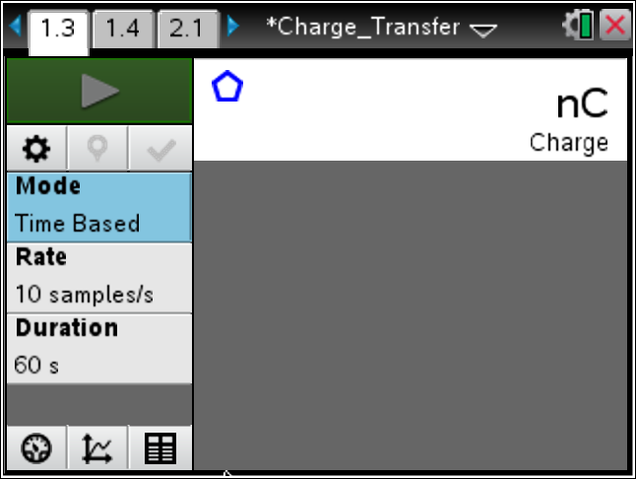
Answer the following questions here.
Q4. What happens to the pieces of tape now when you bring them near each other?

Q5. Explain how the pieces of tape became charged.

8. Set up the data collection as an Events with Entry experiment (Menu > Experiment > Collection Mode > Events with Entry). Press the Start Collection button to start the data collection. |  | 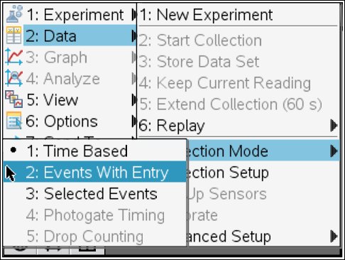

Move to page 1.4.
9. Observe and record the charge readings as you bring one of the pieces of tape near the can, then inside but not touching the can, and then touching the can. To collect a data point, select Keep data button . A dialog box will appear. In the dialog box, enter a number representing which data point you are collecting (for example, you may use 1 for the tape near the can, 2 for the tape inside the can, and 3 for the tape touching the can). A graph should appear on page 1.4 as you collect your data.
10. Repeat Step 9 for the other piece of tape. (Remember to ground the metal can and zero the Charge Sensor before collecting the data.) After data are collected, click on Stop Data Collection and disconnect the sensor.
11. Page 1.4 contains a blank Graph & Geometry application. Change the graph type to a scatter plot (Menu > Graph Entry/Edit > Scatter Plot) and use the entry line to set the x-axis to the variable run1.event and the y-axis to run1.charge. Use (Window/Zoom > Zoom-Data) to ensure that all of the data  are visible. | 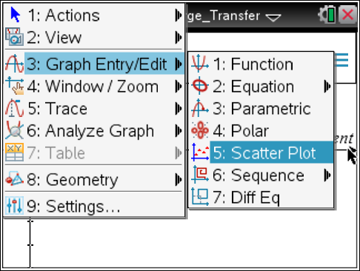
Answer the following questions here.
Q6. Explain why measuring the charge on the can allows you to determine the charge on each piece
of tape.

Q7. Can you compare all three measurements? Which one do you think is most precise?

Problem 2: Induced Charge Change with Distance
Move to page 2.1.  1. Next, you will explore how induced charge changes with distance. Connect the sensor to the TI-Nspire, and set up data collection for Events with Entry. Zero the Charge Sensor. | 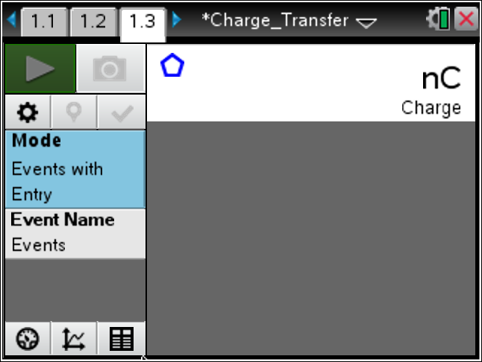
2. Hold a positively charged piece of tape about 1 cm from the can. (Use a ruler to measure the approximate distance between the tape and the can, but do not allow the ruler to touch the tape or the can.) Once the charge reading has stabilized, collect the data point. Enter 0.01 in the dialog box.
3. Move the tape approximately 1 cm farther away from the can, wait for the reading to stabilize, and record another data point. Enter 0.02 in the dialog box.
4. Repeat Step 3 three or four more times.
5. After data are collected, click on Stop Data Collection and disconnect the sensor.

Move to page 2.2.  6. Page 2.2 contains a blank Graphs & Geometry application. Change the graph type to a scatter plot (Menu > Graph Entry/Edit > Scatter Plot) and use the entry line to set the x-axis to the variable run1.event and the y-axis to run1.charge. Use (Window/Zoom > Zoom-Data) to ensure that all of the data  are visible. | 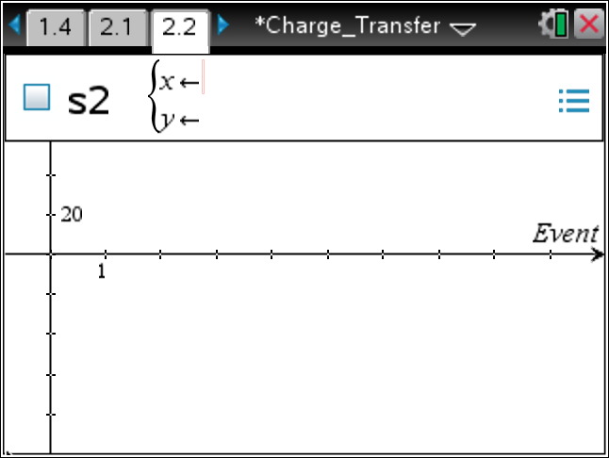
Answer the following questions here.
Q1. Explain why the magnitude of induced charge changes as you move the tape away from the can.

Q2. What mathematical function appears to best fit the data that describe the change of induced charge as the tape moves away from the can?

Move to page 2.3.  7. Page 2.3 contains a Data & Statistics application. Use this application to plot charge vs. distance for the data you collected. | 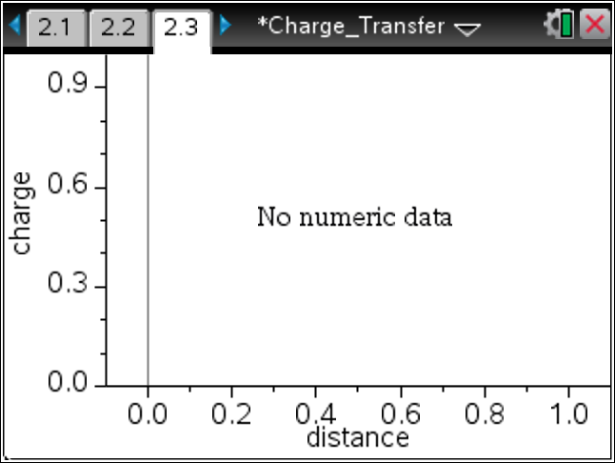
8. Use the Regression tool (Menu > Analyze > Regression) to identify a best-fit curve for the data you collected. Try several different types of regressions to determine which best fits the data. Identify the two functions that appear to fit the data best. | 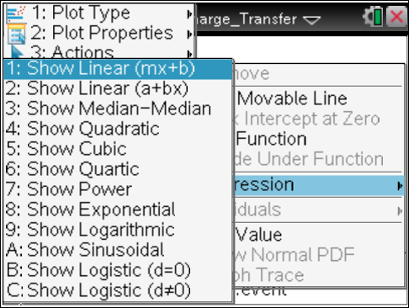
Answer the following question here.
Q3. Which two functions appear to fit the data best?

Move to page 2.4.  9. Page 2.4 contains a Lists & Spreadsheet application. Assign the distance values you collected to column A (distance) by typing =run1.event in the formula bar. Assign the charge values you collected to column B (charge) by typing =run1.charge in the formula bar. | 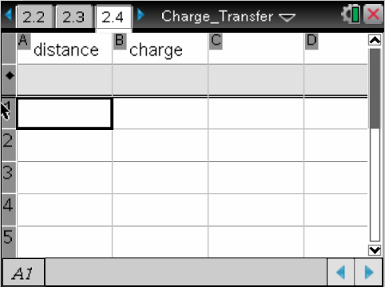
10. Highlight columns A and B and use the Regression tool (Menu > Statistics > Stat Calculations) to find r² values for the two best-fit regressions you identified in Step 8. Display the results of the regressions in separate columns on page 2.4. | 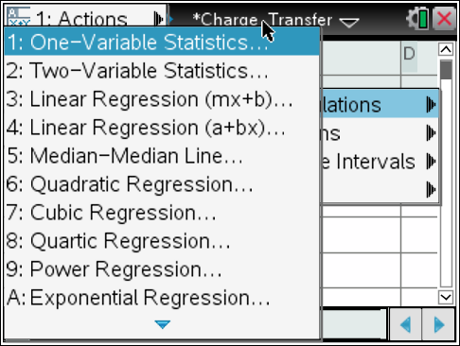
Answer the following question here.
Q4. Based on the r² values for the two regressions, which one fits the data best? What is the best-fit equation for the data? Do both models make physical sense?

Problem 3: Process of Charge Leakage with Time
Answer the following questions here.
Q1. What happens over time to the charge of an object that has been charged by rubbing?

Q2. How does humidity affect static electricity? Why?

Move to page 3.1.  1. Next, you will explore how the charge on the tape changes over time. To do this, you will need to collect time series data. Move to page 3.1, connect the sensor to the TI-Nspire and set up the data collection for a time graph (Menu > Experiment > Collection Mode > Time Based). Set the time between samples to  60 seconds and the experiment length to 1,200 seconds. | 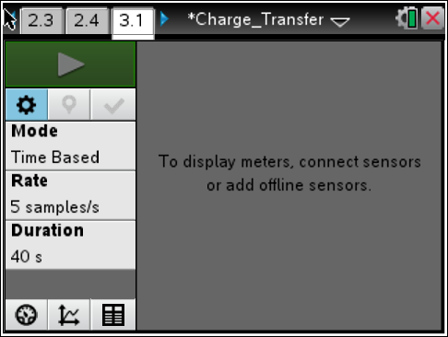
2. To collect data, first press Reset on the sensor. Then, charge one piece of tape positively, drop it into the can, and press the Start Collection button on the data collection box. While the experiment is running, answer Question 3.
Answer the following question here.
Q3. Predict how charge will change with time. What type of function do you think will best fit the data?

Move to page 3.2.  3. After data are collected, click on Stop Data Collection and disconnect the sensor.  4. Page 3.2 contains a blank Graph & Geometry application. Change the graph type to a scatter plot (Menu > Graph Entry/Edit > Scatter Plot) and use the entry line to set the x-axis to the variable run1.time and the y-axis to run1.charge. Use (Window/Zoom > Zoom-Data) to ensure that all of the data  are visible. | 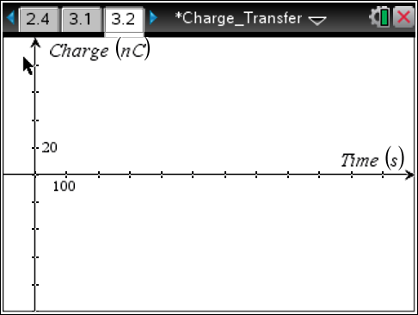
Answer the following question here.
Q4. What mathematical function appears to best fit the data that describe the changing charge
over time?

Move to page 3.3.  5. Move to page 3.3, which contains a Lists & Spreadsheet application. Assign the time values you collected to column A (time) by typing =run1.time in the formula bar. Assign the charge values you collected to column B (charge) by typing =run1.charge in the formula bar. | 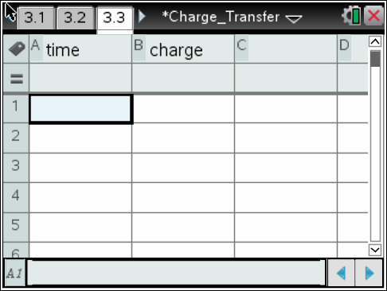
6. Use the Regression tool (Menu > Stat Calculations) to carry out a regression on your data. | 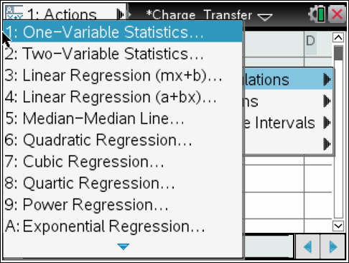
Return to page 3.2.
7. Move back to page 3.2, change the graph to a function graph, and display the regression equation along with the scatter plot of the collected data.
Answer the following questions here.
Q5. Write the mathematical equation for the best-fit line for your data.

Q6. Do your results agree with the prediction you made in Question 3? If not, identify any errors in reasoning that you made.

