Dog days or Dog years?  ID: 11682 | Time required  15 minutes

Activity Overview
In this activity, students will use ordered pairs, table of values, and a scatter plot to determine a function that represents real world data. Students will respond to questions about dog ages in human years, domain, range, and how the slope appears to be changing in the data/graph. In the extension students will use what they have learned in the activity to analyze cat’s ages.

Topic: Linear Functions
- Representing input/output values as ordered pairs
- Analyzing data from table of value and scatter plot
- Determining functions to represent linear data

Teacher Preparation and Notes
- Teacher preparation includes instruction with vocabulary such as domain and range, and how to plot data values on the coordinate plane.
- Before beginning the activity, students should clear all lists and turn off functions. To clear the lists, press   and scroll down until the arrow is in front of ClrAllLists. Press enter twice. To clear any functions, press  and then press  when the cursor is next to each Y= equation.
- Much student learning can take place in a discussion of such “common knowledge” as a dog’s age is equal to 7 human years. The website mentioned in the file (onlineconversion.com) states that this is a common misconception, and that dog experts have provided the information used to program the online conversion calculator. The extension involves students finding an online conversion for a cat’s age. This can lead to excellent comparisons and higher order thinking by the student.
- To download the student worksheet, go to education.ti.com/exchange and enter “11682” in the quick search box.

Associated Materials
- DogDays_Student.doc
- CONVERT.8xp (program)

Suggested Related Activities
To download any activity listed, go to education.ti.com/exchange and enter the number in the quick search box.
- Body Relationships (TI-84 Plus with TI-Navigator) — 8538
- Balloons (TI-84 Plus with TI-Navigator) — 8535
- Chirp, Jump, Scatter (TI-84 Plus family) — 11514

Problem 1 – Ordered Pairs
The website www.onlineconversion.com was used to obtain the data used in this activity.
The first option of the program CONVERT, converts the age of a dog to the age of a human. Students are to enter different ages and the calculator will output the human age.  Encourage students to try ages other than whole numbers. (i.e., Enter 6.5 for 6 ½ years.)  Using this model, students are to develop ordered pairs that follow the format (dog’s age, equivalent human age). | 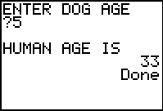
On the worksheet, students are told that the common claim about dog’s age in human years is each dog year is equal to 7 human years. They should be able to determine ordered pairs from this information, but if not explain to them that if a dog is 2 years old, its body is equal to that of a 14 year old human. If a dog lives 10 years, it is like being a 70 year old human.
Students should see that early on it may seem that Spot’s age follows the claim; his age does not support the claim after about 6 years old.
Problem 2 – Table of values and Scatter plot
Selecting option 2 will enter data into lists L₁ and L₂. These are 9 ordered pairs taken from the first part of the activity.  Dog Age (L₁): 0, 1, 2, 3, 4, 5, 6, 7, 8  Human Age (L₂): 0, 10.5, 21, 25, 29, 33, 37, 41, 45  Students can then set up a scatter plot to see the overall pattern of the data.  Discuss with students what information they can gather from the lists or the scatter plot that they could not from the converter. They can use the  feature to move through the data points on the scatter plot.  They should notice a pattern developing from the plot, a steady increase in human age after dog age of 2. Students should notice a change in slope in the scatter plot at age 2. | 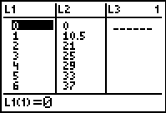  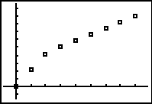
The table ends at age 8 dog years. Ask students how they can predict the age of a dog older than 8. Then explain to students that they will be using the data to find functions which will help them make predictions.  Students are to use 2 two points from each part of the graph to the write functions or equations of a line. They can return to the Home screen ( ) to compute the slope. | 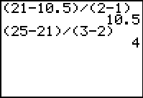
After writing the functions, students can graph them on the scatter plot by putting both in the □ screen. This could provide an introduction to a discussion about the use of piecewise functions. For this graph it would be,  To graph only the section that represents the data, you will need to restrict the domain.  Y₁ = 10.5X*(X≥0)*(X<2)  Y₂ = (4X+13)(X≥2) | 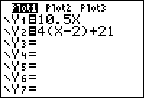  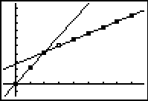
Students can now use the graph to predict the human age of a dog older than 8 using the  feature. They may need to widen the window. To do this, press  and change the Xmax and Ymax numbers.  They are to also determine the domain and range for the relationship between dog years and human years (x ≥ 0, y ≥ 0). If needed, remind students that the domain is the set of input values for a function (x-values of the ordered pairs) and the range is the set of output values for a function (the y-values of the ordered pairs).  In conclusion to the activity, students are to determine from their analysis of the data if the claim, 1 dog year = 7 human years, is true or false. | 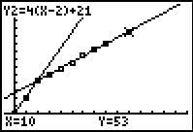

Extension – Cat age converter
Students are now asked to perform the same exploration and discovery to determine the function(s) that predict the human age equivalency for cat years. Using the 3rd option of the program, they will determine ordered pairs and then enter the Cat ages in L₁ and Human ages in L₂.  Students should make a scatter plot and then find functions to represent the different parts of the plot.  The piecewise function that can be used to describe the data is  The website www.bettycat.com/home/ages.html was used to obtain the information for this extension. | 