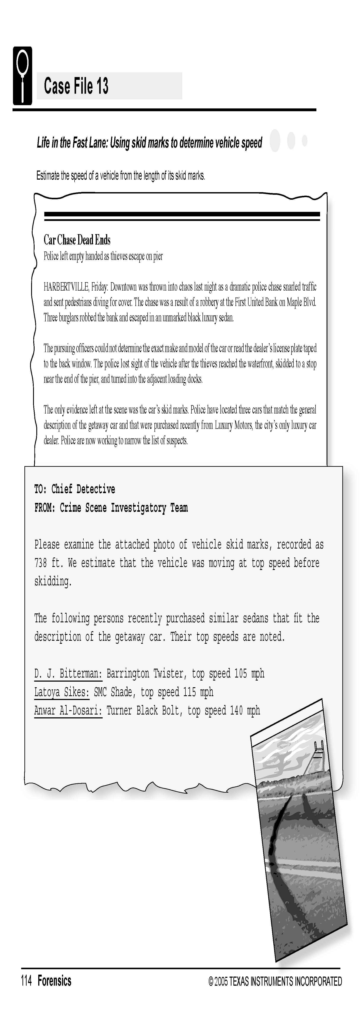

Science Objectives
- Determine the speed of a vehicle before its brakes were applied.
- Determine the coefficient of friction between a vehicle and a road surface.
- Convert between SI units and Imperial units.
- Rearrange equations to solve for different variables.

Activity Materials
- TI-NspireTM technology  - Case 13 Life In The Fast Lane.tns file  - Vernier Dual-Range Force Sensor with Vernier EasyLink™  - heavy toy car or cart | - thread, string, or yarn  - metric tape measure or meter stick  - chalk or tape  - tissue  - C-Clamp or duct tape
Procedure
Open the TI-Nspire document Case 13 Life In The Fast Lane.tns.  In this data-gathering activity, you will estimate the speed of a vehicle from the length of its skid marks. |  | 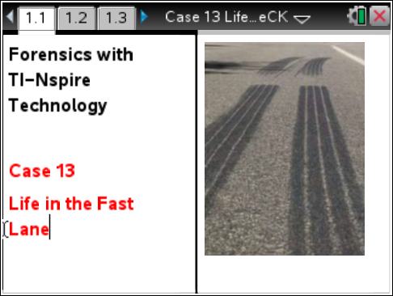
Part 1 – Determining the Coefficient of Friction
Move to pages 1.2–1.9.
1. In order to model a vehicle that is skidding and not rolling, you need to prevent its wheels from rotating. If you are using a Hall’s carriage, use a tight rubber band between the axles. If you are using a toy car, stuff tissue in the wheel wells and/or use masking tape. Make sure that the vehicle slides, without the wheels moving, when you push it along.
2. Tie a 15 cm piece of thread, string, or yarn to the front end of the vehicle.
3. Set the switch on the Dual-Range Force Sensor to ± 10 N. Connect the Force Sensor to TI-Nspire using EasyLink. Your set-up should resemble the picture to the right. |  | 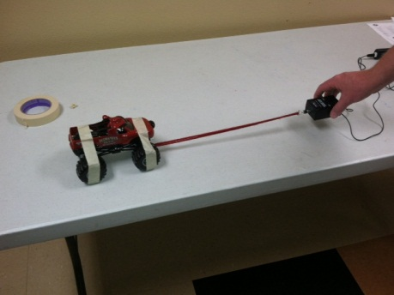
4. Zero the Force Sensor with nothing attached to it:
- Place the Force Sensor on a flat, smooth surface, with its hook parallel to the surface.
- Carefully attach the hook on the sensor to the thread connected to the vehicle. Make sure that there is no tension on the thread.
- When the force reading is fairly constant, press Menu and select Experiment > Sensor Set-up > Zero. The force reading displayed on the screen should be close to zero.
5. When you are collecting data, it is best to have one person pulling the vehicle and a second person on the computer or handheld.
- Using a steady force, pull on the force sensor to move the vehicle across the smooth, flat surface at as constant a speed as possible.
- After the vehicle has started moving, start data collection .
- Continue pulling the vehicle at a constant speed until data collection has ended. Note: Make sure the Force Sensor remains flat on the surface at all times. If the sensor is lifted off the surface, your force readings will be inaccurate.
- The force will look uneven because the range on the y-axis is small. As long as you pull with a constant force, your results should be fine. If your graph has any spikes or dips that are much larger than the rest, repeat to collect a new set of data.

Your graph will look similar to the one shown. The force will look uneven because the range on the y-axis is small. As long as you pull with a constant force, your results should be fine. If your graph has any spikes or dips that are much larger than the rest, repeat Step 5 to collect a new set of data. |  |  | 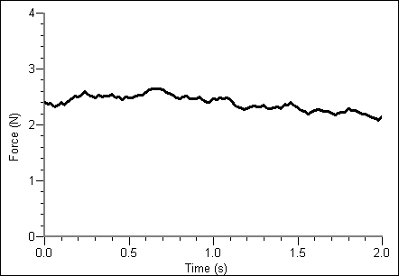
6. Compute the average force with which you pulled the vehicle. Since the vehicle was moving at a constant speed (there was no acceleration), the force with which you pulled it was equal to the force exerted by friction (the forces were balanced).
- Press menu and choose Analyze > Statistics.
- The calculated statistics will be displayed. Record the Mean (average) force (in N) in your Evidence Record. This is the average force with which you pulled the vehicle.
7. Weigh the vehicle.
- Disconnect the string from both the vehicle and the Force Sensor. Hold the Force Sensor vertically at least 30 cm above your surface so that the vehicle will not touch it when suspended from the string. Attach the string to the hook on the Force Sensor but not to the car.
- Carefully attach the vehicle to the thread connected to the sensor. Try not to let the vehicle swing or twist on the thread. Press menu and select Experiment > Sensor Set-up > Zero. The force reading displayed on the screen should be close to zero
- The vehicle hanging from the Force Sensor should be relatively stationary. When the displayed force reading is fairly constant, start data collection. Hold the vehicle steady until data collection has ended, then carefully remove the vehicle from the hook on the Force Sensor.
8. Repeat Step 6 to find the mean value, which is the average weight of the vehicle. Record this in the Evidence Record.
9. Divide the average force by which you pulled the vehicle, which equals the friction force, by the average weight of the vehicle. The result is μ, the coefficient of friction for the vehicle and the surface it skidded on. Record the coefficient of friction in your Evidence Record. Note: The force and weight are given in Newtons, but the resulting coefficient of friction has no units because you divide Newtons by Newtons.

Part 2 – Finding Speed from Skidding Distance
Move to pages 2.1–2.4.
10. Use chalk or tape to make a starting line for your measurements on the flat, smooth surface you are using.
11. Simulate the car chase by pushing the vehicle and letting it skid to a stop.
- Remove the string from the vehicle. Leave the vehicle’s wheels locked.
- Place the vehicle a short distance behind the starting line, and push it toward the starting line with a constant force.
- Release the vehicle just as its front wheels cross the starting line.
- Wait until the vehicle is still, and mark the location of its front wheels.
- Measure the distance from the starting line to the place where the vehicle’s front wheels stopped, in meters. Record this as the skidding distance in your Evidence Record
12. Use the speed equation to calculate the speed that the vehicle was traveling when it crossed the starting line and began to skid. The speed equation is:
v =
Where v is velocity (speed) at the start of the skid, g is acceleration due to gravity (9.8 m/s² or 32 ft/s²), μ is the coefficient of friction, and d is the distance (in meters) the vehicle skidded before stopping. Note: Be sure that your measurement units are consistent with one another.

13. Repeat Steps 10 and 11 at least two more times to fill in your Evidence Record.

Evidence Record
Value
Average Sliding Friction (N)
(Equal to average force used to pull vehicle)
Average weight of vehicle (N)
Coefficient of friction, μ
μ = Sliding friction (N)
Weight of vehicle (N)

Trial Number | Skidding Distance (m) | Speed (m/s)
1
2
3

Case Analysis
Move to page 4.1–4.12.
Answer the following questions here, in the .tns file, or both.
Q1. Rearrange the speed equation to solve for d, the skidding distance. Show your work.

Q2. In most cases, an accident investigator cannot accurately compute μ, the coefficient of friction. However, tests have been done to establish a range of values for μ that apply to most situations. In general, the coefficient of friction for a car on an asphalt road is between 0.5 and 0.9. Using this information and the equation from question 1, fill in the final two columns in the table below. Note: 1 mph = 1.47 ft/s.
Coefficient of Friction | Speed of Car  (m/s) | Speed of Car  (mph) | Skidding Distance  (m) | Skidding Distance  (ft)
0.5 | 13.41 | 30
0.9 | 13.41 | 30
0.5 | 20.12 | 45
0.9 | 20.12 | 45
0.5 | 26.82 | 60
0.9 | 26.82 | 60
0.5 | 40.24 | 90
0.9 | 40.24 | 90

Q3. In general, what happens to the skidding distance when the speed doubles?

Q4. Give an example of a real situation in which the smaller coefficient of friction (0.5) may apply.

Q5. Give an example of a real situation in which the larger coefficient of friction (0.9) may apply.

Q6. Using the length of the skid marks from the crime scene report, calculate the range of possible speeds of the getaway car, in miles per hour, assuming the smaller coefficient of friction is correct.

Q7. Using the length of the skid marks again, calculate the range of possible speeds of the getaway car, in miles per hour, assuming the larger coefficient of friction is correct.

Q8. Considering the conditions of the road and the getaway car, which coefficient of friction do you think most likely applied during the car chase? Explain your answer.

Q9. Based on your answer to Question 8, which suspect’s car was most likely involved in the car chase?

