Mapping the Ocean Floor
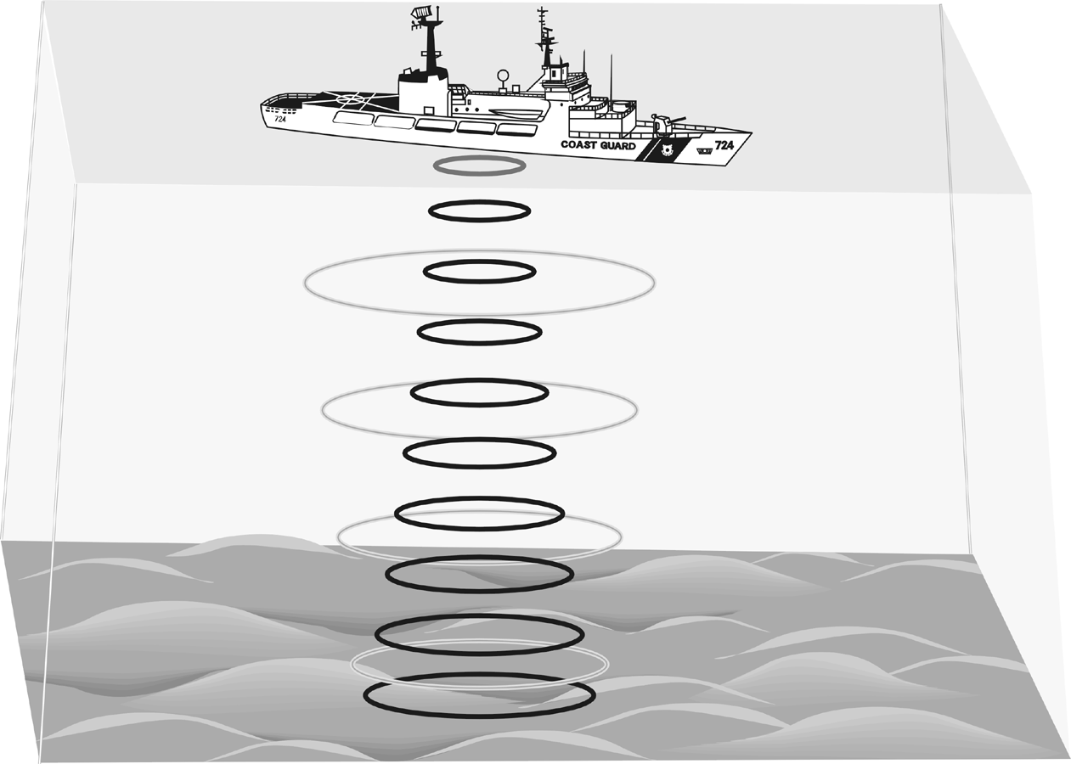
Oceanographers, marine geologists, and archeologists use echo sounders to investigate objects below the surfaces of bodies of water. An echo sounder consists of a transducer that sends out and receives sound waves. A signal is sent out and bounces back from a submerged surface. Scientists use the speed of sound in water and the time it takes for the signal to bounce back to calculate the depth of the object. The deeper the object, the longer it takes for the sound to return. A map of the ocean floor is made by sending out a series of “pings” in a grid pattern and recording the depths. Echo sounders use different frequencies to map different things on the ocean floor.
Sonar, which is short for sound navigation ranging, is the name given to this echo sounding system. It was invented during World War I to detect submarines. The Vernier Motion Detector works in a similar manner. In this activity, you will use a Motion Detector to map objects on a simulated ocean floor.

OBJECTIVES
In this experiment, you will
- Use a Motion Detector to measure distances.
- Map simulated ocean floors.

MATERIALS
TI-Nspire handheld or | 1 m board
computer and TI-Nspire software | masking tape
Motion Detector | 2 or more boxes

PRE-LAB QUESTIONS
1. What else can you think of that measures distance by sending out a sound signal?
2. What factors make it difficult to study the ocean floor directly?
Figure 1
PROCEDURE
Part I Ocean Floor 1
1. Prepare the Motion Detector for data collection.
- Get the board that will act as the support for your Motion Detector.
- Tape or clamp the Motion Detector to one end of the board. Make sure that the round screen of the Motion Detector is not covered and is pointing downward.
- Place the board with the Motion Detector flat on your table as shown in Figure 1.

2. Prepare the ocean floor for data collection.
- Place the box on the floor underneath the Motion Detector. Note: The Motion Detector must be at least 40 cm from the top of the box.
- Line up the Motion Detector so that when it is moved along the table edge it will pass over the box.
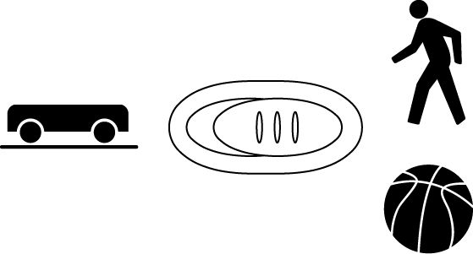
3. Connect the Motion Detector to the data-collection interface. Connect the interface to the TI-Nspire handheld or computer.
4. Choose New Experiment from the Experiment menu. Choose Collection Setup from the Experiment menu. Enter 4 as the rate (samples/second) and 15 as the experiment duration in seconds. Select OK.
5. Collect distance data.
- Move the board to position the Motion Detector to the left of the box.
- When everything is ready, start data collection by pressing the play button . Then, slowly slide the board across the tabletop so that the Motion Detector passes over and past the box.

6. Determine and record the distance to the floor.
- Identify a flat portion of the graph that represents the floor.
- Click and drag the cursor across the data in the flat portion of the graph.
- Choose Statistics►Position from the Analyze menu .
- Record the mean (average) distance to the floor in meters.
7. Determine and record the distance to the box.
- Identify the flat portion of the graph that represents the box.
- Click and drag the cursor across the region that represents the box to select the region.
- Choose Statistics►Position from the Analyze menu .
- Record the mean (average) distance to the box in meters.

8. Sketch and label your graph.
Part II Ocean Floor 2
9. Prepare Ocean Floor 2.
- Set up two boxes in the shape of steps. The tallest box must be at least 40 cm from the Motion Detector.
- Repeat Steps 5–8. Be sure to record all three distances.

Part III Hidden Ocean Floor
10. Your teacher will have a hidden ocean floor for you to measure. Repeat Steps 5–8 for the concealed object or objects

Graph Sketches
Ocean Floor 1 Ocean Floor 2 Hidden Ocean Floor

DATA
 | Distance to floor  (m) | Distance to box (m) | Box height  (m)
Ocean floor 1
single box
Ocean floor 2
box 1
Ocean floor 2
box 2
Hidden ocean floor
box 1
Hidden ocean floor
box 2
Hidden ocean floor
box 3 (if detected)
PROCESSING THE DATA
1. In the space provided in the data table above, find the height of each box. Do this by subtracting the distance to the box from the distance to the floor.
2. Which was your best result? Why do you think it was better than your other results?
3. How did the shape of your graph compare to the actual object(s) in each case? Explain.

EXTENSIONS
1. Try other hidden ocean-floor arrangements.
2. Research the sonar process and compare it to what you did in this activity.

