Open the TI-Nspire document DNA_Structure.tns.

The “instructions” for the structure and function of all living things are contained in their DNA. All organisms rely on the same basic genetic code, using the same 4 building blocks (nucleotides) to make organisms ranging in complexity from yeast to you. A single deoxyribonucleic acid molecule, or DNA, can be millions of nucleotides long!
Life as we know it is possible because DNA can replicate, allowing us to grow and reproduce. Understanding the structure of DNA is important for understanding how DNA is replicated. The structure of DNA was first solved in 1953 by James Watson and Francis Crick. In this lesson, you’ll learn about DNA structure by exploring several simulations.
Part 1: Introduction
Move to pages 1.2 and 1.3.
DNA provides the molecular instructions that guide the building of all living organisms. It contains the genetic instructions to make an organism as complex as YOU As you will see in this lesson, the structure of DNA is actually very simple and quite repetitive. The basic building blocks are the same in all organisms from tiny bacteria to your pets!
- By interacting with several simulations in this lesson you will learn, about the structure of DNA and how that structure influences its characteristics. On the next page, you'll see a diagram of some DNA. Follow the instructions on the page to learn about DNA before answering the questions on the following pages.
Move to page 1.4
This page shows a double helix, which is the basic three dimensional structure of DNA. Tap the “next” arrow to see some parts of DNA.
Move to pages 1.5 – 1.6. Answer questions 1 and 2 here and/or in the .tns file.
Q1. How many separate strands of DNA are in the double helix?
A. 0
B. 1
C. 2
D. 3
Q2. The phosphate backbone is covalently bonded to a ____________ .

A. nucleotide base
B. base pair
C. double helix
D. phosphate

Part 2: Chargaff’s Rules

Move to pages 2.1 – 2.2.
- Chargaff was a scientist who studied DNA before the structure or function of this molecule was fully understood. He made two key observations that were essential for solving the structure of DNA. Read about him and his observations on pages 2.1 and 2.2.
DNA has 4 nucleotide building blocks, also called “bases”: adenine (A), thymine (T), cytosine (C), and guanine (G). Before the structure of DNA was known, Erwin Chargaff, an Austrian professor at Columbia University, made two essential observations about the bases which helped lay the groundwork for others to solve the double-helical structure of DNA.

The first of Chargaff's rules was that in ANY sample of DNA from ANY organism, there is always about the same percentage of A as there is of T, and the same percentage of C as G. The second rule was that the amounts of A and T or C and G were similar on a single strand of DNA.

Move to page 2.3.  - In this simulation, you can change the amount of each base in a hypothetical sample of DNA to see how it affects the percentages of the other three nucleotides, based on Chargaff’s rules. Try several different combinations. | 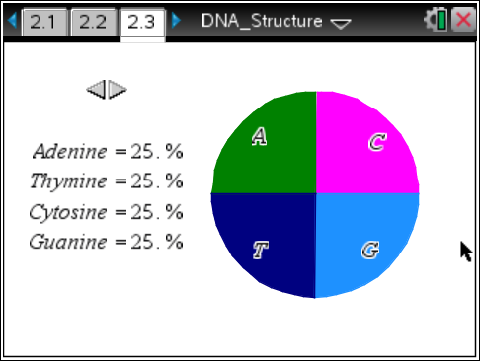
Move to pages 2.4 – 2.6. Answer questions 3 – 5 here and/or in the .tns file.

Q3. Based on Chargaff's rules, which are the correct base pairs? (Select all that apply).

A. Adenine and Thymine
B. Thymine and Cytosine
C. Cytosine and Guanine
D. Guanine and Guanine

Q4. If a DNA molecule is 29% Guanine, what percent will be Thymine?

- 21%
- 25%
- 27%
- 29%

Q5. Are there limits to the amount of any base pair in DNA? For example, can you have DNA that is 52% A? Explain.

Part 3: DNA Structure

Move to page 3.1 – 3.2.
Now that you know more about the overall structure of DNA, you will take a closer look at the nucleotides to understand how each component of the structure influences the function of DNA. When the structure of DNA was solved, it became clear that both strands can be a template to create new DNA strands.

4. Next, you will look more closely at the molecular structure of DNA, including the specific types of molecular interactions and charges on the DNA molecule. When finished reading the Directions Box, select in the top right corner to close the pop-up box. Tap the wrench icon if you need to view the directions again.

Explore this simulation thoroughly before moving on to answer the questions on the following pages.
Move to pages 3.3 – 3.5. Answer questions 6 – 8 here and/or in the .tns file.

Q6. Does DNA have an overall charge? Explain.

Q7. Which structure(s) is/are found in the backbone of DNA? (Select all that apply).

- Deoxyribose
B. Hydrogen bond
C. Base pair
D. Phosphates
Q8. Is the base pair A-T bound more tightly than the base pair G-C? Explain.

Part 4: Base Pairing
Move to page 4.1 – 4.2.
5. Now that you have explored the structure of DNA, you will try to predict DNA sequences. On page 4.2, you will see a sequence of DNA. Use the up and down arrows to select the appropriate base to make a base pair for each base in the sequence. When you have completed all five bases, check your answer by taping the Play button. If you get one or more bases incorrect, press the Pause button to try again. To try a new sequence, select the Reset button.

Move to pages 4.3 – 4.4. Answer questions 9 – 10 here and/or in the .tns file.

Q9. Both strands have the same sequence of DNA.

- True
- False

Q10. One strand of DNA can be used to solve the sequence of its pair.

- True
- False

