Open the TI-Nspire document First_Derivative_Test.tns.  The first derivative test uses the sign of the first derivative to check whether a critical point for a function f is the location of a local maximum, local minimum, or neither. This activity will illustrate how and why the test works. | 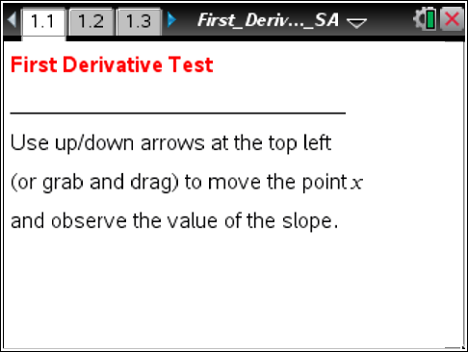

You will want to review these important definitions:
Definition: A function f has a critical point at c if
- the value c is in the domain of the function f (in other words, f(c) is defined) and
- either f′(c) = 0 or f′(c) is undefined.
Definition: A function has a local maximum at c if f(c) ≥ f(x) when x is near c (that is, if f(c) ≥ f(x) for all x in some open interval containing c). Similarly, f has a local minimum at c if f(c) ≤ f(x) when x is near c (if f(c) ≥ f(x) for all x in some open interval containing c).

Move to page 1.2.
1. Each page of problem 1 in the document has a graph of a function with a single critical point.
Tech Tip: Use the up and down arrows to easily change the value of x. Also you can select the value of x and type in the number.
Tech Tip: To change the value of x, tap on the point to highlight it. Then, begin sliding it.
a. Grab the white point on the x-axis and move it to see the slope of the tangent line change as you move along each graph. Complete the table below.

Function  graph on page | Critical point  (and reason why it is a critical point) | Location of local max, local min, or neither | Intervals where slope of tangent line is positive | Intervals where slope of tangent line is negative
1.2 | x =
1.3 | x =
1.4 | x =
1.5 | x =
b. Summarize your findings for the four graphs.

Move to page 2.1.
2. The graph shown here is that of a function with six different critical points indicated on the x-axis (by black dots). Use the up/down arrows at the upper left (or grab and drag) to move the white point along the x-axis and see the slope of the tangent line (when it exists).

a. Explain why each of these marked points is a critical point, and classify each as the location of a local minimum, local maximum, or neither.

Critical  point | Reason why it is  a critical point | Location of local max,  local min, or neither | Describe any change  of sign of f' at x = a
x = –8
x = –6
x = –4
x = –2
x = 1
x = 5

b. Use what you have learned to complete the definition of the first derivative test below:
Suppose f is continuous at the critical point a:
  - If the first derivative f′ changes sign from positive to negative at a, then f(a) is
.
  - If the first derivative f′ changes sign from negative to positive at a, then f(a) is
.
  - If the first derivative f′ does not change sign at a, then f has
.

