Open the TI-Nspire document A_Tale_of_Two_Lines.tns.  How can you take a limit of a quotient when the numerator and denominator are both approaching 0? Simply substituting the limits of the numerator and denominator would result in the nonsensical ratio (called an indeterminate form). This activity will present a powerful method for determining some of these limits that uses geometry and calculus. | 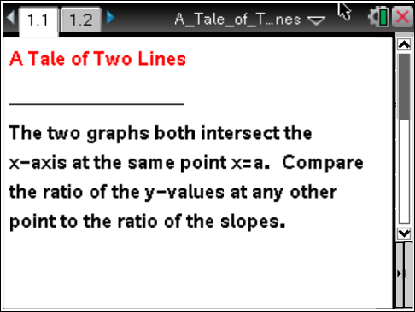

Move to page 1.2.
1. Note that the grid markings on the graph represent the same scale for both x and y. These appear to be the graphs of two linear functions. Call the function with positive slope and the function with negative slope .
a. What is the slope of the graph of f? What is the slope of the graph of g? How do you know?

b. Suppose the intersection point of the two graphs is (a, 0). Use the slope information from part 1a and the point slope form to find expressions for and for that would fit these two linear graphs.

2. Again, note that the grid markings on the graph represent the same scale for both x and y.
a. Use the grid to find the ratio for 4 values of x that are different than x = a.

b. Based on your answer to part 2a, what do you think the limit of is as x approaches a? Explain your reasoning.

3. In question 1, you were asked to find the slopes of the graphs of f and g. What is the ratio of the slope of the graph of f to the slope of the graph of g? How does this compare to the limit you found in question 2?

4. Notice the zooming tool to the left of the screen shows that you are “zoomed in” as much as allowed by the tool. Use the slider to zoom out on the graph.
a. It turns out that these graphs were not straight lines. Why did they look like straight lines when you were zoomed in?

b. The zoomed-in version of the graph allowed us to approximate the slopes of the graphs near x = a. What is another name for the slope of a function at a point?

c. Why does this suggest that is the same as ? Explain your reasoning.

d. Based on your response to part 4b, what is ?

5. What you have seen is the geometry behind something called l’Hôpital’s Rule. L’Hôpital’s Rule states, in part, that for differentiable functions f and g, with and , then = if the limit of the quotients of the derivatives exists. Use l’Hôpital’s Rule to find the following limits, if possible.

