Math Objectives  - Students will determine the domain of rational functions.  - Students will use algebraic concepts to determine the vertical asymptotes of a rational function.  - Students will determine the removable discontinuities of a rational function.  - Students will describe the graph of a rational function given the equation.  - Students will use appropriate tools strategically (CCSS Mathematical Practice).  Vocabulary  - rational function • domain • removable discontinuity  - factors • zeros  About the Lesson  - This lesson involves observing how changing the values in a rational function affects the continuity of the graph of the function.  - As a result, students will:  - Manipulate the factors of the numerator and denominator to observe the effects of changes in the factors.  - Explain how the values in a rational function determine the vertical asymptotes.  - Identify the conditions that must be met for a rational function to have a removable discontinuity.  TI-Nspire™ Navigator™  - Transfer a File.  - Use Class Capture to examine patterns that emerge.  - Use Live Presenter to demonstrate.  - Use Teacher Edition computer software to review student documents.  - Use Quick Poll to assess students’ understanding  Activity Materials  Compatible TI Technologies:  TI-Nspire™ CX Handhelds,   TI-Nspire™ Apps for iPad®,  TI-Nspire™ Software | 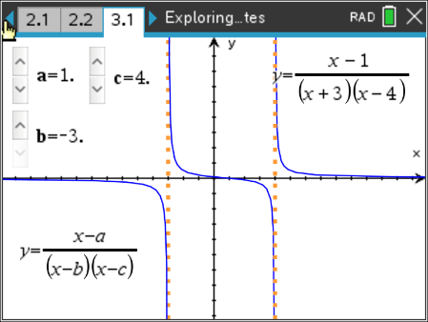  Tech Tips:  - This activity includes screen captures taken from the TI-Nspire CX II handheld. It is also appropriate for use with the TI-Nspire family of products including TI-Nspire software and TI-Nspire App. Slight variations to these directions may be required if using other technologies besides the handheld.  - Watch for additional Tech Tips throughout the activity for the specific technology you are using.  - Access free tutorials at http://education.ti.com/calculators/pd/US/Online-Learning/Tutorials  Lesson Files:  Student Activity  Exploring Vertical Asymptotes_Nspire_Student.pdf  Exploring Vertical Asymptotes_Nspire_Student.doc  Exploring Vertical Asymptotes.tns
Open the TI-Nspire document Exploring_Vertical_Asymptotes.tns  Given the equation of a rational function, will you always be able to determine the domain? In this activity, you will explore vertical asymptotes and removable discontinuities. | 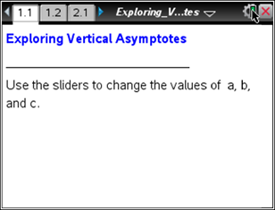

____________________________________________________________________________

Discussion Points and Possible Answers

Tech Tip: Students can self-check their answers to the included assessment questions by selecting MENU > Check Answer > Check Answer.

Tech Tip: Students can self-check their answers to the included assessment questions by selecting > Check Answer.

Move to page 1.2.

1. Use ▲ and ▼ to change the value of a. Describe how the graph changes.

Sample answers: One of the vertical asymptotes moves. The
other vertical asymptote stays the same. When a = b, there is only one vertical asymptote. The forms of the curves bounded by the asymptotes dilate but do not reflect.

2. Use ▲ and ▼ to change the value of b. Describe how the graph changes.

Sample answers: The other vertical asymptote moves, while the first vertical asymptote stays the same. When a = b, there is only one vertical asymptote. The forms of the curves bounded by the asymptotes dilate but do not reflect.

3. What do the values of a and b represent in the function?

Answer: a and b are the zeros of the denominator or the values of x at which the function is undefined.

4. What are the equations of the vertical asymptotes?

Answer: x = a and x = b. When a = b, there is only one asymptote, x = a = b.

TI-Nspire Navigator Opportunity: Live Presenter/Class Capture See Note 1 below.

5. State the domain of the function in terms of a, b, and c.

Answer: $\left(-∞, a\right)∪\left(a, b\right)∪(b, ∞)$ when $a<b$, $\left(-∞, b\right)∪\left(b, a\right)∪(a, ∞)$ when $b<a$,
or $\left(-∞, a\right)∪(a, ∞)$ when $a=b$

6. Use ▲ and ▼ to change the value of c. How does changing c affect the domain?

Answer: Changing c only dilates the curves bounded by the asymptotes. It does not move the asymptotes. Therefore, the domain is not affected.

7. Describe how you could find the vertical asymptotes for any rational function with a constant numerator.

Answer: Factor the denominator. Solve the denominator to find the zeros of the
denominator.

Teacher Tip: Removable discontinuity will be addressed in the next section. Students could discuss the need for the “with a constant in the numerator” qualifier.

Move to page 2.1.

8. Use ▲ and ▼ to set a = 2 and b = –1, and then change the value of c. For which values of c are there no asymptotes? Explain why there are no asymptotes for these values of c.

Answer: When c = b = –1 and c = a = 2, there is no asymptote. The graph looks like a line with a “hole” at x = c = a or x = c = b.
When a = c, the factor (x – a) in the numerator reduces with the factor (x – c) in the denominator, leaving the graph y = x – b. When b = c, the factor (x – b) in the numerator reduces with the factor (x – c) in the denominator, leaving the graph y = x – a.
TI-Nspire Navigator Opportunity: Class Capture See Note 2 below.

9. The “hole” in the graph is called a removable discontinuity. Explain why the hole exists and how you might remove it by modifying the function definition.
Sample answer: The domain of the function is $\left(-∞, c\right) ∪(c, ∞)$. The value of c will always be undefined regardless of the values of a and b. When the value of c does not equal either a or b, there is an asymptote at x = c. However, when c equals either a or b, there is only a hole. If that hole was removed, the graph would be continuous. Suppose that there is a hole at x = c. If the function definition is modified so that f(c) is defined to equal the limit of the function as x approaches c, the discontinuity is removed. For example, in question 10, there is a hole at
x = -6. Since the limit of the function as x approaches -6 is -9, modifying the function definition to include f(-6) = -9 will remove the discontinuity.

Extension: This could be a nice place to discuss limit notation with a hole. $\lim_{x→-6}{f\left(x\right)= -9}$.

Move to page 2.2.
10. Answer the question on Page 2.2.
Describe the graph of the function | 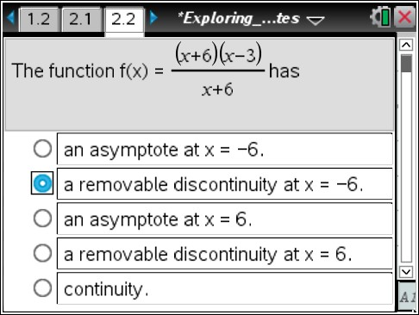  .
Answer: See the screenshot to the right.

TI-Nspire Navigator Opportunity: Quick Poll See Note 3 below.

Move to page 3.1.

11. Use ▲ and ▼ to set b = –1 and c = 4. Then use ▲ and ▼ to change the value of a.
a. Describe how the graph changes as the value of a changes.

Sample answer: The graph bounded by the two asymptotes x = –1 and x = 4 dilates, but the asymptotes do not move. For certain values of a, there is only one asymptote.

b. What is the domain of the function in terms of a, b, and c?

Answer: $\left(-∞, b\right)∪\left(b, c\right)∪(c, ∞)$ when $b<c$ .

Teacher Tip: It is important to note that the domain would be $\left(-∞, c\right)∪\left(c, b\right)∪(b, ∞)$ when $c<b$ or $\left(-∞, b\right)∪(c, ∞)$ when $b=c$.

c. For which values of a is there only one asymptote? Describe the graph at these values.

Answer: When a = b = –1 or a = c = 4, there is only one asymptote. The graph looks like a translation of an inverse variation. There is also a hole (a removable discontinuity).

d. Explain algebraically why the graph looks as it does at these points.

Answer: When a = b, the factor (x – a) in the numerator reduces with the factor (x – b) in the
denominator, leaving the graph $y= \frac{1}{x-c}$ . When a = c, the factor (x – a) in the numerator
reduces with the factor (x – c) in the denominator, leaving the graph $y= \frac{1}{x-b}$. The domain of
the function remains the same regardless of the factors that reduce. When a equals either b or c, there is a removable discontinuity instead of an asymptote.

12. Describe how the domain would change if you changed the values of b and c.

Answer: The domain is $\left(-∞, b\right)∪\left(b, c\right)∪(c, ∞)$ when $b<c$, $\left(-∞, c\right)∪\left(c, b\right)∪(b, ∞)$
when $c<b$, or $\left(-∞, b\right)∪(c, ∞)$ when $b=c$

Teacher Tip: This is a good time to revisit Question 7. Students could discuss how to find the vertical asymptotes for any rational function.

Move to page 3.2.
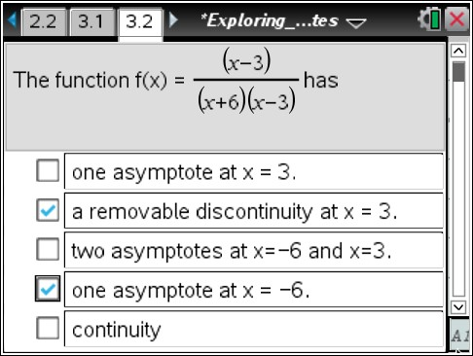
13. Answer the question on Page 3.2.
Describe the graph of the function .
Answer: See the screenshot to the right.
Move to page 4.1.

14. Answer the questions on Pages 4.2 and 4.3.
Holes were discussed in question 9. While manipulating the sliders for a and b on
Page 4.1, what would a and b have to be for f1(x) to have a hole? To have a vertical asymptote?

Answers:
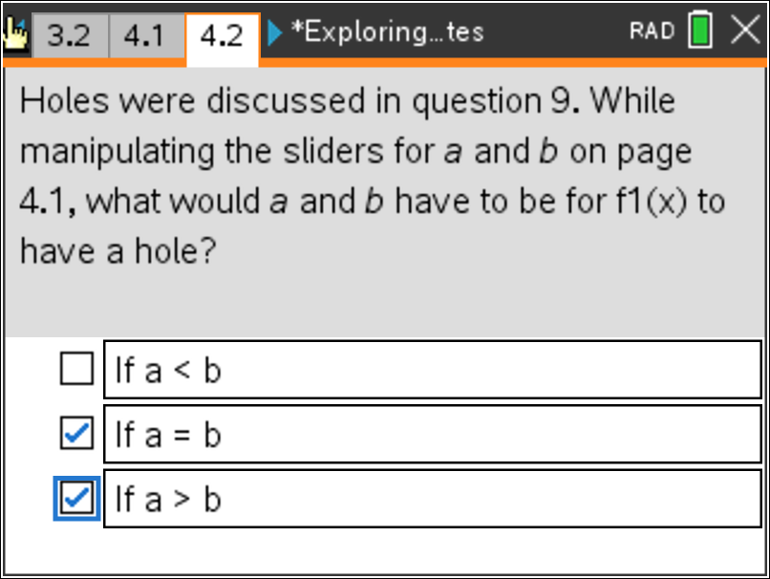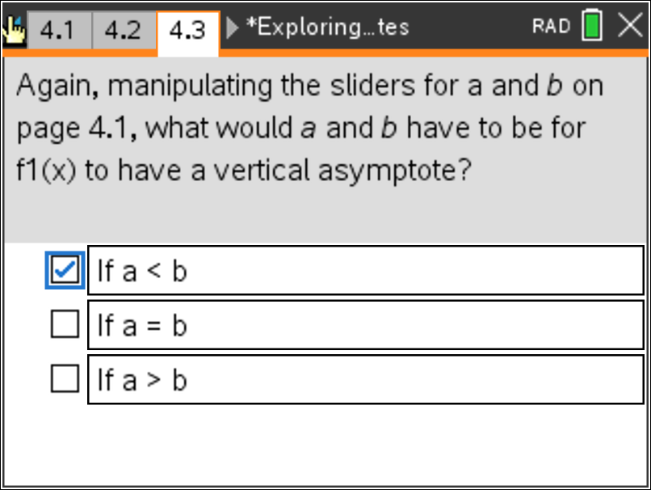

TI-Nspire Navigator Opportunity: Quick Poll See Note 4 below.

Wrap Up
Upon completion of the discussion, the teacher should ensure that students are able to understand:
• How to determine the vertical asymptotes of a rational function.
• What conditions must be true for a rational function to have a removable discontinuity.

Assessment
Embedded questions on Pages 2.2 and 3.2.

TI-Nspire Navigator

Note 1 Question 4, Live Presenter/Class Capture
Choose a student to become the Live Presenter. Have the student demonstrate and explain how he or she found the vertical asymptotes. Discuss the domain for each scenario. This will help students answer Question 5.

Turn off Live Presenter. Turn on the Auto-Refresh feature (30-second intervals might be reasonable).

TI-Nspire Navigator can be used to monitor student progress. You might want to leave Class Capture projected (without student names). This will enable both you and the students to monitor their progress. Alternatively, you might want to turn off the projector so the student screens are visible only to you.

As you circulate around the classroom, frequently check Class Capture to identify students who need help. Use this information to decide whether to provide individual assistance or bring the class together to address what seems to be a common misunderstanding. After the class discussion, students should begin Question 5.

Note 2 Question 8, Class Capture
After most students have found what conditions result in the function having no asymptotes, you might ask students to change the values of a, b, and c. Use Class Capture to show the results of each student.
Ask students to comment on any patterns they may see.

Note 3 Question 10: Quick Poll (Multiple Choice)
Instead of having students self-check, change the teacher settings for this question to exam and send Page 2.2 as a Quick Poll. You can save the results and show a Class Analysis to discuss possible misunderstandings students may have.
If students had difficulty, you can review the concepts covered in Questions 1–9 above. It might be useful to pair students up, assigning students of different abilities to the same group.

After the class discussion, students should go to Page 3.1 and begin Question 11.

Note 4 Question 13: Quick Poll (Multiple Choice)
Instead of having students self-check, change the teacher settings for this question to exam and send Page 3.2 as a Quick Poll. You can save the results and show a Class Analysis to discuss possible misunderstandings students may have.

Note 5
You might want to delete students’ files from their handhelds. If students share handhelds, you will have to resend the documents for your next class.

