Open the TI-Nspire™ document Function_Notation.tns.  In this activity, you will explore function machines. By varying the input, you will see the output of functions such as  f(x) = 2x – 6. You will also investigate principles involving how functions are expressed and what the notation represents. | 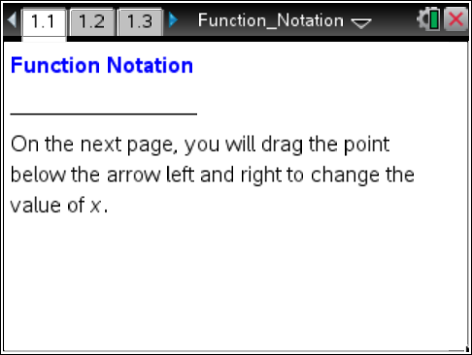

Move to page 1.2.

1. What do x and f(x) represent in the function machine?

Move to page 1.3.

2. Move the point to change the value of x. Use the function machine to complete the table.
Input (x) | Output f(x)
0
2
4
 | 8
–3
 | –14
 | 0

3. a. Given the input variable x, explain the steps the function machine takes to find the output for the rule f(x) = 2x – 6.

b. Use one of the input values from question 2 to show how substitution gives you the same output.

c. Describe why the function machine could be called a substitution machine.

Move to page 1.4.

4. A mystery function is shown.
    - Find h(9).

    - Find h(3).

    - Find a rule for h(x).

    - Use your rule to find h(7).

    - Check your result for h(7) using the function machine.

    - What is h(a)?

5. David says that f(2) means the same thing as f(x) = 2. Do you agree? Why or why not?
6. Given find the following:

a.

b.

c.

d.

e. g(1) + h(1)

f.

