Science Objectives
- Identify the musical notes that make up the combination to a safe.
- Detect the waveform of a musical note, using a Microphone.
- Calculate the frequency of a musical note from the period of its waveform.

Activity Materials
- TI-NspireTM Technology  - Case_3_Name_That_Tune.tns file  - TI-Nspire Lab Cradle |  | - Vernier microphone  - electronic keyboard or tuning forks and a soft tuning-fork hammer
Procedure
Open the TI-Nspire document Case_3_Name_That_Tune.tns.

In this activity, you will analyze sound waves to calculate the frequency, or pitch, of musical notes.
Part 1 – Preparing for Data Collection
Move to pages 1.2–1.5.
1. Read the directions on these pages to become familiar with how to collect the data.

Part 2 – Collecting Data
Move to page 2.1.

2. Connect the microphone to the TI-Nspire Lab Cradle.
musical keyboard
microphone
3. Now your group will collect data to determine the frequency of each note.  - In your group of three, assign the roles so that one person operates the keyboard, the second person holds the microphone, and the third person operates the data collection on the TI-Nspire document.  - Set the keyboard to play a flute tone. |  |  |  | 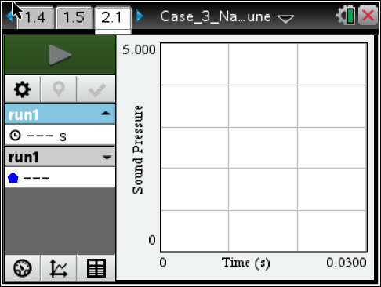
- Produce the first note to study, C. Hold the tone steady for a second or two (until the waveform appears on the screen).

- Hold the microphone about 1 cm from the keyboard speaker. Start the data collection by pressing .

- Store each run (data collection of one note) by pressing  before you move onto the next note! You should see a color change and the run box (on the left side of the screen) should change to “run2.”

Note: The waveform on the screen should look like one of the waveforms in the Sample Evidence section of this activity sheet. If it does not, reposition the microphone and repeat data collection — it will overwrite your present note if you have not stored it.
Note: You can collect the data with tuning forks if a keyboard is not available. If using tuning forks, be sure not to hit them too hard as the pattern will not be smooth.
Part 3 – Analyzing the Data
4. Once you have collected suitable data, you are ready to analyze the waveform to calculate the period and the frequency (or pitch) of the note.
- Start with run 1. Press the run box. When the drop-down list appears, choose run1.

- To analyze the data, press b and select Analyze > Interpolate. Where you click on the graph, data will appear on the left side-panel.

- Click the crest of the first waveform and record the time. Then click the crest of the last waveform and record the time. Subtract to find the difference in time, ∆t value, between the crest of the first waveform and the crest of the last waveform. Divide the difference, Δt, by the number of cycles to determine the period of the waveform.

Note: If the cycles are too close together, you can zoom in on an area by pressing b and select Graph > Zoom In.

- Record the period, T, (to three significant figures) in your Evidence Record. For example, 0.00230 has three significant figures.

e. Calculate the frequency, f, of the note using the equation f = . Record the frequency of the note in the Evidence Record. The unit for frequency is s^{–1} or hertz (Hz). One hertz equals one cycle per second.

5. Repeat Step 3-4 for the remaining notes. Use the figure below as a reference point to locate the notes. The musical notes are also identified with a subscript number indicating what octave they are in, such as C₄.
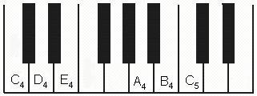
Evidence Record
Note | Period, T  (sec) | Frequency, ƒ  (cycles/sec or Hz)

6. Calculate the period and frequency of each of the notes in the Sample Evidence section of this activity sheet, using the ∆t values shown for each set of waveforms.

7. Compare the frequencies of the notes recorded in the Evidence Record to the frequencies of the notes found on Evans’s computer hard drive. Determine the combination of notes that was stored on the hard drive.

Sample Evidence
Notes from Mr. Evans’s Computer Hard Drive
First note  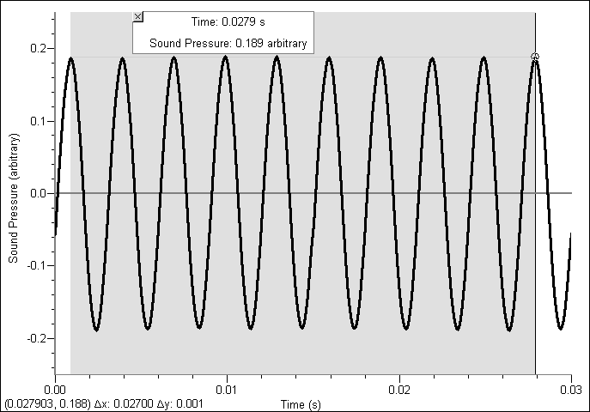  Period: ____________  Frequency: ___________  Note: ____________ | Second note  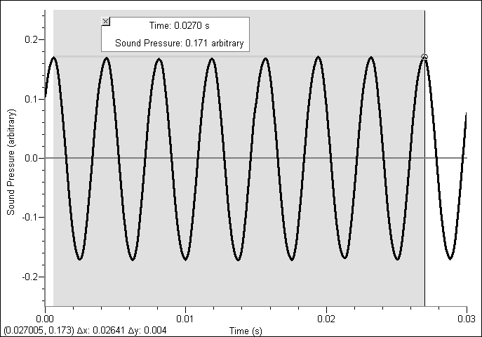  Period: ____________  Frequency: ___________  Note: ____________
Third note  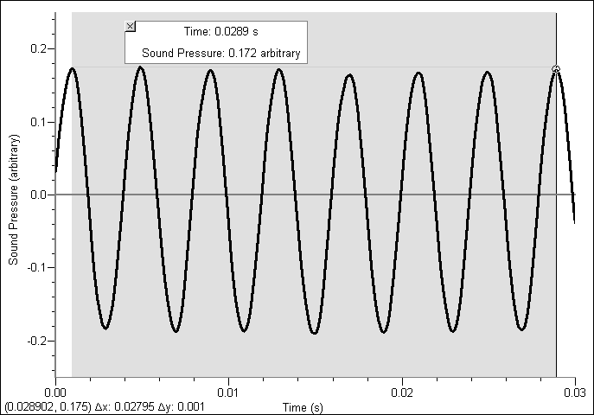  Period: ____________  Frequency: ___________  Note: ____________ | Fourth note  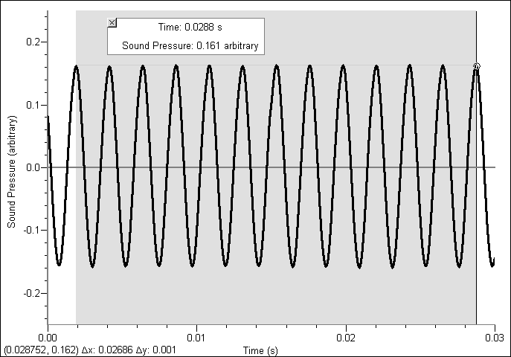  Period: ____________  Frequency: ___________  Note: ____________
Fifth note  Period: ____________  Frequency: ___________  Note: ____________ | Sixth note  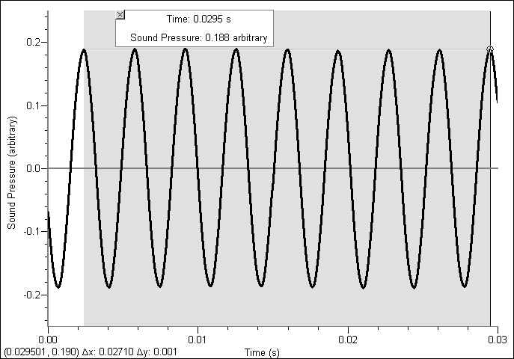  Period: ____________  Frequency: ___________  Note: ____________
Order of tones in Evans’s hard drive, using the musical notes:__________________________

Case Analysis
Move to pages 3.1 – 3.7.
Answer the following questions in the .tns file, here on the activity sheet, or both.
Q1. In Step 4, you measured the time between two crests in the waveform of each note. Could you have determined the frequency from two adjacent troughs (low points) in the waveforms? Explain why the period and frequency of a waveform calculated using the time between two crests are the same as when using two troughs.

Q2. Like all waves, sound waves have a frequency and a wavelength. The speed of sound in air is about 340 m/s. Frequency is measured in cycles per second. Speed is measured in meters per second. Wavelength is measured in meters. Using this information, write an equation that shows how you can calculate the wavelength of a wave if you know its frequency and speed.

Q3. Using the equation you wrote for Question 2, calculate the wavelength of each of the notes produced by the tuning forks in your Evidence Record. Show all your work.

Q4. Using the equation you wrote for Question 2, explain how frequency and wavelength are related.

Q5. The police determined that the correct combination for the safe corresponded to the following order of wavelengths: E₄, C₅, B₄, A₄, C₄, D₄.
Did Evans record the safe combination, or was his recording of another combination of notes? How do you know?

