Open the TI-Nspire document Hit_the_Target.tns.  In this activity you will explore the horizontal distance traveled by a marble after rolling down a ramp and off a table. Based on the data you collect, you will develop a model that will relate: 1. the horizontal distance traveled by the marble (the range) to the distance it rolls down the ramp, and 2. the angle of the ramp. Once you have developed your model, you will be challenged to use your calculations to hit a target on the floor on the first attempt. | 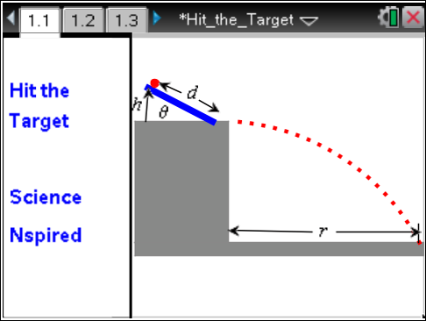

Materials
- marble
- ruler with a center groove or an alternate flat surface to use as a ramp
- carbon paper or an alternate method for marking the landing spot of the marble
- plumb line (a weight hanging from a string)
- meterstick or measuring tape
- paper, pencil, and tape
Procedure
1. Prop up the ramp so that the lower end of the ramp is near the edge of the table.
2. Measure the length of the ramp, L, and the height, h, of the upper end from the table surface.
3. Calculate and record the angle of the ramp using . Make sure your TI-Nspire™ is in degree mode. To check, from the handheld Home screen choose Settings > Document Settings. Make sure the Angle setting is Degree and not Radian.
Tech Tip: To check the angle setting, select . The Document Settings menu will appear. Make sure that the Angle setting is Degree and not Radian.
4. Place the marble on the ramp. Allow it to roll down the ramp to get a general idea where it will hit the floor. Tape a piece of paper to the floor at this location. If you have carbon paper, lay it with the carbon side down on top of the paper taped to the floor. If you have another method for marking the landing spot of the marble, prepare it.
5. Return the marble to the ramp. Measure and record the distance along the ramp from the bottom of the ramp to the place where the marble is released. This is the “release distance.” Release the marble so that it rolls down the ramp, rolls off the table, and hits the floor. Verify that the marble left a mark on the paper taped to the floor.
6. Use the plumb line to mark the point on the floor directly below the place where the marble leaves the table. Carefully measure and record the distance from this point to the location where the marble hits the floor. This is the range of the projectile.
7. Systematically vary the release distance and the angle of the ramp. Remember to change one variable at a time. Carefully record the angle of the ramp, the release distance, and the range of the projectile for each trial. Test several release distances for each angle. Complete enough trials that you have a wide variety of ranges for the projectile.

Analysis
Move to pages 1.2 and 1.3.
1. Record the data in the Lists & Spreadsheet on page 1.2. The variables are represented as follows: θ stands for the angle of the ramp, d stands for the release distance up the ramp, and r stands for the range of the projectile. The spreadsheet is set up so that you may enter several different data sets. For example, you can organize your data so that the measurements for each angle form a separate data set. In this case, all of the angles in a particular column will be the same. This will allow you to make separate range vs. release-distance graphs for each angle. You may add columns as needed.
Tech Tip: To add or modify the data in a spreadsheet cell, double-tap the cell. The keyboard will appear. Enter the numerical value and then select enter.
Move to pages 1.4 and 1.5.
2. This Graphs page allows you to view all of your data sets at once. You may add data sets if needed by expanding the entry line near the lower left corner of the screen. The page is set up to plot the range of the projectile on the y-axis and the release distance up the ramp on the x-axis. You may wish to add a label beside each data set to identify the corresponding ramp angle.
Tech Tip: You may need to adjust the view to see all of the data. Select Menu or  > Window/Zoom > Zoom-Data.
Move to pages 1.6–1.8.
3. These pages are Data & Statistics pages, which you may use to analyze your data sets individually. You will find some analysis tools to help you by selecting Menu > Analyze. Develop a mathematical model that allows you to relate the range of the projectile to the release distance up the ramp and the angle of the ramp. Record your model here:

Tech Tip: To access the analysis tools, select > Analyze. You may need to back-out to the main Tools Menu to see the desired menu option.
4. Inform your teacher when you have developed your model. Your teacher will give you give you a target to hit on the floor. Measure the range to the target, and record it here:

Range to Target: ___________________

Use the model from your analysis to determine: 1. the angle of the ramp and 2. the release distance up the ramp needed to make the projectile hit the target. Record your values here:

Ramp angle, θ: ___________________

Release distance, d: ___________________

If you have collected sufficient data and analyzed it appropriately, you should be able to hit the target on the first try.
5. Write a report explaining your data analysis and the results of your test. If you did not hit the target, report the amount of error, discuss likely sources of error, and suggest ways to improve.

