Open the TI-Nspire document Interactive_pH_Titation.tns.  What are the features of a pH titration curve? In this activity you will be able to interact with a weak acid-strong base titration curve. You will vary the acid ionization constant, the initial concentration of the weak acid, and the initial concentration of the weak base. You will discover the characteristics of the pH curve, including the equivalence point and the “half-way” point. | 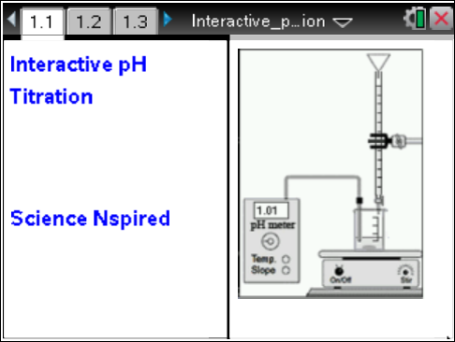

Move to pages 1.2 and 1.3. |  | Press / ¢ and / ¡ to navigate through the lesson.
Read the introduction. Familiarize yourself with the variable names and parameters for the titration: Ka is the ionization constant of the weak acid, ca0 is the initial concentration of the weak acid, cb is the concentration of the strong base (cb is set by multiplying ca0 by a factor 0.75, 1.0, or 2.0). The initial volume of the weak acid solution is 50 mL. |  | 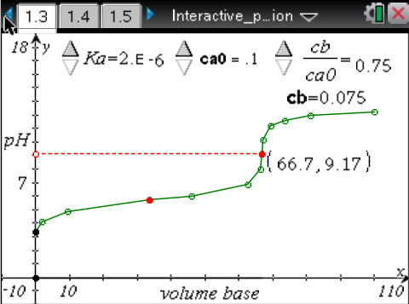
Move to pages 1.4–1.11. Answer the following questions here or in the .tns file.
Q1. Adjust the three sliders on page 1.3 one at a time. Observe how the pH titration curve changes with each parameter. In the space below, record your observations on how changing the various parameters affect the curve.

Q2. What is the significance of the solid data point in the steep part of the titration curve (connected to the dotted horizontal line)?

Q3. The initial pH __________.
A. is equal to 7.0  B. depends only on Ka | C. depends on Ka and ca0  D. depends on Ka, ca0, and cb
Q4. Increasing Ka corresponds to a _____ acid and a _____ initial pH.
A. stronger, higher  B. stronger, lower | C. weaker, higher  D. weaker, lower
Q5. The pH at the equivalence point __________.
A. is equal to 7.0  B. depends only on Ka | C. depends on Ka and ca0  D. depends on Ka, cao, and cb
Q6. Write an equation to determine the volume of base vbeq at the equivalence point in terms of ca0, cb, and the initial volume of acid va0.

Q7. What is the significance of the pH at the solid data point in the flat part of the titration curve?
Hint: pKa = – log Ka.

Q8. What volume of base corresponds to this data point?

Q9. In the region around this data point, the pH changes ________ with the volume of base. This region is known as the "buffer region" of the titration curve.
A. rapidly | B. slowly

