Open the TI-Nspire document Areas_of_Polygons.tns.  The area of a polygon can be quickly calculated when certain measurements are given. What if only the locations of the vertices are known? In this activity, you will use matrices to calculate the areas of triangles and convex polygons. | 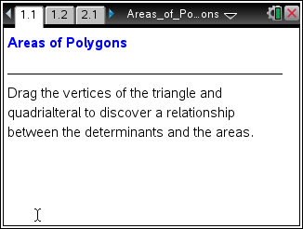

Move to page 1.2. | Press / ¢ and / ¡ to navigate through the lesson.
1. A triangle is given. The coordinates of each vertex are linked to the x- and y-values in the first two columns of the matrix.
- Drag any of the vertices to form a right triangle. What is the base and height of your triangle? Explain how those values justify the area. Show the formula with values used.

- Drag any vertex on the triangle. What values change in the upper and lower parts of the page?

- What is the relationship between the determinant and the area of the triangle?

- Why does the matrix have 1’s in the third column?

e. Michael says the value of his determinant is –10, so the triangle has an area of –5. Is he correct?

f. What does it mean when the value of the determinate expression is 0? Confirm your answer by dragging the vertices of the triangle until the determinant expression equals zero.

Move to page 2.1.

2. A quadrilateral that has been divided into two triangles is given. The coordinates of each vertex are linked to the x- and y-values of the matrix.

a. Drag any of the vertices to form a rectangle or square. What is the base and height of your rectangle or square? Explain how those values justify the area. Show the formula with values used.

b. What values change when you drag any vertex on the quadrilateral?

c. What is the relationship between the determinant and the area of the quadrilateral?

d. Does the method work if the quadrilateral is concave? Try it.

3. How would this method be used to find the area of a convex pentagon?

