Open the TI-Nspire document Exploring_Expressions.tns.  Substituting different values for variables results in different values for an algebraic expression involving those variables. In this activity, you’ll use a number line to change the value of variables and investigate the resulting changes in an algebraic expression. | 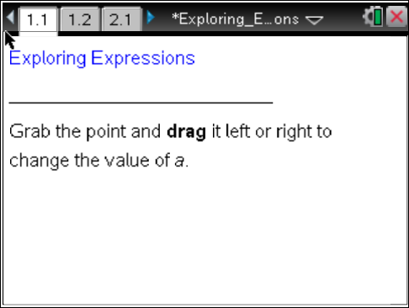

Move to page 1.2. | Press / ¢ and / ¡ to navigate through the lesson.
1. As you grab the point and move the arrow beneath the number line, what numbers change? What numbers stay the same?

2. Move the point until a = 4. How does the value of the expression 2(a) + −7 change as you move the point from a = 4 to a = 5?

3. What value of a would make the expression exactly equal to 0?

Read page 2.1. Then move to page 2.2.

4. Move the two points so that a is positive (a > 0) and b is positive (b > 0):
a. Is the value of the expression 5a + 4b positive or negative?

b. Is this true for all positive values of a and b? Why or why not?

5. Move the two points so that a is negative (a < 0) and b is negative (b < 0):
a. Is the value of the expression 5a + 4b positive or negative?

b. Is this true for all negative values of a and b? Why or why not?

6. Is it possible for the value of 5a + 4b to be negative if a and b have opposite signs? Why or why not?

7. Move the points so that a = −2 and b = 3:
a. If the value of a is increased by 1, how does the value of 5a + 4b change?

b. Would your answer to part 7a still be the same if you started at a different value of a? Why do you think so? Explain your answer.

8. Move the points so that a = −2 and b = 3:
a. If the value of b is increased by 1, how does the value of 5a + 4b change?

b. Would your answer to part 8a still be the same if you started at a different value of b? Why do you think so? Explain your answer.

9. If you had the expression 3a + 4b and increased the value of the variable a by 1, how would the value of the expression change?

10. Is it possible to write an expression for which an increase in the value of a would cause the value of the expression to decrease? If so, give an example of such an expression. If not, explain why it is not possible.

