Open the TI-Nspire™ document Conserv of Momentum Lab.tns.  Why is it when you’re skateboarding and the board hits a curb you keep going even though the board stopped? If you’re moving faster on the board, do you go farther? In this experiment, we will try to quantify this experience and give you tools to predict the outcomes. | 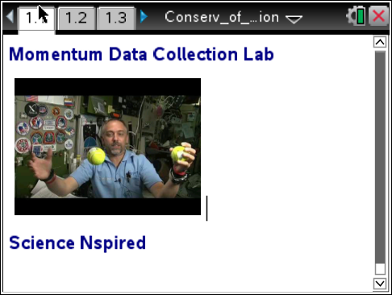

Move to page 1.2.

1. Acquire two dynamic carts and CBR 2™’s. Connect the CBR 2’s to the carts and determine the mass of the carts.
2. Double-click on mcart1:= and replace zero with the mass of Cart 1 and CBR 2.
3. Repeat for Cart 2.

Move to page 1.3.

4. Load the spring on the spring cart, and place both carts on the track.
5. Aim the CBR 2’s toward the end of the track that they will be traveling toward.
6. Place an object at each end of the ramp to act as a target for the CBR 2 signals.

Move to page 1.4.

7. Connect the CBR 2 to the TI-Nspire™ Lab Cradle.
8. Move to the DataQuest page.

Move to page 1.5.

9. Press the carts against one another.
10. Press the Start button, and release the carts.
11. When the carts get to the end of the ramp, stop sampling by clicking on the Stop button.
11. Select the region of the graph where the carts were traveling down the track.
- On the DataQuest graph, click on the line where the cart starts moving, drag to where it ends, and click again to select the region.
- Select Data > Strikeout > Outside selected region.
12. Perform a linear curve fit on this region of each graph.
Move to page 1.7.
13. The slope of the line represents the __________.
- Distance the cart traveled.
- The time the cart traveled.
- The velocity of the cart.
- The acceleration of the cart.

Move to page 1.8.

14. Enter the velocity of Cart 1 into vcart1:= and the velocity of Cart 2 into vcart2:= on the momentum page.

Move to page 1.9.

15. Calculate the momentum of each cart.

Move to page 1.10.

16. How does the velocity of Cart 1 compare to Cart 2?

Move to page 1.11.

17. How does the momentum compare between Cart 1 and Cart 2?

Move to page 1.12.

18. If the mass of Cart 1 is doubled, what should happen to the velocities of the carts?
- Cart 1 will travel faster than Cart 2.
- Both carts will travel at the same velocity.
- Cart 1 will travel slower than Cart 2.
- With the given information, it cannot be determined.

Move to page 1.13.

19. If the mass of Cart 1 is doubled, the momentum ___________.
- Of Cart 1 will be great than 2.
- Of Cart 2 will be great than 1.
- Will be the same for both carts.
- Cannot be determined with the information given.

