Open the TI-Nspire document Polar_Conics.tns.  In this activity, you will explore how to express an ellipse, a hyperbola, and a parabola from a single equation and investigate the different parameters of the equation. | 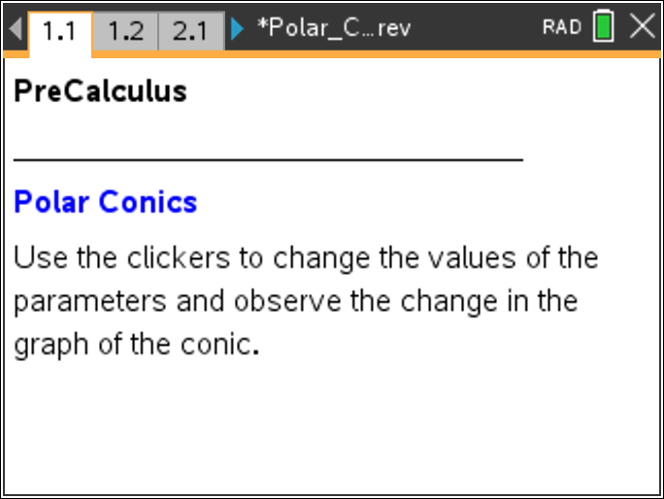

A conic is defined as the locus of points in a plane whose distance from a fixed point (focus) and a fixed line (directrix) is a constant ratio. This ratio is called the eccentricity, e, of the conic. The polar notation for the ellipse, hyperbola, and parabola is given by the equation:
OR
where e is the eccentricity and d is the distance from the origin to the directrix.

By expressing the equation in polar coordinates, we can generate all three types of conics from a single equation.

Move to page 1.2. | Press / ¢ and / ¡ to navigate through the lesson.
1. Use the clicker to change the values of the eccentricity, e. For what values of e is the conic a parabola? An ellipse? A hyperbola?

Move to page 2.2.

2. Use the clicker to change the values of d, the distance between a point on the conic and the directrix.
a. Set e = 1. When the conic is a parabola, what effect does d have on the graph of the function?

b. Set e < 1. When the conic is an ellipse, what effect does d have on the graph of the function?

c. When the conic is a hyperbola, what effect does d have on the graph of the function ?

3. Adjust the parameters to create an ellipse that is 9 units in width, and make a note of those parameters. Are these the only parameters that will create such an ellipse? Explain.

4. Adjust the parameters to create a hyperbola for which the vertices of the branches are 6 units apart, and make a note of those parameters. Are these the only parameters that will create such a hyperbola? Explain.

Move to page 3.2.

5. Use the clicker to adjust the value of a, the phase shift.
a. Set e = 1. When the conic is a parabola, what effect does a have on the graph of the function?

b. Set e < 1. When the conic is an ellipse, what effect does a have on the graph of the function?

c. Set e > 1. When the conic is a hyperbola, what effect does a have on the graph of the function?

6. Is it possible to adjust the values of a and e so that the resulting conic is a parabola centered about the y-axis? If so, what parameters yield this result? If not, explain why not.

7. Which type of conic will result from each of the following equations? How do you know?
a.
b.
c.

