Open the TI-Nspire document Concave_Mirrors.tns.  When you go to a fun house, why do the mirrors make you larger or smaller or upside down? In this activity we will be exploring one type of curved mirror, concave, which “holds water.” | 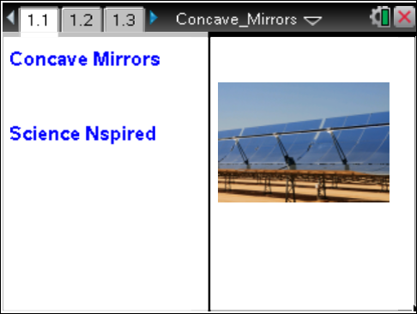

In this activity you will be exploring the production of images and virtual images that are created when an object is moved along the principal axis of a concave mirror. A real image forms when the image is on the same side of the mirror as the object. Carefully note the position of the focal point (fp) and where the image forms when the object is on either side of fp. Also observe what happens exactly at the focal point. |  | Press / ¢ and / ¡ to navigate through the lesson.
Move to page 1.2.
1. Read the instructions for the simulation.
Move to page 1.3.  2. Grab the base of the object arrow and move it toward the concave mirror to observe the effect on the image. |  | 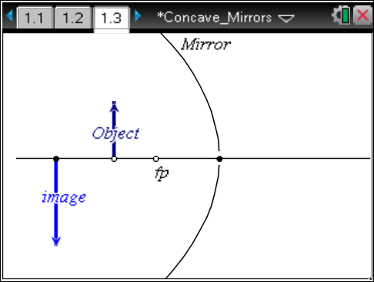
Move to pages 1.4–1.10. Answer the following questions here or in the .tns file.
Q1. Describe the image formed when the object is farther than the focal point (fp) is from the mirror.

Q2. Describe the image formed when the object is between the focal point and the concave mirror.

Q3. What are the relative positions of the focal point, object, and mirror when the image formed by a concave mirror is a real image?

Q4. What are the relative positions of the focal point, object, and mirror when the image formed by a concave mirror is a virtual image?

Q5. What are the relative positions of the focal point, object, and mirror when the image is smaller than the object?

Q6. What are the relative positions of the focal point, object, and mirror when the image is the same size as the object?

Q7. What are the relative positions of the focal point, object, and mirror when the image formed by a concave mirror is larger than the object?

Move to pages 2.1 and 2.2.
3. Read the instructions for the simulation on page 2.3. The simulation displays the distance to the focal point (f), the height of the object (H_{o}), the distance between the object and the focal point (S_{o}), the height of the image (H_{i}), and the distance between the image and the focal point (S_{i}).
Move to page 2.3.
4. Move the object by dragging the bottom point. Press /^ to capture the values for f, H_{o}, S_{o}, H_{i} and S_{i}. Continue to move the Object and capture data. Make sure to capture some data between the focal point and the mirror. Collect data for 10 to 15 locations of the Object. |  | 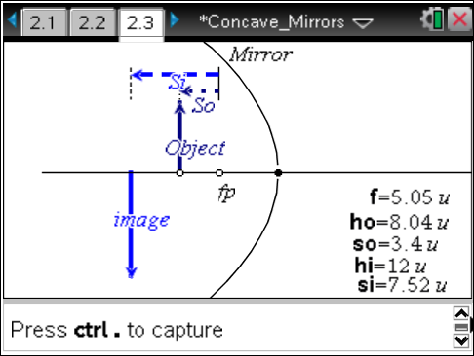
Move to pages 2.4 and 2.5.  5. Select the variables Imgd and objd in columns A and B of the spreadsheet. Graph the image distance (Imgd) vs. the object distance (objd). |  | 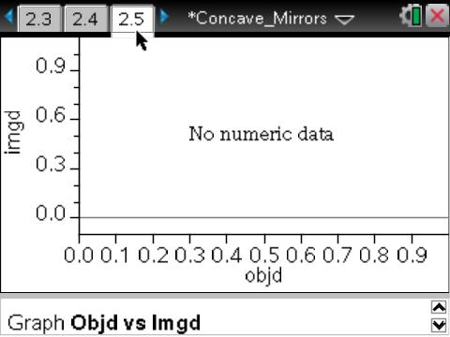
Move to pages 2.6 and 2.7. Answer the following questions here or in the .tns file.
Q8. Describe the relationship between the object distance (objd) and image distance (imgd)
(S_{o} and S_{i}).

Q9. Write the equation for the curve that best fits your data.

Move to pages 3.1–3.4.
6. Adjust the focal length of the mirror by moving point fp to a new location. Try your best to get it very near a whole number. Adjust the Object and capture the data again. Find the best fit equation for the data after it is generated.  7. Graph image distance (imgd) vs. object distance (objd). | 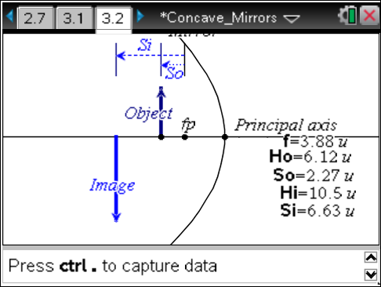
Move to pages 3.5 and 3.6. Answer the following questions here or in the .tns file.
Q10. How is the focal point represented in the equation generated for the graph?

Q11. Write the equation that fits your new data set in terms of S_{o}, S_{i} and f.

Move to pages 3.7–3.10.
The magnification of an object is the ratio of the image height to the object height:
H_{i}/H_{o} = Magnification
8. On page 3.9, use column F to calculate the magnification of each data point collected. Assign this column to the variable mag. Then make a graph of magnification (mag) vs. object distance (objd) on page 3.10. | 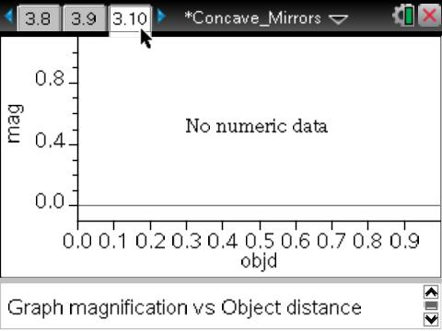
Move to pages 3.11–3.13. Answer the following questions here or in the .tns file.
Q12. How is magnification affected by the Object’s distance from the focal point?

Q13. What is the equation for the best fit curve for magnification vs. object distance?

Q14. How does changing the position of the focal point affect the magnification?

