Science Objectives  - Students will discover that the hydrologic cycle is an interaction among the atmosphere, the hydrosphere, and the lithosphere.  - Students will identify which of the three states of water exist in the different phases of the hydrologic cycle.  - Students will change the average global atmospheric temperature to observe resultant effects on sea level and the number of heavy precipitation (storm) events.  Vocabulary  About the Lesson  - Students will use an interactive model of the hydrologic cycle to observe which states of water exist in each phase.  - Students will change average global atmospheric temperature using a slider to observe the effects on sea level and storm events.  - As a result, students will:  - Be able to identify which states of water could be present in five phases of the hydrologic cycle.  - Understand that the amount of water in the hydrologic cycle remains constant.  - Understand the consequences of global warming on sea level and storm events.  TI-Nspire™ Navigator™  - Send out the The_Water_Cycle.tns file.  - Monitor student progress using Class Capture.  - Use Live Presenter to spotlight student answers.  Activity Materials  - Compatible TI Technologies:  TI-Nspire™ CX Handhelds,   TI-Nspire™ Apps for iPad®,  TI-Nspire™ Software |  | 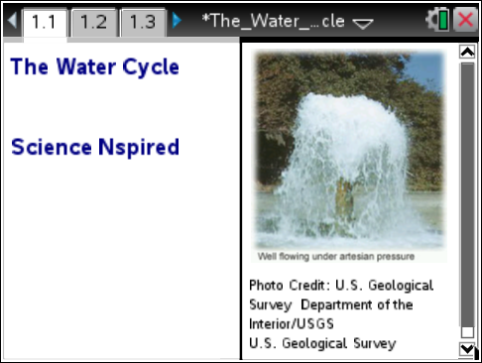  Tech Tips:  - This activity includes class captures taken from the TI-Nspire CX handheld. It is also appropriate for use with the TI-Nspire family of products including TI-Nspire software and TI-Nspire App. Slight variations to these directions may be required if using other technologies besides the handheld.  - Watch for additional Tech Tips throughout the activity for the specific technology you are using.  - Access free tutorials at http://education.ti.com/  calculators/pd/US/Online-Learning/Tutorials  Lesson Files:  Student Activity  - The_Water_Cycle_Student  .doc  - The_Water_Cycle_Student  .pdf  TI-Nspire document  - The_Water_Cycle.tns
  - hydrosphere | - precipitation
  - lithosphere | - infiltration
  - atmosphere | - runoff
  - condensation | - phases
  - evaporation
Discussion Points and Possible Answers
Have students read the background information stated on their activity sheet.

Move to pages 1.2 – 1.4.
Have students answer questions 1 - 3 on the device, the activity sheet, or both.
Q1. Water stored in the ground is part of the hydrologic (water) cycle. True or False?

Answer: true

Q2. Condensation is when air turns into a liquid. True or False?

Answer: false

Q3. There is less water on Earth now than there was 500 years ago. True or False?

Answer: false

Move to page 1.5.  1. Using the touchpad or mouse, students will tap or move the cursor over the picture to see 5 phases of the hydrologic cycle. They should watch the movement of the water in its different states, read the descriptions, and think about in which states water might be present during each phase of the cycle. | 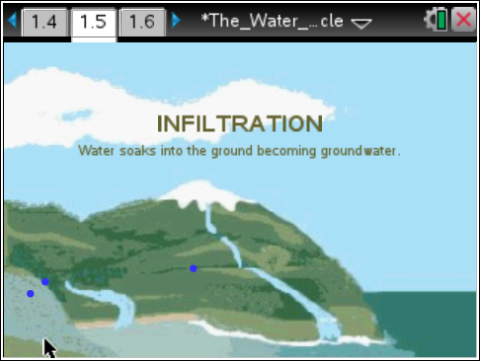
States of water:
- Blue solid circles = liquid water
- Open circles with white outlines = gas
- Open circles with blue outlines = water vapor changing state into tiny water droplets
- Short dashes = water in liquid and/or solid form

NOTE: Transpiration, while an integral part of the cycle, is not represented in this simulation.

Tech Tip: To observe the five phases of the hydrologic cycle, have students tap various parts of the screen to reveal the text.
Tech Tip: To access the Directions again, have students select b or Document Tools () > The Water Cycle > Directions.
Tech Tip: To access the Directions again, have students select > Directions.
Move to pages 1.6 – 1.11.
Have students answer questions 4 - 9 on the device, the activity sheet, or both.

Q4. In which state or states does water exist during precipitation?

Answer: D. liquid or solid

Q5. In which state or states does water exist if it has been condensed?

Answer: C. liquid

Q6. Clouds are made of ___________.

Answer: A. liquid

Q7. Into which state or states is water changing during evaporation?

Answer: C. gas only

Q8. In which state or states does water exist during infiltration?

Answer: B. liquid only

Q9. Can water exist as a solid in the atmosphere?

Answer: Yes

Move to pages 2.1 – 2.3.
Have students answer questions 10 and 11 on the device, the activity sheet, or both.

Q10. If the average global atmospheric temperature increases, what do you predict will happen to sea level?

Answer: A. The sea level will rise.

Q11. Predict what might happen to the severity of storms as the average global atmospheric temperature increases.

Answer: A. Storms would become more severe.

Move to page 2.4.  2. Have students read the directions for the simulation on page 2.4. In this simulation, students will change the average global atmospheric temperature to observe the effect on sea level and severity/occurrence of storms.  This simulation uses the 20th Century average of 14.8°C (58.6°F) with an EPA predicted 6°C (11°F) increase over the next 100 years. | 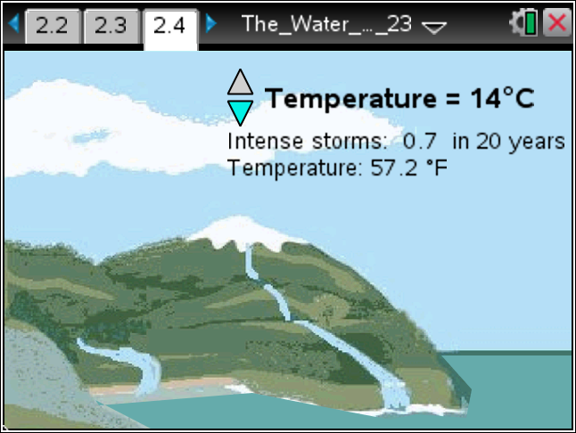
Move to pages 2.5 – 2.9.
Have students answer questions 12 - 16 on the device, the activity sheet, or both.

Q12. What happens to the sea level as the average global atmospheric temperature increases?

Sample Answer: The sea level increases.

Q13. Which of the following is a plausible hypothesis for the increase in sea level?

Answer: B. The ice, snow, and permafrost stored in the hydrologic cycle are melting.

Q14. Based on this simulation, what is predicted to happen to the number of intense storms as the global average temperature increases?

Answer: A. Increase in number

Q15. What do you think is happening to the rate of evaporation and condensation as the average global atmospheric temperature increases?

Sample Answer: The rates of both are increasing which in turn increases the frequency and severity of precipitation events.

TI-Nspire Navigator Opportunities

Make a student a Live Presenter during a whole class review of the stages in the hydrologic cycle. Use Class capture to monitor students’ progress through the lesson. Use quick poll to send formative assessment questions during the lesson.

Wrap Up
When students are finished with the activity, retrieve the .tns file using TI-Nspire Navigator. Save grades to Portfolio. Discuss activity questions using Slide Show.

Assessment
- Formative assessment will consist of questions embedded in the .tns file. The questions will be graded when the .tns file is retrieved. The Slide Show will be utilized to give students immediate feedback on their assessment.
- Summative assessment will consist of questions/problems on the chapter test or a performance assessment where students diagram, label and explain how water moves in the hydrologic cycle. Use of the RAFT (Role, Audience, Format, Topic) strategy: Have students write journal entries from the perspective of a water drop traveling with her friends on a trip through the hydrologic cycle.

