Open the TI-Nspire document build-an-atom_HS.tns.  In this lesson you will manipulate an atom’s composition and observe the change in the atom’s identity, stability, overall charge, size, and atomic symbol. |  | 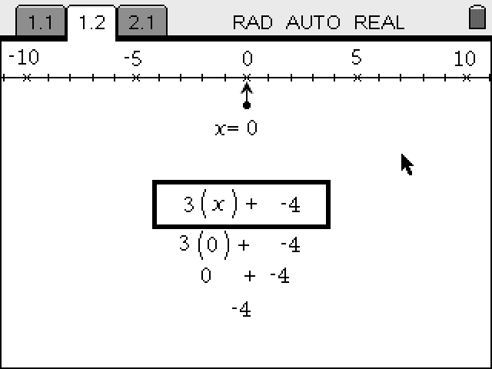  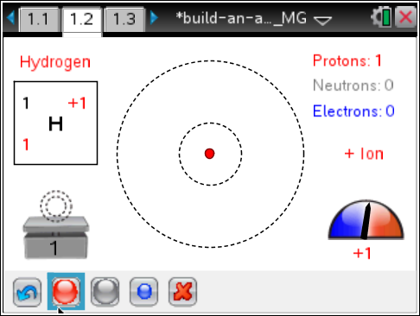
The Bohr atomic model, introduced by Niels Bohr in 1913, describes an atom as a positively charged nucleus comprised of protons and neutrons surrounded by electrons. In this model, electrons orbit the nucleus in circular paths at different distances called electron shells. This model became popular because it fit the experimental results for Hydrogen. Later, the application of the model to heavier atoms explained some of the properties of elements as demonstrated in the Periodic Table of Elements. The model is useful for explaining similarities between different ions (positively or negatively charged atoms) and isotopes (atoms with the same number of protons but different numbers of neutrons). Scientists use the atomic symbol, , where Z is the mass number, A is the atomic number, and C is the net charge of the atom. Thus element symbol, X, is modified by the use of superscripts to specify a particular isotope of the given element and with a subscript indicating the number of protons, defining the element. Additionally, superscripts may be used to indicate the ionization or oxidation state of an element.

Move to page 1.2.
On this page you can add protons, neutrons and electrons to build an atom and observe the relationship between the number of particles and the properties of the atom. Select to add a proton. Select to add a neutron. Select to add an electron. To remove the particle, select the proton, neutron, or electron and then useto remove. In this simulation, the mass number, the net charge, and the atomic symbol automatically update. The simulation will also show the properties of the atom you constructed: whether it is an ion or neutral atom, and when the atom is unstable.
Part 1: Identity of the Element
1. Create atoms with various combinations of protons, neutrons, and electrons, and observe what changes and what remains the same. Record you observations for each combination in the table on the next page.
Number of Protons | Number of Neutrons | Number of Electrons | Atomic Symbol | Atomic Number | Mass Number

Q1. What happens when you change the number of protons keeping the numbers of other particles the same?

Q2. What happens when you change the number of neutrons keeping the numbers of other particles the same?

Q3. What happens when you change the number of electrons keeping the numbers of other particles the same?

Q4. Based on your observations, answer the following questions about the parts of the atomic symbol:
a. What is atomic number?

b. What is mass number?

c. What is the net charge?

Part 2: Nucleus Stability
2. Reset 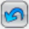 the simulation. Now you will explore the relationship between the protons and neutrons for the nucleus as they relate to the stability of the atom. Start with one proton and then add neutrons one at a time, recording all stable combinations (isotopes) in the table below. Continue the simulation until you use all available protons. The first two rows of the table are completed for you as an example.
Element | Number of Protons | Number of Neutrons |  | Element | Number of Protons | Number of Neutrons
H | 1 | 0
H | 1 | 1

Move to page 1.3  3. The page displays a Lists & Spreadsheet application. Column A is labeled protons and column B is labeled neutrons. Enter the data you collected in Question 2 in the corresponding columns.  4. Follow the steps below to create a scatter plot on the handheld.  - Select both lists, by placing your cursor in a cell in the protons column, and continue to press £ until the entire list is highlighted.  - Press and hold g, and press ¢ to highlight both lists.  - Release g.  - Press Menu > Data > Quick Graph.  - A scatter plot will be created with the list to the left as the  independent variable list  5. You can select Doc > Page Layout > Custom Split and then ¡ and ¢ to adjust the scatter plot window. | 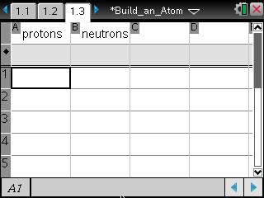
Tech Tip: To create a scatter plot, select  > Data > Quick Graph. Students can then add variables to the desired axes. Note that in some cases, a you may need to back-out to the main Tools Menu to see the desired menu option.
Q5. What is the average ratio between the number of protons and number of neutrons that provides for a stable isotope?

6. To add the best fit line, select Menu > Analyze > Regression > Show Linear. The regression line and equation will appear on the scatter plot.

Tech Tip: Be sure to have the graph screen active. To create a best fit line, select > Analyze > Regression > Show Linear. You may need to back-out to the main Tools Menu to see the desired menu option.

Q6. What is the meaning of the slope of the best fit line?

Part 3: The Size of an Atom  Move back to page 1.2.  7. Now explore how placement of electrons affects the size of an atom. In the simulation only two shells are shown, n = 1 and n = 2. | 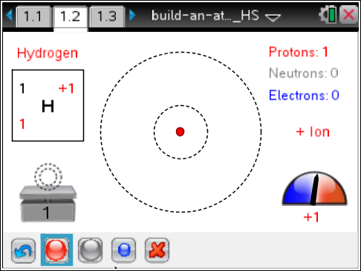
8. Start with a Hydrogen isotope with one proton and no neutrons. Then add one electron at a time and record your observations in the table below. When describing the size, state whether the size increases, decreases, or does not change.
Total Number of Electrons | Net Charge | Number of Electrons in Shell n = 1 | Number of Electrons in Shell n = 2 | Size
1
2
3
4
5

Q7. What did you notice about how the electrons were placed as you added them to the Hydrogen atom?

Q8. What happens to the size of the atom as you add electrons? Do you see a pattern?

9. For each chemical element record the shell where the last electron is placed to build a neutral atom. The electrons in the outermost shell are called valence electrons.

H ___________, He ___________, Li ___________, Be ___________, B ___________,

C ___________, N ___________, O ___________, F ___________, Ne ___________

Q9. Which elements have valence electrons only on the shell n = 1 when the atom is neutral? Where are these elements located in the periodic table?

Q10. Which elements have valence electrons in the shell n = 2 when the atom is neutral? Where are these elements located in the periodic table?

Q8. Q11. Where would you expect the valence electrons to be placed for sodium and iron?

Q12. Compare the sizes of the following atoms. Explain your reasoning for each case:

a. and

b. and

c. and

Part 4: Build an Atom Game  Move to page 1.4.  The game has 4 levels. You can select the level in the lower left corner.  Each game has 5 questions. For each question there are two tries. On the second try, click “Show Answer” to see the correct answer if you did not get it correct. There are two types of questions. One where you are given the atomic symbol and the other where you are given the number of protons, etc.  Record your score after completing the game. | 